Д. Хатрусово
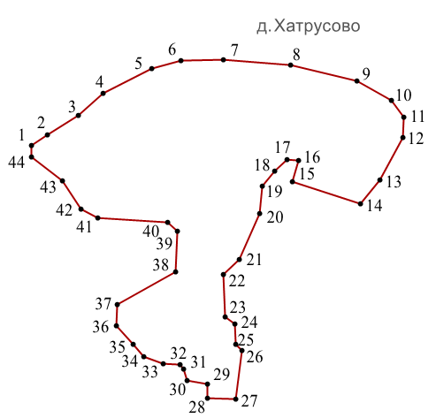
Условное обозначение точки | Координаты
Условное обозначение точки | X | Y
1 | 422842.01 | 1228761.05
2 | 422861.99 | 1228790.05
3 | 422899.00 | 1228850.05
4 | 422942.01 | 1228898.06
5 | 422988.99 | 1228991.05
6 | 423004.00 | 1229047.05
7 | 423006.00 | 1229128.05
8 | 422995.00 | 1229256.05
9 | 422965.01 | 1229384.05
10 | 422928.00 | 1229449.03
11 | 422896.01 | 1229474.05
12 | 422857.00 | 1229471.04
13 | 422775.01 | 1229427.04
14 | 422730.01 | 1229390.04
15 | 422772.01 | 1229260.05
16 | 422813.00 | 1229271.05
17 | 422814.01 | 1229250.05
18 | 422793.01 | 1229226.04
19 | 422763.01 | 1229203.04
20 | 422711.02 | 1229197.04
21 | 422624.01 | 1229158.04
22 | 422595.01 | 1229128.06
23 | 422513.02 | 1229132.05
24 | 422499.02 | 1229150.05
25 | 422460.01 | 1229151.05
26 | 422449.02 | 1229164.05
27 | 422355.02 | 1229152.05
28 | 422357.01 | 1229097.04
29 | 422385.01 | 1229098.06
30 | 422391.02 | 1229059.04
31 | 422413.01 | 1229052.04
32 | 422422.01 | 1229045.05
33 | 422424.01 | 1229012.05
34 | 422437.01 | 1228975.05
35 | 422460.01 | 1228955.05
36 | 422496.02 | 1228923.04
37 | 422537.00 | 1228924.04
38 | 422599.01 | 1229037.05
39 | 422678.01 | 1229039.05
40 | 422695.01 | 1229021.04
41 | 422702.00 | 1228887.04
42 | 422719.01 | 1228856.05
43 | 422774.00 | 1228820.04
 | 437093.99 | 1242830.00

Д. Клемятино
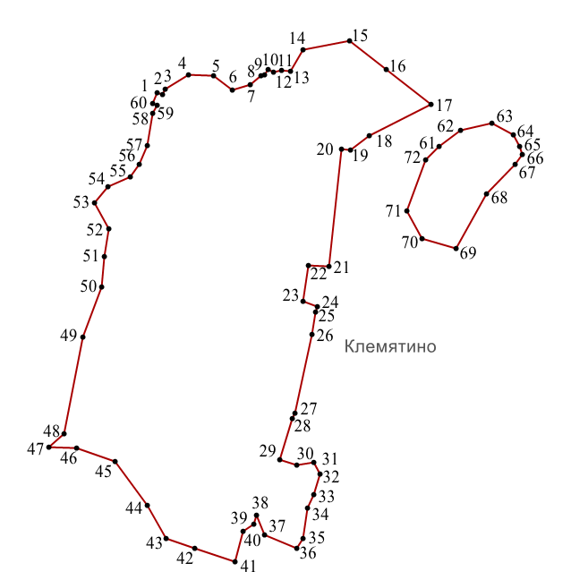
Условное обозначение точки | Координаты
Условное обозначение точки | X | Y
1 | 425077.66 | 1226949.03
2 | 425073.91 | 1226958.70
3 | 425083.92 | 1226964.04
4 | 425110.92 | 1227008.06
5 | 425109.91 | 1227055.04
6 | 425082.92 | 1227091.05
7 | 425091.92 | 1227125.05
8 | 425109.92 | 1227144.04
9 | 425111.72 | 1227151.85
10 | 425121.55 | 1227157.72
11 | 425115.64 | 1227168.81
12 | 425118.93 | 1227183.05
13 | 425116.92 | 1227200.05
14 | 425157.93 | 1227224.05
15 | 425175.91 | 1227313.05
16 | 425120.92 | 1227381.06
17 | 425054.92 | 1227466.04
18 | 424994.93 | 1227349.04
19 | 424967.92 | 1227314.04
20 | 424970.92 | 1227297.06
21 | 424748.94 | 1227274.06
22 | 424750.41 | 1227235.11
23 | 424682.30 | 1227225.08
24 | 424672.75 | 1227251.42
25 | 424662.66 | 1227248.43
26 | 424620.16 | 1227240.63
27 | 424471.30 | 1227209.77
28 | 424459.93 | 1227204.05
29 | 424382.93 | 1227180.05
30 | 424372.94 | 1227212.06
31 | 424377.93 | 1227244.05
32 | 424354.95 | 1227256.05
33 | 424316.94 | 1227244.06
34 | 424290.94 | 1227233.05
35 | 424232.95 | 1227225.05
36 | 424214.95 | 1227212.06
37 | 424240.95 | 1227152.05
38 | 424277.94 | 1227136.05
39 | 424260.94 | 1227132.05
40 | 424247.94 | 1227111.05
41 | 424189.94 | 1227096.05
42 | 424214.70 | 1227020.32
43 | 424232.95 | 1226966.06
44 | 424295.94 | 1226929.06
45 | 424379.95 | 1226869.06
46 | 424404.93 | 1226796.06
47 | 424405.93 | 1226744.06
48 | 424431.93 | 1226773.06
49 | 424614.92 | 1226807.06
50 | 424708.93 | 1226844.06
51 | 424767.92 | 1226849.04
52 | 424818.92 | 1226856.06
53 | 424868.92 | 1226830.04
54 | 424898.92 | 1226856.04
55 | 424917.92 | 1226897.04
56 | 424940.92 | 1226915.04
57 | 424976.91 | 1226930.06
58 | 425038.92 | 1226940.04
59 | 425054.12 | 1226948.15
60 | 425057.30 | 1226940.66
61 | 424975.55 | 1227482.56
62 | 425006.19 | 1227522.53
63 | 425019.51 | 1227582.47
64 | 424998.19 | 1227622.44
65 | 424975.55 | 1227634.43
66 | 424960.89 | 1227639.76
67 | 424942.24 | 1227626.43
68 | 424884.96 | 1227571.82
69 | 424782.38 | 1227513.20
70 | 424801.03 | 1227449.26
71 | 424854.32 | 1227421.28

Д. Барсуки
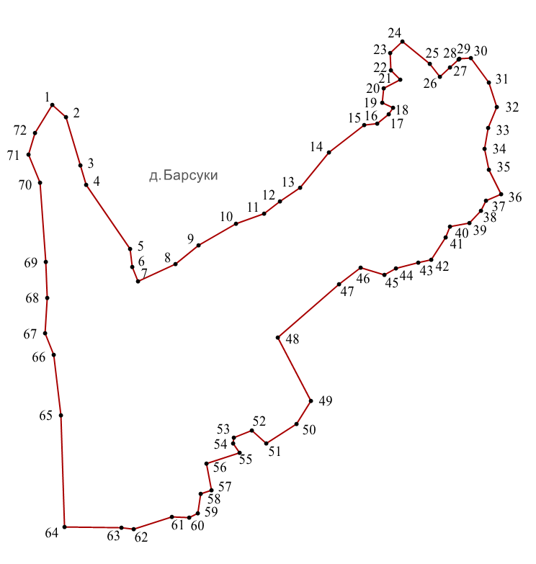
Условное обозначение точки | Координаты
Условное обозначение точки | X | Y
1 | 426596.87 | 1226533.04
2 | 426567.87 | 1226566.05
3 | 426453.87 | 1226599.05
4 | 426408.87 | 1226613.05
5 | 426257.88 | 1226716.05
6 | 426215.89 | 1226722.05
7 | 426181.88 | 1226735.05
8 | 426221.89 | 1226823.04
9 | 426265.88 | 1226878.05
10 | 426316.89 | 1226966.04
11 | 426339.88 | 1227031.04
12 | 426369.88 | 1227069.04
13 | 426400.88 | 1227116.05
14 | 426484.88 | 1227183.05
15 | 426548.88 | 1227267.04
16 | 426552.87 | 1227298.04
17 | 426573.88 | 1227324.05
18 | 426589.89 | 1227334.04
19 | 426600.88 | 1227309.05
20 | 426635.88 | 1227313.04
21 | 426655.87 | 1227352.04
22 | 426677.87 | 1227329.04
23 | 426717.88 | 1227328.04
24 | 426745.88 | 1227356.04
25 | 426692.87 | 1227420.04
26 | 426662.88 | 1227445.04
27 | 426683.89 | 1227469.04
28 | 426702.87 | 1227488.04
29 | 426704.88 | 1227490.04
30 | 426706.88 | 1227517.04
31 | 426648.88 | 1227559.03
32 | 426590.88 | 1227579.05
33 | 426541.89 | 1227558.05
34 | 426492.88 | 1227549.05
35 | 426443.89 | 1227560.05
36 | 426385.89 | 1227588.03
37 | 426370.90 | 1227553.04
38 | 426346.90 | 1227541.05
39 | 426317.89 | 1227514.04
40 | 426309.89 | 1227468.04
41 | 426284.89 | 1227458.04
42 | 426231.89 | 1227424.05
43 | 426224.89 | 1227393.05
44 | 426211.89 | 1227342.04
45 | 426195.89 | 1227314.04
46 | 426212.89 | 1227258.05
47 | 426173.89 | 1227208.03
48 | 426049.89 | 1227063.04
49 | 425900.90 | 1227141.05
50 | 425845.90 | 1227108.05
51 | 425799.90 | 1227036.05
52 | 425830.89 | 1227003.05
53 | 425813.90 | 1226960.05
54 | 425800.90 | 1226959.04
55 | 425778.89 | 1226973.04
56 | 425752.90 | 1226895.04
57 | 425690.90 | 1226908.05
58 | 425681.90 | 1226883.05
59 | 425635.90 | 1226875.04
60 | 425624.90 | 1226855.04
61 | 425627.90 | 1226815.04
62 | 425598.89 | 1226725.05
63 | 425601.90 | 1226696.04
64 | 425602.90 | 1226562.05
65 | 425866.88 | 1226553.05
66 | 426007.89 | 1226537.06
67 | 426059.88 | 1226516.05
68 | 426141.88 | 1226521.04
69 | 426226.88 | 1226518.05
70 | 426412.87 | 1226504.04
71 | 426478.88 | 1226477.05
72 | 426529.88 | 1226492.04

Д. Ярковичи
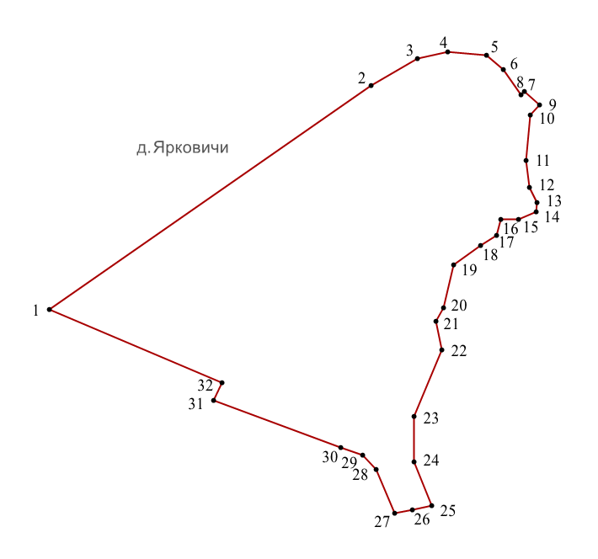
Условное обозначение точки | Координаты
Условное обозначение точки | X | Y
1 | 424535.98 | 1229515.05
2 | 424984.96 | 1230162.04
3 | 425039.95 | 1230255.04
4 | 425052.96 | 1230317.03
5 | 425045.96 | 1230395.03
6 | 425016.96 | 1230428.04
7 | 424966.38 | 1230463.58
8 | 424973.95 | 1230471.48
9 | 424946.19 | 1230501.59
10 | 424926.89 | 1230483.12
11 | 424834.96 | 1230474.03
12 | 424780.96 | 1230481.03
13 | 424749.98 | 1230496.04
14 | 424731.96 | 1230495.03
15 | 424715.97 | 1230459.04
16 | 424715.97 | 1230424.04
17 | 424684.97 | 1230415.03
18 | 424663.16 | 1230383.40
19 | 424624.97 | 1230328.03
20 | 424537.98 | 1230308.03
21 | 424510.98 | 1230293.03
22 | 424454.28 | 1230304.68
23 | 424319.55 | 1230248.69
24 | 424228.56 | 1230248.69
25 | 424139.99 | 1230285.03
26 | 424131.99 | 1230245.03
27 | 424124.98 | 1230210.04
28 | 424213.98 | 1230173.03
29 | 424242.98 | 1230146.04
30 | 424256.98 | 1230102.04
31 | 424352.26 | 1229845.27
32 | 424388.63 | 1229863.53

Д. Потемкино
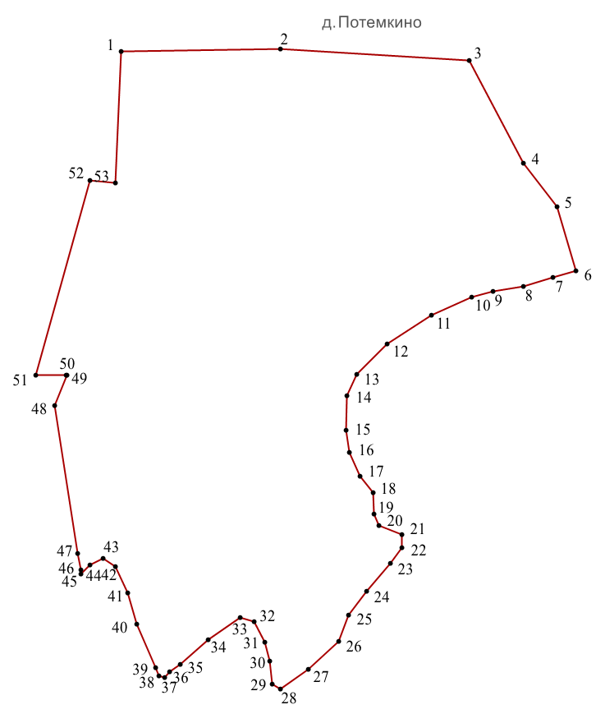
Условное обозначение точки | Координаты
Условное обозначение точки | X | Y
1 | 425208.98 | 1232333.03
2 | 425214.98 | 1232662.01
3 | 425190.00 | 1233052.01
4 | 424977.99 | 1233164.02
5 | 424889.00 | 1233232.01
6 | 424757.55 | 1233271.85
7 | 424743.29 | 1233224.80
8 | 424724.50 | 1233162.80
9 | 424714.96 | 1233100.61
10 | 424703.18 | 1233057.12
11 | 424665.14 | 1232974.05
12 | 424606.08 | 1232883.03
13 | 424544.35 | 1232819.64
14 | 424499.67 | 1232799.77
15 | 424428.67 | 1232796.93
16 | 424382.63 | 1232804.71
17 | 424333.96 | 1232826.96
18 | 424299.74 | 1232853.20
19 | 424255.03 | 1232855.71
20 | 424232.66 | 1232864.87
21 | 424214.20 | 1232913.54
22 | 424186.58 | 1232913.46
23 | 424153.74 | 1232889.67
24 | 424097.16 | 1232840.64
25 | 424047.33 | 1232802.46
26 | 423993.44 | 1232782.55
27 | 423935.66 | 1232719.18
28 | 423894.97 | 1232662.44
29 | 423905.51 | 1232645.35
30 | 423952.66 | 1232640.33
31 | 423990.99 | 1232629.79
32 | 424034.41 | 1232607.52
33 | 424042.34 | 1232578.57
34 | 423996.39 | 1232513.92
35 | 423946.49 | 1232455.84
36 | 423930.71 | 1232433.27
37 | 423919.22 | 1232423.70
38 | 423921.56 | 1232412.31
39 | 423938.22 | 1232404.95
40 | 424028.64 | 1232364.99
41 | 424092.36 | 1232346.80
42 | 424147.83 | 1232322.07
43 | 424163.64 | 1232297.10
44 | 424150.52 | 1232269.41
45 | 424131.88 | 1232250.30
46 | 424140.02 | 1232250.03
47 | 424175.00 | 1232244.02
48 | 424478.99 | 1232196.01
49 | 424542.00 | 1232221.03
50 | 424541.99 | 1232220.03
51 | 424542.73 | 1232157.52
52 | 424942.98 | 1232268.85
53 | 424937.99 | 1232322.03

Д. Ивановское
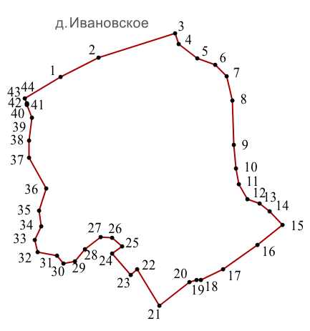
Условное обозначение точки | Координаты
Условное обозначение точки | X | Y
1 | 426659.97 | 1234133.01
2 | 426706.97 | 1234224.01
3 | 426763.96 | 1234404.00
4 | 426737.97 | 1234413.99
5 | 426704.97 | 1234458.00
6 | 426689.97 | 1234499.00
7 | 426661.98 | 1234526.01
8 | 426604.97 | 1234541.01
9 | 426498.97 | 1234543.01
10 | 426443.97 | 1234549.01
11 | 426405.99 | 1234555.01
12 | 426370.98 | 1234576.01
13 | 426360.00 | 1234604.01
14 | 426341.98 | 1234629.01
15 | 426309.98 | 1234658.00
16 | 426261.98 | 1234599.01
17 | 426204.98 | 1234519.00
18 | 426178.98 | 1234466.01
19 | 426178.98 | 1234455.01
20 | 426174.98 | 1234438.00
21 | 426118.99 | 1234367.00
22 | 426204.92 | 1234314.73
23 | 426191.14 | 1234299.18
24 | 426242.17 | 1234256.49
25 | 426259.91 | 1234278.59
26 | 426278.98 | 1234255.00
27 | 426280.98 | 1234229.00
28 | 426251.98 | 1234191.01
29 | 426222.97 | 1234167.00
30 | 426218.98 | 1234141.00
31 | 426236.98 | 1234126.01
32 | 426245.97 | 1234079.00
33 | 426274.97 | 1234073.01
34 | 426306.97 | 1234088.01
35 | 426343.97 | 1234083.00
36 | 426395.97 | 1234100.00
37 | 426468.98 | 1234059.01
38 | 426509.97 | 1234060.01
39 | 426563.96 | 1234066.01
40 | 426594.69 | 1234054.65
41 | 426594.74 | 1234054.61
42 | 426597.72 | 1234053.50
43 | 426597.74 | 1234053.52
44 | 426609.96 | 1234049.00

Д. Усадище
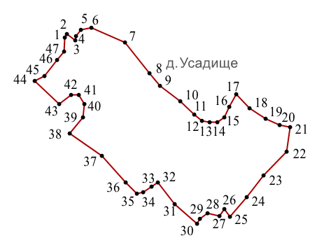
Условное обозначение точки | Координаты
Условное обозначение точки | X | Y
1 | 427743.92 | 1233098.01
2 | 427752.92 | 1233102.00
3 | 427736.92 | 1233123.01
4 | 427746.92 | 1233125.01
5 | 427762.92 | 1233136.01
6 | 427767.92 | 1233161.00
7 | 427731.94 | 1233243.01
8 | 427657.94 | 1233303.01
9 | 427626.92 | 1233327.01
10 | 427590.94 | 1233376.01
11 | 427557.94 | 1233410.00
12 | 427542.93 | 1233429.00
13 | 427538.93 | 1233448.00
14 | 427539.93 | 1233466.01
15 | 427551.93 | 1233483.01
16 | 427575.94 | 1233495.00
17 | 427606.93 | 1233512.99
18 | 427572.93 | 1233544.99
19 | 427547.93 | 1233583.01
20 | 427532.93 | 1233617.01
21 | 427526.94 | 1233643.01
22 | 427467.94 | 1233635.00
23 | 427410.94 | 1233578.00
24 | 427358.94 | 1233537.99
25 | 427309.94 | 1233497.00
26 | 427329.93 | 1233484.01
27 | 427312.64 | 1233472.47
28 | 427319.77 | 1233443.35
29 | 427305.31 | 1233423.48
30 | 427293.22 | 1233416.60
31 | 427340.93 | 1233364.00
32 | 427393.01 | 1233323.19
33 | 427382.83 | 1233306.64
34 | 427370.69 | 1233287.18
35 | 427366.49 | 1233271.34
36 | 427393.93 | 1233244.01
37 | 427457.93 | 1233187.01
38 | 427512.93 | 1233109.00
39 | 427551.93 | 1233142.01
40 | 427582.93 | 1233144.01
41 | 427604.93 | 1233132.01
42 | 427605.93 | 1233113.00
43 | 427583.93 | 1233083.00
44 | 427639.92 | 1233024.00
45 | 427650.92 | 1233048.01
46 | 427690.92 | 1233079.01
47 | 427710.92 | 1233096.01

Д. Пахомово
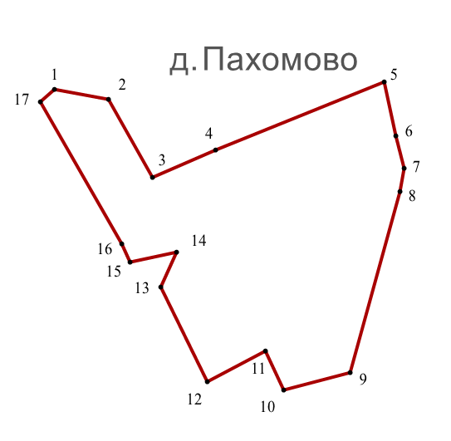
Условное обозначение точки | Координаты
Условное обозначение точки | X | Y
1 | 427317.61 | 1234267.18
2 | 427307.66 | 1234322.19
3 | 427228.18 | 1234367.38
4 | 427255.99 | 1234432.01
5 | 427324.96 | 1234603.97
6 | 427270.03 | 1234615.99
7 | 427237.00 | 1234624.01
8 | 427213.03 | 1234619.96
9 | 427028.88 | 1234568.82
10 | 427011.09 | 1234500.89
11 | 427051.16 | 1234482.50
12 | 427019.27 | 1234423.64
13 | 427115.74 | 1234376.22
14 | 427151.30 | 1234391.81
15 | 427141.40 | 1234344.74
16 | 427160.06 | 1234335.88
17 | 427305.22 | 1234253.05
Д. Колычево
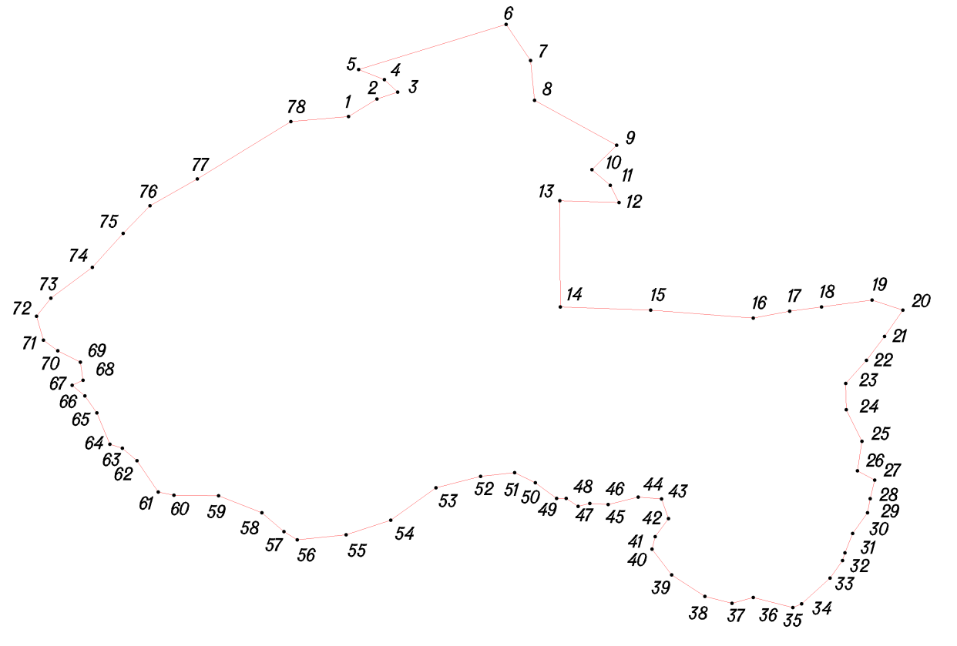
Условное обозначение точки | Координаты
Условное обозначение точки | X | Y
1 | 428039.02 | 1235584.97
2 | 428066.95 | 1235630.02
3 | 428077.96 | 1235662.97
4 | 428098.03 | 1235642.00
5 | 428114.00 | 1235601.02
6 | 428186.02 | 1235835.79
7 | 428128.27 | 1235874.55
8 | 428065.02 | 1235880.96
9 | 427993.69 | 1236011.58
10 | 427954.51 | 1235972.29
11 | 427929.47 | 1236001.58
12 | 427902.25 | 1236015.31
13 | 427905.01 | 1235921.01
14 | 427736.03 | 1235921.99
15 | 427730.73 | 1236065.83
16 | 427717.96 | 1236229.01
17 | 427728.97 | 1236287.04
18 | 427735.94 | 1236337.62
19 | 427747.01 | 1236418.03
20 | 427731.01 | 1236467.00
21 | 427689.03 | 1236438.04
22 | 427650.99 | 1236409.02
23 | 427614.01 | 1236376.04
24 | 427571.98 | 1236377.05
25 | 427521.98 | 1236402.04
26 | 427474.95 | 1236394.97
27 | 427460.11 | 1236422.45
28 | 427430.38 | 1236415.03
29 | 427407.99 | 1236410.96
30 | 427375.01 | 1236387.02
31 | 427344.03 | 1236375.02
32 | 427332.04 | 1236371.00
33 | 427304.02 | 1236351.04
34 | 427263.03 | 1236306.03
35 | 427256.97 | 1236292.03
36 | 427272.97 | 1236228.97
37 | 427263.96 | 1236194.99
38 | 427274.98 | 1236152.03
39 | 427308.96 | 1236099.00
40 | 427349.95 | 1236068.00
41 | 427370.01 | 1236073.00
42 | 427398.94 | 1236094.01
43 | 427430.03 | 1236083.02
44 | 427432.95 | 1236045.97
45 | 427421.00 | 1235998.00
46 | 427423.00 | 1235969.00
47 | 427418.02 | 1235950.05
48 | 427431.04 | 1235931.02
49 | 427431.03 | 1235915.94
50 | 427455.99 | 1235881.98
51 | 427472.04 | 1235848.98
52 | 427465.97 | 1235795.04
53 | 427448.01 | 1235723.97
54 | 427396.04 | 1235652.00
55 | 427373.05 | 1235580.96
56 | 427364.99 | 1235502.97
57 | 427377.99 | 1235481.95
58 | 427407.98 | 1235446.96
59 | 427435.00 | 1235378.00
60 | 427435.95 | 1235307.02
61 | 427440.97 | 1235282.03
62 | 427490.99 | 1235248.04
63 | 427511.04 | 1235224.98
64 | 427517.00 | 1235205.02
65 | 427567.03 | 1235184.01
66 | 427594.05 | 1235165.01
67 | 427610.97 | 1235145.03
68 | 427618.96 | 1235162.00
69 | 427647.99 | 1235158.03
70 | 427666.01 | 1235122.02
71 | 427683.03 | 1235099.04
72 | 427720.97 | 1235088.01
73 | 427750.02 | 1235111.02
74 | 427799.02 | 1235176.99
75 | 427853.02 | 1235225.95
76 | 427897.02 | 1235268.97
77 | 427939.95 | 1235344.02
78 | 428030.96 | 1235492.99

Д. Сестрино
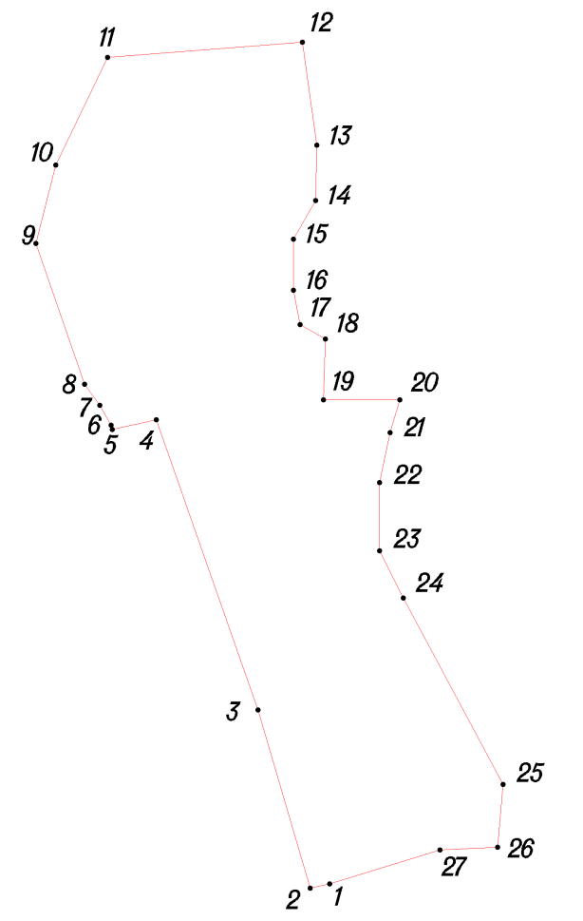
Условное обозначение точки | Координаты
Условное обозначение точки | X | Y
1 | 428513.16 | 1233801.61
2 | 428508.80 | 1233780.13
3 | 428702.15 | 1233723.69
4 | 429016.81 | 1233613.20
5 | 429006.00 | 1233565.16
6 | 429010.80 | 1233563.96
7 | 429032.42 | 1233551.95
8 | 429055.24 | 1233535.13
9 | 429207.76 | 1233482.29
10 | 429293.03 | 1233503.91
11 | 429409.52 | 1233560.35
12 | 429426.34 | 1233771.73
13 | 429314.65 | 1233787.34
14 | 429254.60 | 1233786.14
15 | 429212.56 | 1233762.12
16 | 429157.32 | 1233762.12
17 | 429120.09 | 1233769.32
18 | 429104.48 | 1233796.95
19 | 429038.42 | 1233794.54
20 | 429038.42 | 1233877.41
21 | 429002.80 | 1233867.09
22 | 428948.71 | 1233855.70
23 | 428874.69 | 1233855.70
24 | 428823.45 | 1233881.32
25 | 428621.33 | 1233989.50
26 | 428553.01 | 1233983.81
27 | 428550.16 | 1233921.18

Д. Ламоново
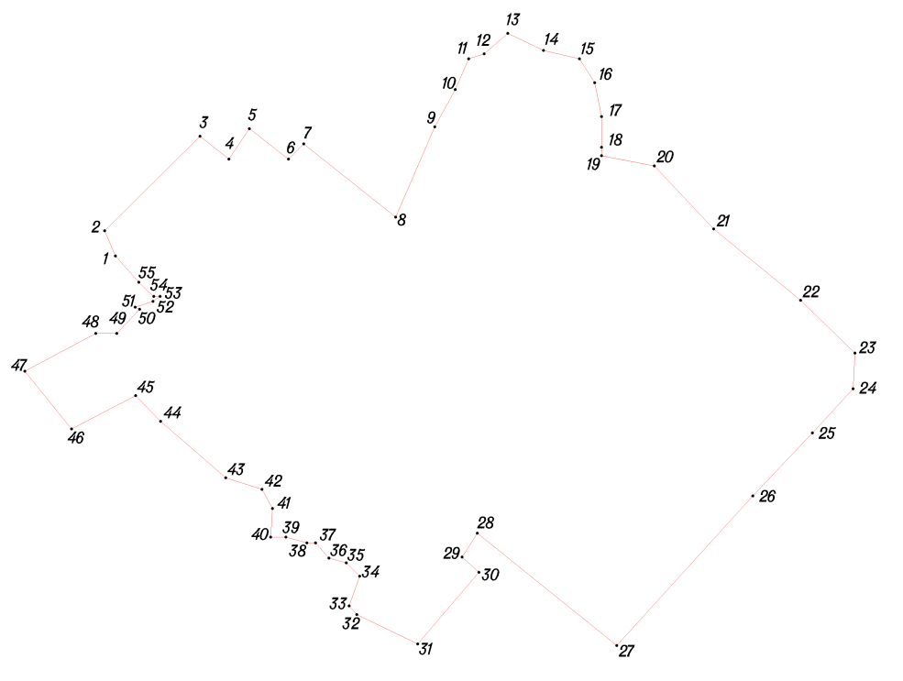
Условное обозначение точки | Координаты
Условное обозначение точки | X | Y
1 | 428907.02 | 1230627.70
2 | 428951.79 | 1230608.74
3 | 429119.59 | 1230778.07
4 | 429078.79 | 1230829.27
5 | 429133.13 | 1230865.50
6 | 429078.79 | 1230934.92
7 | 429105.96 | 1230962.09
8 | 428976.16 | 1231125.10
9 | 429136.15 | 1231194.52
10 | 429202.55 | 1231230.75
11 | 429256.89 | 1231254.90
12 | 429265.94 | 1231282.06
13 | 429302.17 | 1231324.32
14 | 429271.98 | 1231387.71
15 | 429256.89 | 1231451.10
16 | 429214.63 | 1231478.27
17 | 429154.26 | 1231490.35
18 | 429099.92 | 1231490.35
19 | 429084.83 | 1231490.35
20 | 429066.72 | 1231583.92
21 | 428955.03 | 1231689.57
22 | 428828.25 | 1231843.52
23 | 428734.67 | 1231940.12
24 | 428671.28 | 1231937.10
25 | 428592.80 | 1231864.65
26 | 428481.11 | 1231759.00
27 | 428215.47 | 1231517.51
28 | 428414.70 | 1231269.99
29 | 428372.44 | 1231242.82
30 | 428345.27 | 1231273.01
31 | 428218.49 | 1231164.34
32 | 428270.37 | 1231056.05
33 | 428285.66 | 1231042.46
34 | 428338.29 | 1231061.14
35 | 428362.06 | 1231037.37
36 | 428370.55 | 1231006.81
37 | 428397.72 | 1230983.03
38 | 428397.72 | 1230967.75
39 | 428407.91 | 1230930.40
40 | 428407.91 | 1230903.23
41 | 428458.85 | 1230906.63
42 | 428492.81 | 1230887.95
43 | 428513.18 | 1230823.43
44 | 428613.36 | 1230707.96
45 | 428659.21 | 1230663.82
46 | 428599.78 | 1230550.05
47 | 428702.49 | 1230467.14
48 | 428769.48 | 1230592.94
49 | 428769.48 | 1230630.19
50 | 428812.45 | 1230670.63
51 | 428816.24 | 1230663.05
52 | 428826.36 | 1230694.65
53 | 428835.20 | 1230707.29
54 | 428835.20 | 1230695.91
55 | 428860.48 | 1230669.37

Д. Шабаново
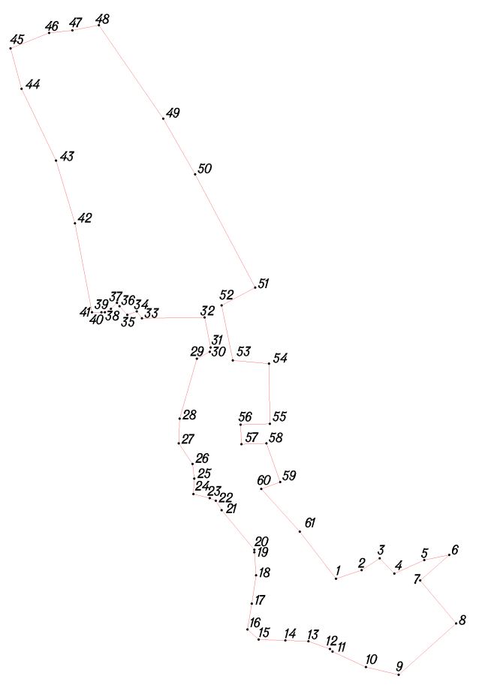
Условное обозначение точки | Координаты
Условное обозначение точки | X | Y
1 | 430117.55 | 1229259.64
2 | 430136.13 | 1229315.38
3 | 430162.14 | 1229354.40
4 | 430128.70 | 1229385.99
5 | 430158.43 | 1229451.02
6 | 430169.58 | 1229504.90
7 | 430113.83 | 1229441.73
8 | 430020.93 | 1229519.77
9 | 429909.45 | 1229395.28
10 | 429926.17 | 1229324.67
11 | 429959.61 | 1229252.20
12 | 429965.19 | 1229246.63
13 | 429981.91 | 1229200.18
14 | 429983.77 | 1229150.01
15 | 429985.63 | 1229092.41
16 | 430007.92 | 1229068.26
17 | 430063.67 | 1229077.55
18 | 430124.98 | 1229086.84
19 | 430175.15 | 1229083.12
20 | 430180.73 | 1229083.12
21 | 430266.20 | 1229012.51
22 | 430286.64 | 1228999.51
23 | 430292.21 | 1228986.50
24 | 430301.50 | 1228951.20
25 | 430334.95 | 1228953.06
26 | 430366.53 | 1228949.34
27 | 430411.13 | 1228919.61
28 | 430465.01 | 1228921.47
29 | 430595.08 | 1228958.63
30 | 430609.94 | 1228986.50
31 | 430619.23 | 1228988.36
32 | 430684.26 | 1228975.35
33 | 430682.40 | 1228839.71
34 | 430697.27 | 1228828.56
35 | 430689.84 | 1228808.13
36 | 430708.42 | 1228791.40
37 | 430715.85 | 1228785.83
38 | 430702.84 | 1228772.82
39 | 430695.41 | 1228759.82
40 | 430695.41 | 1228752.38
41 | 430695.41 | 1228731.94
42 | 430888.65 | 1228694.78
43 | 431024.29 | 1228653.91
44 | 431180.37 | 1228579.58
45 | 431267.70 | 1228555.43
46 | 431301.14 | 1228639.04
47 | 431306.72 | 1228689.21
48 | 431317.87 | 1228746.81
49 | 431115.34 | 1228886.16
50 | 430994.56 | 1228954.91
51 | 430749.30 | 1229084.98
52 | 430710.28 | 1229012.51
53 | 430591.36 | 1229036.67
54 | 430583.93 | 1229114.71
55 | 430453.86 | 1229116.57
56 | 430452.00 | 1229053.39
57 | 430409.27 | 1229055.25
58 | 430411.13 | 1229109.13
59 | 430327.51 | 1229138.86
60 | 430312.65 | 1229097.98
61 | 430219.74 | 1229181.60

Д. Пищалово
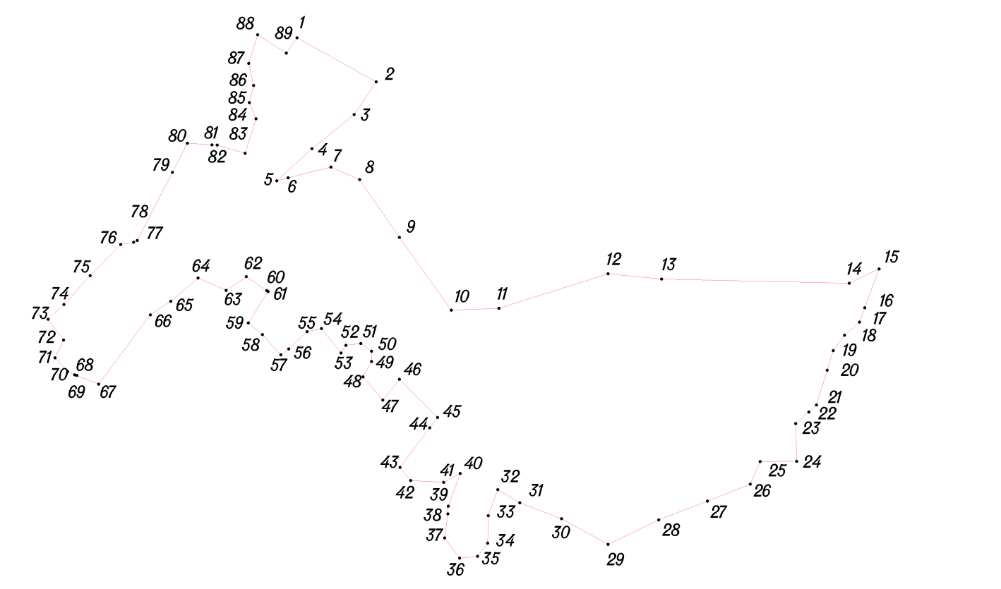
Условное обозначение точки | Координаты
Условное обозначение точки | X | Y
1 | 430290.04 | 1236124.98
2 | 430215.94 | 1236258.00
3 | 430160.93 | 1236220.98
4 | 430103.95 | 1236150.04
5 | 430049.98 | 1236090.98
6 | 430054.96 | 1236110.04
7 | 430073.02 | 1236181.99
8 | 430051.99 | 1236229.99
9 | 429954.95 | 1236296.96
10 | 429833.03 | 1236384.02
11 | 429835.98 | 1236464.04
12 | 429893.96 | 1236646.99
13 | 429885.02 | 1236736.97
14 | 429877.96 | 1237051.97
15 | 429902.00 | 1237101.97
16 | 429837.03 | 1237077.97
17 | 429813.02 | 1237069.03
18 | 429790.99 | 1237043.98
19 | 429764.99 | 1237024.97
20 | 429732.33 | 1237014.93
21 | 429673.95 | 1236996.97
22 | 429661.97 | 1236983.96
23 | 429642.66 | 1236962.14
24 | 429579.29 | 1236963.55
25 | 429578.95 | 1236902.29
26 | 429541.06 | 1236885.82
27 | 429512.64 | 1236813.99
28 | 429481.03 | 1236732.00
29 | 429440.03 | 1236647.04
30 | 429482.97 | 1236568.95
31 | 429509.96 | 1236498.99
32 | 429531.99 | 1236462.02
33 | 429488.02 | 1236445.97
34 | 429441.95 | 1236445.04
35 | 429419.98 | 1236427.97
36 | 429417.03 | 1236397.99
37 | 429450.72 | 1236372.88
38 | 429491.17 | 1236378.19
39 | 429503.97 | 1236379.02
40 | 429558.95 | 1236399.05
41 | 429543.95 | 1236371.05
42 | 429547.04 | 1236316.02
43 | 429569.02 | 1236298.02
44 | 429635.47 | 1236347.88
45 | 429653.01 | 1236361.04
46 | 429716.97 | 1236296.99
47 | 429681.94 | 1236268.98
48 | 429721.01 | 1236236.00
49 | 429746.96 | 1236250.01
50 | 429763.97 | 1236250.02
51 | 429777.00 | 1236232.00
52 | 429773.99 | 1236207.02
53 | 429760.95 | 1236198.97
54 | 429802.03 | 1236165.97
55 | 429797.01 | 1236142.01
56 | 429768.00 | 1236111.02
57 | 429758.04 | 1236097.97
58 | 429791.99 | 1236067.02
59 | 429811.60 | 1236043.17
60 | 429864.15 | 1236076.45
61 | 429865.97 | 1236074.05
62 | 429889.04 | 1236040.00
63 | 429866.02 | 1236006.03
64 | 429886.99 | 1235959.02
65 | 429848.00 | 1235912.99
66 | 429824.99 | 1235879.01
67 | 429708.93 | 1235792.16
68 | 429723.48 | 1235755.42
69 | 429724.50 | 1235751.67
70 | 429729.71 | 1235739.90
71 | 429752.79 | 1235718.99
72 | 429782.71 | 1235732.98
73 | 429817.71 | 1235707.24
74 | 429842.30 | 1235733.84
75 | 429890.98 | 1235777.97
76 | 429942.98 | 1235828.97
77 | 429946.95 | 1235850.71
78 | 429949.95 | 1235856.99
79 | 430063.97 | 1235915.97
80 | 430112.95 | 1235940.99
81 | 430110.27 | 1235982.44
82 | 430110.03 | 1235991.03
83 | 430096.02 | 1236037.98
84 | 430154.00 | 1236056.02
85 | 430180.97 | 1236045.00
86 | 430209.99 | 1236052.02
87 | 430246.94 | 1236044.05
88 | 430294.94 | 1236059.04
89 | 430264.04 | 1236106.97

Д. Бакланово
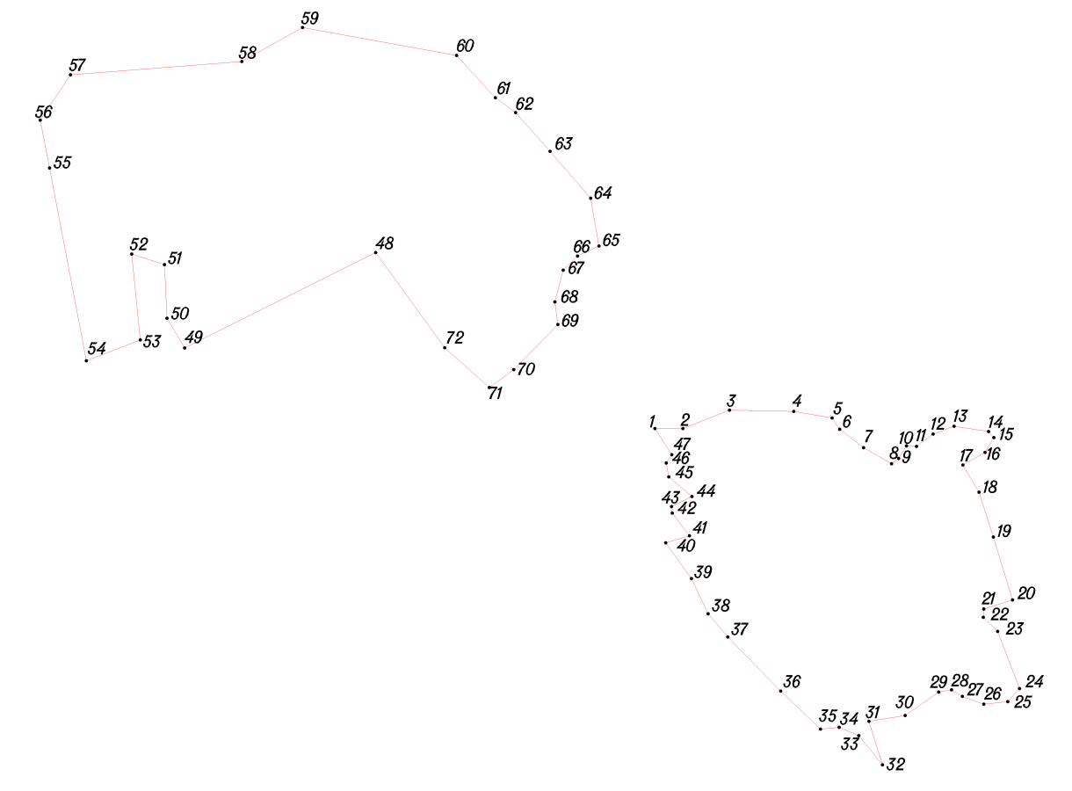
Условное обозначение точки | Координаты
Условное обозначение точки | X | Y
1 | 432765.94 | 1230498.02
2 | 432765.94 | 1230498.02
3 | 432605.37 | 1230177.39
4 | 432605.37 | 1230177.39
5 | 432655.38 | 1230148.05
6 | 432655.38 | 1230148.05
7 | 432745.49 | 1230143.52
8 | 432745.49 | 1230143.52
9 | 432763.12 | 1230088.66
10 | 432763.12 | 1230088.66
11 | 432618.88 | 1230103.04
12 | 432618.88 | 1230103.04
13 | 432583.69 | 1230012.52
14 | 432583.69 | 1230012.52
15 | 432907.84 | 1229950.75
16 | 432907.84 | 1229950.75
17 | 432988.42 | 1229935.39
18 | 432988.42 | 1229935.39
19 | 433064.24 | 1229985.98
20 | 433064.24 | 1229985.98
21 | 433086.80 | 1230273.50
22 | 433086.80 | 1230273.50
23 | 433143.82 | 1230375.38
24 | 433143.82 | 1230375.38
25 | 433097.14 | 1230633.99
26 | 433097.14 | 1230633.99
27 | 433026.04 | 1230699.04
28 | 433026.04 | 1230699.04
29 | 433000.95 | 1230733.02
30 | 433000.95 | 1230733.02
31 | 432935.94 | 1230791.03
32 | 432935.94 | 1230791.03
33 | 432857.02 | 1230858.94
34 | 432857.02 | 1230858.94
35 | 432776.97 | 1230872.98
36 | 432776.97 | 1230872.98
37 | 432759.99 | 1230837.02
38 | 432759.99 | 1230837.02
39 | 432735.96 | 1230812.99
40 | 432735.96 | 1230812.99
41 | 432682.94 | 1230799.02
42 | 432682.94 | 1230799.02
43 | 432644.96 | 1230803.96
44 | 432644.96 | 1230803.96
45 | 432569.04 | 1230730.04
46 | 432569.04 | 1230730.04
47 | 432539.05 | 1230689.02
48 | 432765.94 | 1230498.02
49 | 432605.37 | 1230177.39
50 | 432655.38 | 1230148.05
51 | 432745.49 | 1230143.52
52 | 432763.12 | 1230088.66
53 | 432618.88 | 1230103.04
54 | 432583.69 | 1230012.52
55 | 432907.84 | 1229950.75
56 | 432988.42 | 1229935.39
57 | 433064.24 | 1229985.98
58 | 433086.80 | 1230273.50
59 | 433143.82 | 1230375.38
60 | 433097.14 | 1230633.99
61 | 433026.04 | 1230699.04
62 | 433000.95 | 1230733.02
63 | 432935.94 | 1230791.03
64 | 432857.02 | 1230858.94
65 | 432776.97 | 1230872.98
66 | 432759.99 | 1230837.02
67 | 432735.96 | 1230812.99
68 | 432682.94 | 1230799.02
69 | 432644.96 | 1230803.96
70 | 432569.04 | 1230730.04
71 | 432539.05 | 1230689.02
72 | 432606.03 | 1230613.99

Д. Покровка
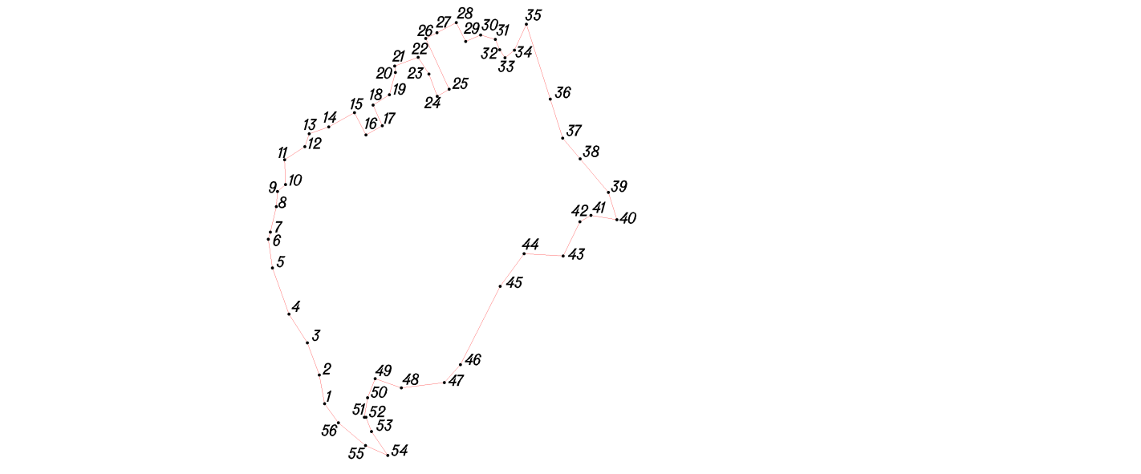
Условное обозначение точки | Координаты
Условное обозначение точки | X | Y
1 | 434083.03 | 1228846.97
2 | 434135.96 | 1228836.98
3 | 434195.01 | 1228815.00
4 | 434247.96 | 1228781.03
5 | 434333.02 | 1228750.99
6 | 434385.96 | 1228742.98
7 | 434398.97 | 1228747.04
8 | 434446.03 | 1228758.00
9 | 434474.01 | 1228759.99
10 | 434486.60 | 1228775.00
11 | 434532.05 | 1228773.12
12 | 434556.48 | 1228810.35
13 | 434579.82 | 1228818.44
14 | 434592.60 | 1228854.26
15 | 434618.97 | 1228902.00
16 | 434578.00 | 1228923.01
17 | 434595.03 | 1228952.98
18 | 434633.02 | 1228935.95
19 | 434651.95 | 1228965.99
20 | 434692.98 | 1228977.04
21 | 434704.94 | 1228975.98
22 | 434720.98 | 1229018.99
23 | 434689.96 | 1229038.96
24 | 434649.04 | 1229053.99
25 | 434662.05 | 1229076.10
26 | 434755.53 | 1229032.95
27 | 434766.25 | 1229053.45
28 | 434784.86 | 1229089.07
29 | 434750.05 | 1229106.46
30 | 434762.02 | 1229134.02
31 | 434753.99 | 1229161.00
32 | 434734.94 | 1229169.02
33 | 434720.04 | 1229178.97
34 | 434733.95 | 1229196.05
35 | 434782.00 | 1229218.03
36 | 434643.71 | 1229262.12
37 | 434572.01 | 1229284.98
38 | 434533.94 | 1229317.00
39 | 434472.00 | 1229369.02
40 | 434421.94 | 1229385.03
41 | 434430.01 | 1229336.97
42 | 434417.98 | 1229316.96
43 | 434354.97 | 1229285.95
44 | 434359.02 | 1229213.99
45 | 434299.03 | 1229170.00
46 | 434155.03 | 1229096.95
47 | 434121.99 | 1229067.02
48 | 434112.02 | 1228988.05
49 | 434129.03 | 1228940.01
50 | 434094.02 | 1228925.97
51 | 434057.97 | 1228920.01
52 | 434057.98 | 1228923.00
53 | 434032.01 | 1228932.96
54 | 433987.99 | 1228962.96
55 | 434005.98 | 1228921.95
56 | 434048.01 | 1228872.00

Д. Обухово
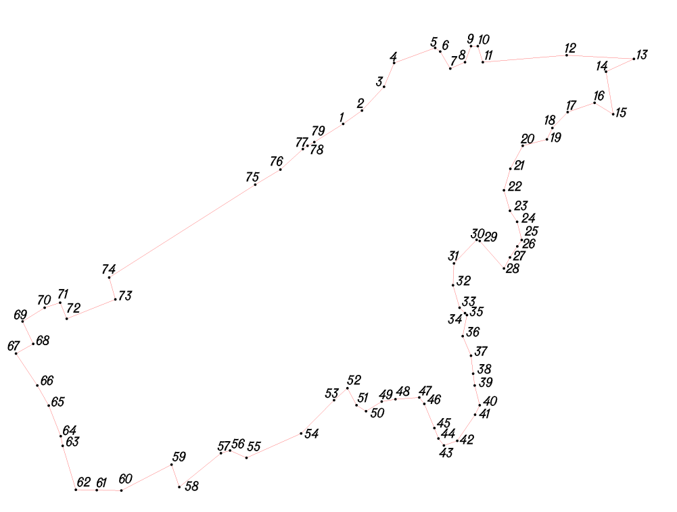
Условное обозначение точки | Координаты
Условное обозначение точки | X | Y
1 | 434685.03 | 1231115.01
2 | 434714.02 | 1231156.00
3 | 434765.99 | 1231204.00
4 | 434817.97 | 1231226.03
5 | 434850.98 | 1231316.00
6 | 434843.02 | 1231327.00
7 | 434805.98 | 1231348.96
8 | 434820.00 | 1231381.02
9 | 434855.01 | 1231393.95
10 | 434855.03 | 1231409.04
11 | 434820.02 | 1231419.97
12 | 434834.94 | 1231603.00
13 | 434826.96 | 1231750.05
14 | 434799.02 | 1231689.02
15 | 434706.12 | 1231704.45
16 | 434731.03 | 1231664.03
17 | 434710.94 | 1231604.98
18 | 434675.99 | 1231571.98
19 | 434651.05 | 1231559.99
20 | 434637.04 | 1231506.96
21 | 434586.94 | 1231480.01
22 | 434539.96 | 1231465.96
23 | 434495.00 | 1231479.04
24 | 434470.99 | 1231494.97
25 | 434431.04 | 1231505.03
26 | 434416.97 | 1231495.04
27 | 434393.01 | 1231479.01
28 | 434368.97 | 1231465.98
29 | 434429.00 | 1231412.97
30 | 434431.74 | 1231406.22
31 | 434380.14 | 1231356.74
32 | 434331.96 | 1231354.98
33 | 434283.01 | 1231369.02
34 | 434271.03 | 1231380.98
35 | 434267.04 | 1231385.03
36 | 434220.99 | 1231376.00
37 | 434177.99 | 1231393.96
38 | 434139.01 | 1231398.96
39 | 434112.98 | 1231402.04
40 | 434070.02 | 1231412.99
41 | 434049.02 | 1231402.96
42 | 433991.98 | 1231363.97
43 | 433982.00 | 1231335.05
44 | 433996.99 | 1231323.00
45 | 434019.95 | 1231314.03
46 | 434072.98 | 1231292.03
47 | 434086.98 | 1231281.05
48 | 434083.04 | 1231228.96
49 | 434077.98 | 1231199.01
50 | 434056.99 | 1231165.01
51 | 434069.99 | 1231143.99
52 | 434106.94 | 1231124.04
53 | 434080.97 | 1231095.04
54 | 434007.99 | 1231023.03
55 | 433955.03 | 1230903.98
56 | 433971.04 | 1230867.98
57 | 433964.95 | 1230848.00
58 | 433891.00 | 1230756.97
59 | 433939.96 | 1230740.03
60 | 433883.48 | 1230630.54
61 | 433884.37 | 1230576.99
62 | 433885.22 | 1230531.28
63 | 433980.87 | 1230502.54
64 | 434002.00 | 1230498.01
65 | 434068.99 | 1230472.02
66 | 434113.04 | 1230447.02
67 | 434183.01 | 1230400.62
68 | 434204.00 | 1230437.97
69 | 434253.00 | 1230415.04
70 | 434282.95 | 1230462.96
71 | 434293.98 | 1230497.01
72 | 434258.95 | 1230511.25
73 | 434301.47 | 1230617.58
74 | 434348.95 | 1230604.05
75 | 434552.04 | 1230923.00
76 | 434584.95 | 1230978.02
77 | 434630.01 | 1231026.96
78 | 434637.04 | 1231037.00
79 | 434645.00 | 1231051.97

д. Макшеево
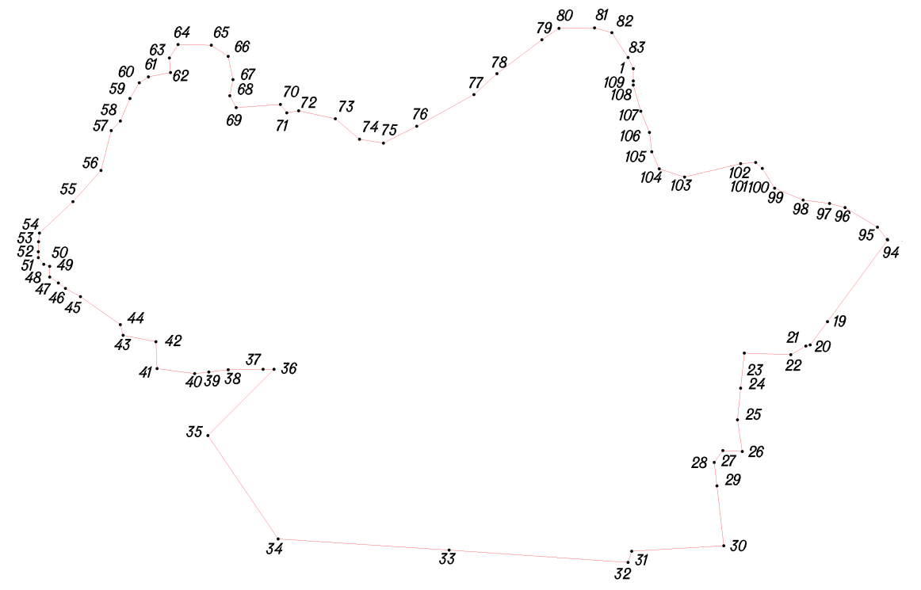
Условное обозначение точки | Координаты
Условное обозначение точки | X | Y
1 | 434738.03 | 1233139.99
2 | 434715.47 | 1233140.02
3 | 434707.94 | 1233140.03
4 | 434658.98 | 1233153.97
5 | 434619.98 | 1233169.97
6 | 434584.01 | 1233173.97
7 | 434552.03 | 1233188.02
8 | 434537.01 | 1233235.04
9 | 434561.98 | 1233339.01
10 | 434564.01 | 1233367.05
11 | 434552.94 | 1233379.04
12 | 434516.01 | 1233401.99
13 | 434494.00 | 1233454.96
14 | 434487.95 | 1233503.99
15 | 434480.03 | 1233532.97
16 | 434443.99 | 1233593.02
17 | 434421.01 | 1233610.98
18 | 434420.01 | 1233612.04
19 | 434268.34 | 1233500.02
20 | 434224.94 | 1233467.97
21 | 434222.97 | 1233460.01
22 | 434206.95 | 1233431.97
23 | 434209.98 | 1233345.97
24 | 434144.67 | 1233339.12
25 | 434085.97 | 1233332.97
26 | 434027.00 | 1233341.97
27 | 434029.02 | 1233305.97
28 | 434006.98 | 1233290.01
29 | 433963.29 | 1233295.07
30 | 433852.02 | 1233307.97
31 | 433842.01 | 1233137.01
32 | 433821.02 | 1233129.97
33 | 433843.94 | 1232797.97
34 | 433864.68 | 1232480.73
35 | 434056.82 | 1232350.35
36 | 434180.03 | 1232472.99
37 | 434179.97 | 1232453.02
38 | 434178.95 | 1232387.96
39 | 434174.97 | 1232352.42
40 | 434172.02 | 1232325.98
41 | 434181.02 | 1232255.98
42 | 434230.99 | 1232253.96
43 | 434242.98 | 1232192.96
44 | 434262.95 | 1232187.97
45 | 434314.97 | 1232114.01
46 | 434330.03 | 1232085.97
47 | 434340.00 | 1232073.05
48 | 434351.03 | 1232056.96
49 | 434370.95 | 1232056.97
50 | 434374.98 | 1232046.02
51 | 434386.98 | 1232035.96
52 | 434398.04 | 1232035.95
53 | 434416.95 | 1232036.03
54 | 434432.96 | 1232037.99
55 | 434490.99 | 1232099.99
56 | 434549.02 | 1232151.99
57 | 434623.01 | 1232171.01
58 | 434640.94 | 1232188.04
59 | 434683.03 | 1232206.00
60 | 434712.03 | 1232223.01
61 | 434723.03 | 1232239.98
62 | 434731.01 | 1232281.03
63 | 434758.04 | 1232278.99
64 | 434783.01 | 1232294.96
65 | 434781.99 | 1232356.96
66 | 434761.02 | 1232387.97
67 | 434718.04 | 1232397.03
68 | 434688.02 | 1232390.97
69 | 434665.99 | 1232402.97
70 | 434671.97 | 1232485.00
71 | 434655.97 | 1232497.02
72 | 434659.96 | 1232519.04
73 | 434645.02 | 1232587.02
74 | 434606.95 | 1232632.02
75 | 434599.96 | 1232676.02
76 | 434631.03 | 1232738.05
77 | 434690.00 | 1232844.03
78 | 434728.98 | 1232886.97
79 | 434792.00 | 1232970.02
80 | 434812.97 | 1233002.02
81 | 434814.00 | 1233067.98
82 | 434804.99 | 1233100.03
83 | 434758.96 | 1233129.96

Д. Крокодиново

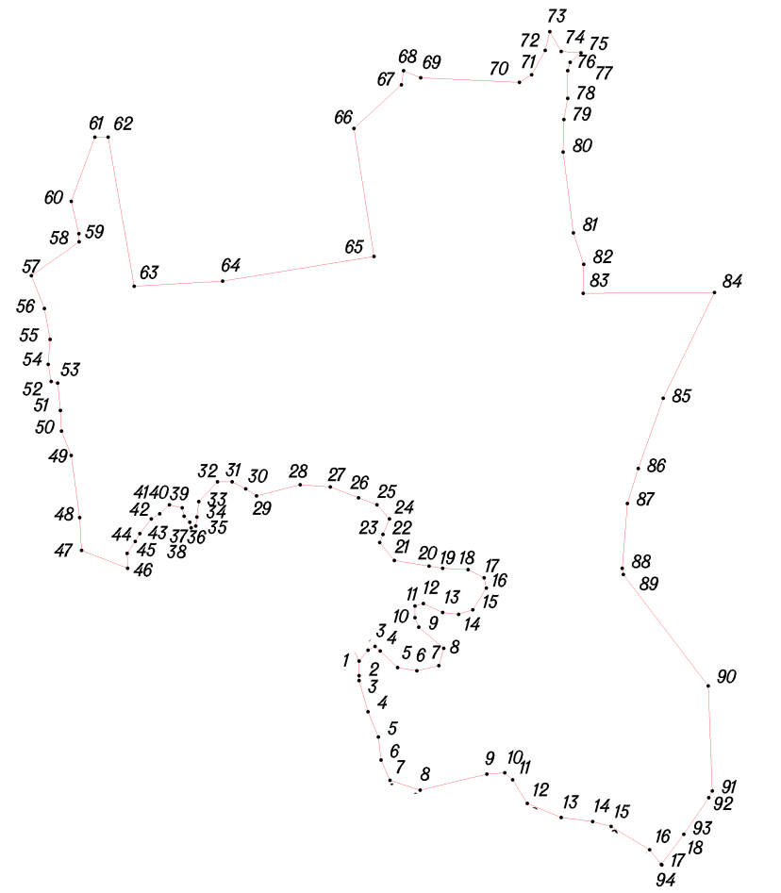
Условное обозначение точки | Координаты
Условное обозначение точки | X | Y
1 | 434738.03 | 1233139.99
2 | 434755.03 | 1233153.99
3 | 434760.96 | 1233164.99
4 | 434753.98 | 1233173.04
5 | 434728.04 | 1233199.98
6 | 434722.94 | 1233229.96
7 | 434730.96 | 1233264.01
8 | 434757.99 | 1233271.97
9 | 434790.96 | 1233232.98
10 | 434806.01 | 1233227.02
11 | 434824.00 | 1233226.96
12 | 434828.02 | 1233239.98
13 | 434813.99 | 1233269.95
14 | 434810.97 | 1233295.03
15 | 434817.98 | 1233317.05
16 | 434851.95 | 1233338.04
17 | 434868.02 | 1233335.00
18 | 434880.99 | 1233309.99
19 | 434882.99 | 1233270.01
20 | 434886.36 | 1233248.93
21 | 434894.96 | 1233195.03
22 | 434922.95 | 1233171.95
23 | 434935.97 | 1233177.01
24 | 434959.97 | 1233187.05
25 | 434981.96 | 1233167.95
26 | 434992.99 | 1233138.98
27 | 435009.94 | 1233095.04
28 | 435012.99 | 1233047.99
29 | 434995.95 | 1232979.97
30 | 435006.99 | 1232962.98
31 | 435017.98 | 1232941.99
32 | 435018.00 | 1232919.02
33 | 434986.99 | 1232889.94
34 | 434963.02 | 1232886.99
35 | 434949.02 | 1232884.99
36 | 434945.95 | 1232878.01
37 | 434955.00 | 1232876.02
38 | 434963.98 | 1232867.05
39 | 434977.03 | 1232864.02
40 | 434982.00 | 1232844.02
41 | 434968.00 | 1232829.03
42 | 434959.96 | 1232815.97
43 | 434936.97 | 1232797.97
44 | 434924.95 | 1232790.95
45 | 434906.04 | 1232778.00
46 | 434883.01 | 1232778.97
47 | 434911.01 | 1232707.05
48 | 434961.97 | 1232703.97
49 | 435059.04 | 1232691.03
50 | 435097.04 | 1232676.01
51 | 435129.01 | 1232674.04
52 | 435172.01 | 1232669.97
53 | 435174.22 | 1232659.72
54 | 435200.97 | 1232655.03
55 | 435240.01 | 1232658.02
56 | 435288.03 | 1232649.03
57 | 435339.48 | 1232628.79
58 | 435392.20 | 1232703.21
59 | 435405.03 | 1232703.03
60 | 435455.34 | 1232691.21
61 | 435555.29 | 1232728.00
62 | 435555.48 | 1232748.47
63 | 435322.95 | 1232789.20
64 | 435330.97 | 1232927.05
65 | 435369.25 | 1233162.91
66 | 435568.98 | 1233131.99
67 | 435636.95 | 1233206.02
68 | 435659.00 | 1233209.00
69 | 435647.95 | 1233235.98
70 | 435641.03 | 1233389.95
71 | 435652.94 | 1233408.96
72 | 435691.04 | 1233429.98
73 | 435719.96 | 1233437.02
74 | 435689.02 | 1233454.99
75 | 435686.95 | 1233485.98
76 | 435672.03 | 1233468.96
77 | 435659.02 | 1233465.01
78 | 435615.97 | 1233464.98
79 | 435583.04 | 1233459.00
80 | 435532.02 | 1233458.00
81 | 435406.03 | 1233473.99
82 | 435356.98 | 1233490.04
83 | 435312.00 | 1233489.03
84 | 435313.02 | 1233694.13
85 | 435148.04 | 1233613.95
86 | 435038.40 | 1233574.97
87 | 434983.95 | 1233557.99
88 | 434882.99 | 1233550.00
89 | 434873.03 | 1233551.82
90 | 434699.39 | 1233684.11
91 | 434535.68 | 1233690.73
92 | 434525.00 | 1233685.00
93 | 434467.95 | 1233646.02
94 | 434421.01 | 1233610.98
95 | 434443.99 | 1233593.02
96 | 434480.03 | 1233532.97
97 | 434487.95 | 1233503.99
98 | 434494.00 | 1233454.96
99 | 434516.01 | 1233401.99
100 | 434552.94 | 1233379.04
101 | 434564.01 | 1233367.05
102 | 434561.98 | 1233339.01
103 | 434537.01 | 1233235.04
104 | 434552.03 | 1233188.02
105 | 434584.01 | 1233173.97
106 | 434619.98 | 1233169.97
107 | 434658.98 | 1233153.97
108 | 434707.94 | 1233140.03
109 | 434715.47 | 1233140.02

Д. Митюшино
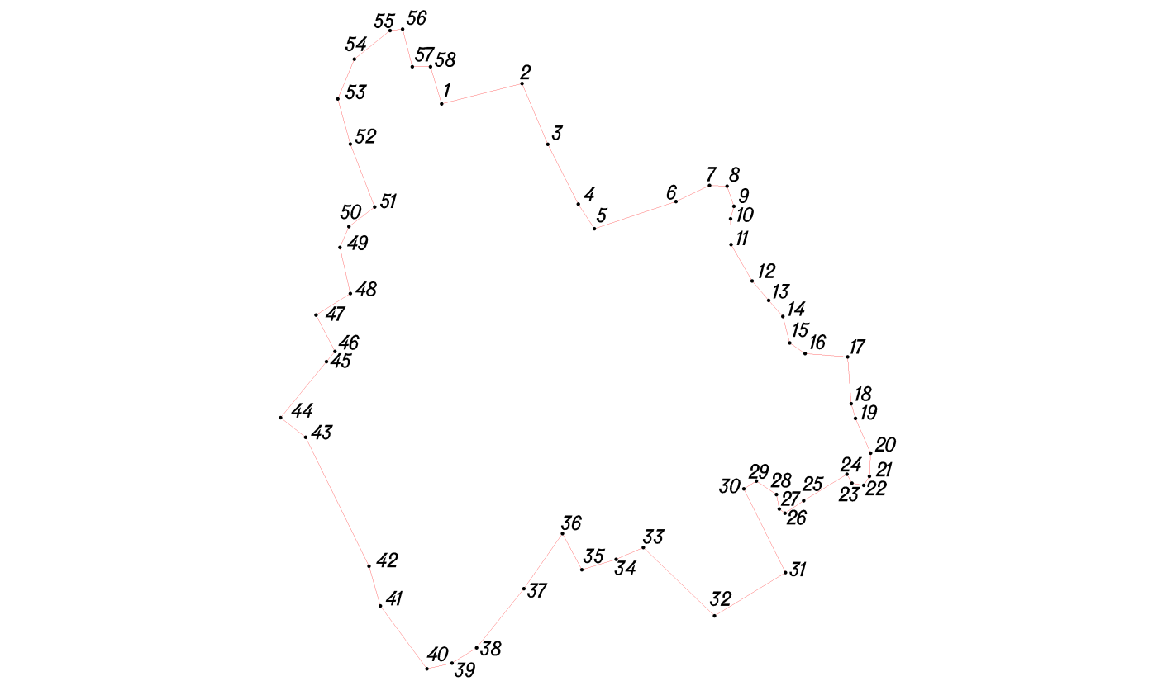
Условное обозначение точки | Координаты
Условное обозначение точки | X | Y
1 | 432559.00 | 1232709.03
2 | 432587.97 | 1232824.04
3 | 432500.97 | 1232861.00
4 | 432415.01 | 1232904.99
5 | 432379.99 | 1232928.01
6 | 432418.94 | 1233044.97
7 | 432441.96 | 1233093.03
8 | 432440.96 | 1233117.97
9 | 432411.96 | 1233128.03
10 | 432394.02 | 1233122.99
11 | 432357.01 | 1233123.97
12 | 432304.95 | 1233153.99
13 | 432277.28 | 1233177.90
14 | 432253.99 | 1233198.02
15 | 432215.96 | 1233207.96
16 | 432200.95 | 1233230.00
17 | 432195.99 | 1233290.95
18 | 432128.95 | 1233295.96
19 | 432107.98 | 1233302.00
20 | 432057.96 | 1233324.00
21 | 432024.94 | 1233322.03
22 | 432012.02 | 1233313.98
23 | 432015.00 | 1233296.99
24 | 432028.02 | 1233289.97
25 | 431990.00 | 1233227.99
26 | 431972.00 | 1233200.98
27 | 431977.97 | 1233193.01
28 | 431998.95 | 1233189.05
29 | 432018.03 | 1233159.96
30 | 432007.03 | 1233141.99
31 | 431887.00 | 1233201.95
32 | 431824.94 | 1233099.96
33 | 431923.00 | 1232997.96
34 | 431906.00 | 1232959.01
35 | 431891.02 | 1232910.03
36 | 431943.00 | 1232882.00
37 | 431864.01 | 1232826.95
38 | 431778.98 | 1232759.01
39 | 431756.98 | 1232723.97
40 | 431748.95 | 1232688.03
41 | 431839.05 | 1232621.00
42 | 431895.94 | 1232604.96
43 | 432081.00 | 1232514.04
44 | 432108.97 | 1232477.97
45 | 432189.15 | 1232543.75
46 | 432204.04 | 1232555.97
47 | 432256.03 | 1232528.94
48 | 432286.99 | 1232578.00
49 | 432352.96 | 1232562.97
50 | 432383.03 | 1232576.01
51 | 432410.99 | 1232612.98
52 | 432501.04 | 1232578.02
53 | 432565.97 | 1232559.95
54 | 432622.99 | 1232583.95
55 | 432664.02 | 1232634.95
56 | 432665.98 | 1232653.00
57 | 432611.98 | 1232666.97
58 | 432611.98 | 1232693.04

Д. Быково
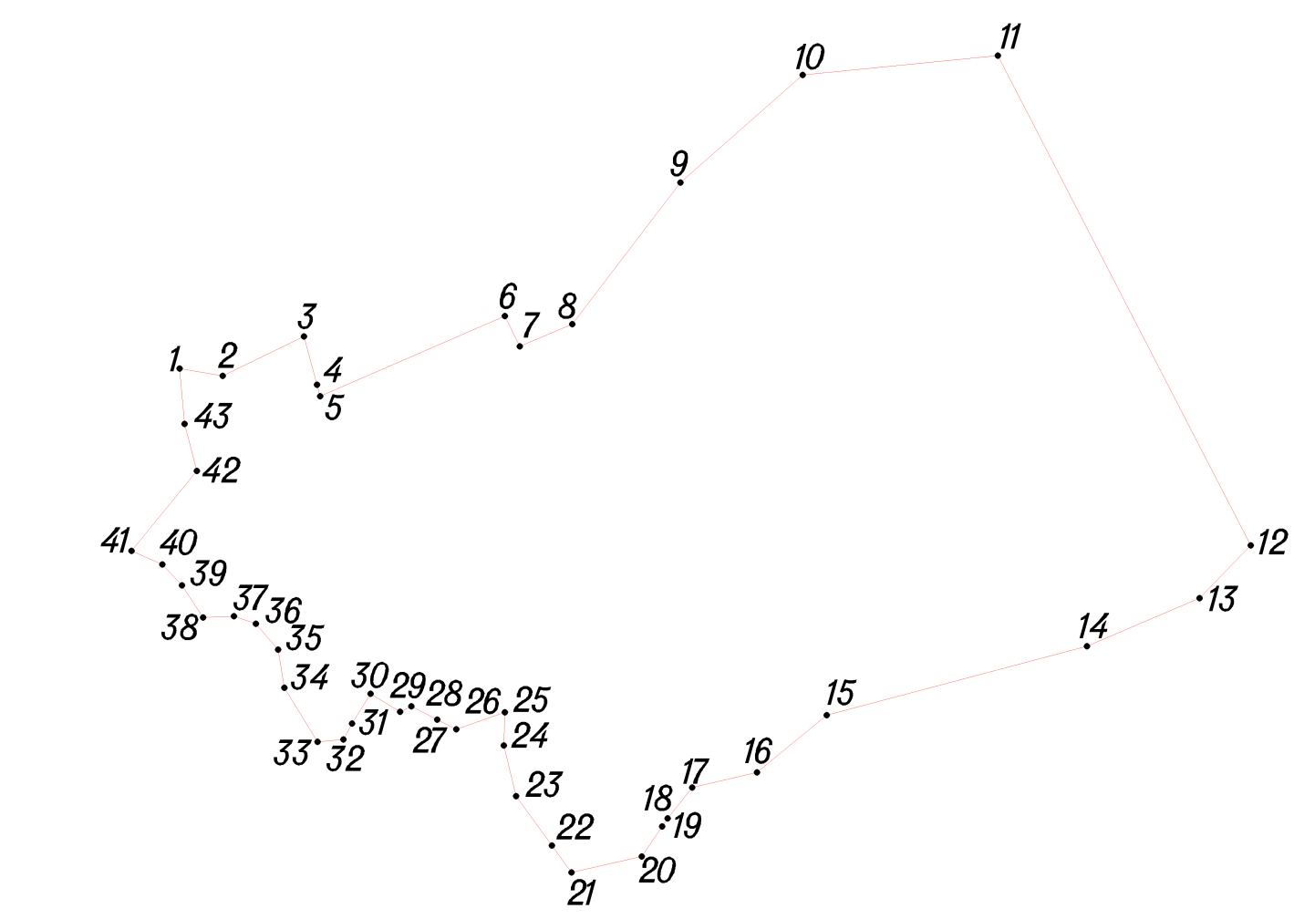
Условное обозначение точки | Координаты
Условное обозначение точки | X | Y
1 | 433796.99 | 1234991.00
2 | 433790.99 | 1235026.00
3 | 433822.99 | 1235092.00
4 | 433783.77 | 1235102.54
5 | 433774.53 | 1235105.02
6 | 433839.67 | 1235254.92
7 | 433814.99 | 1235267.00
8 | 433833.07 | 1235309.72
9 | 433947.97 | 1235397.35
10 | 434035.25 | 1235496.63
11 | 434051.05 | 1235654.98
12 | 433653.54 | 1235860.28
13 | 433610.59 | 1235818.59
14 | 433571.74 | 1235727.23
15 | 433515.75 | 1235516.04
16 | 433469.19 | 1235459.46
17 | 433456.99 | 1235407.00
18 | 433431.99 | 1235387.00
19 | 433425.33 | 1235382.49
20 | 433400.99 | 1235366.00
21 | 433387.99 | 1235309.00
22 | 433409.99 | 1235293.00
23 | 433449.99 | 1235264.00
24 | 433490.99 | 1235254.00
25 | 433517.99 | 1235255.00
26 | 433504.34 | 1235215.56
27 | 433511.99 | 1235200.00
28 | 433522.99 | 1235179.00
29 | 433518.52 | 1235169.91
30 | 433532.99 | 1235146.00
31 | 433508.99 | 1235131.00
32 | 433495.99 | 1235124.00
33 | 433493.99 | 1235103.00
34 | 433537.99 | 1235076.00
35 | 433568.99 | 1235071.00
36 | 433589.99 | 1235053.00
37 | 433595.99 | 1235035.00
38 | 433594.99 | 1235010.00
39 | 433620.99 | 1234993.00
40 | 433637.99 | 1234977.00
41 | 433648.99 | 1234952.00
42 | 433713.99 | 1235005.00
43 | 433751.99 | 1234995.00
Д. Сверчково
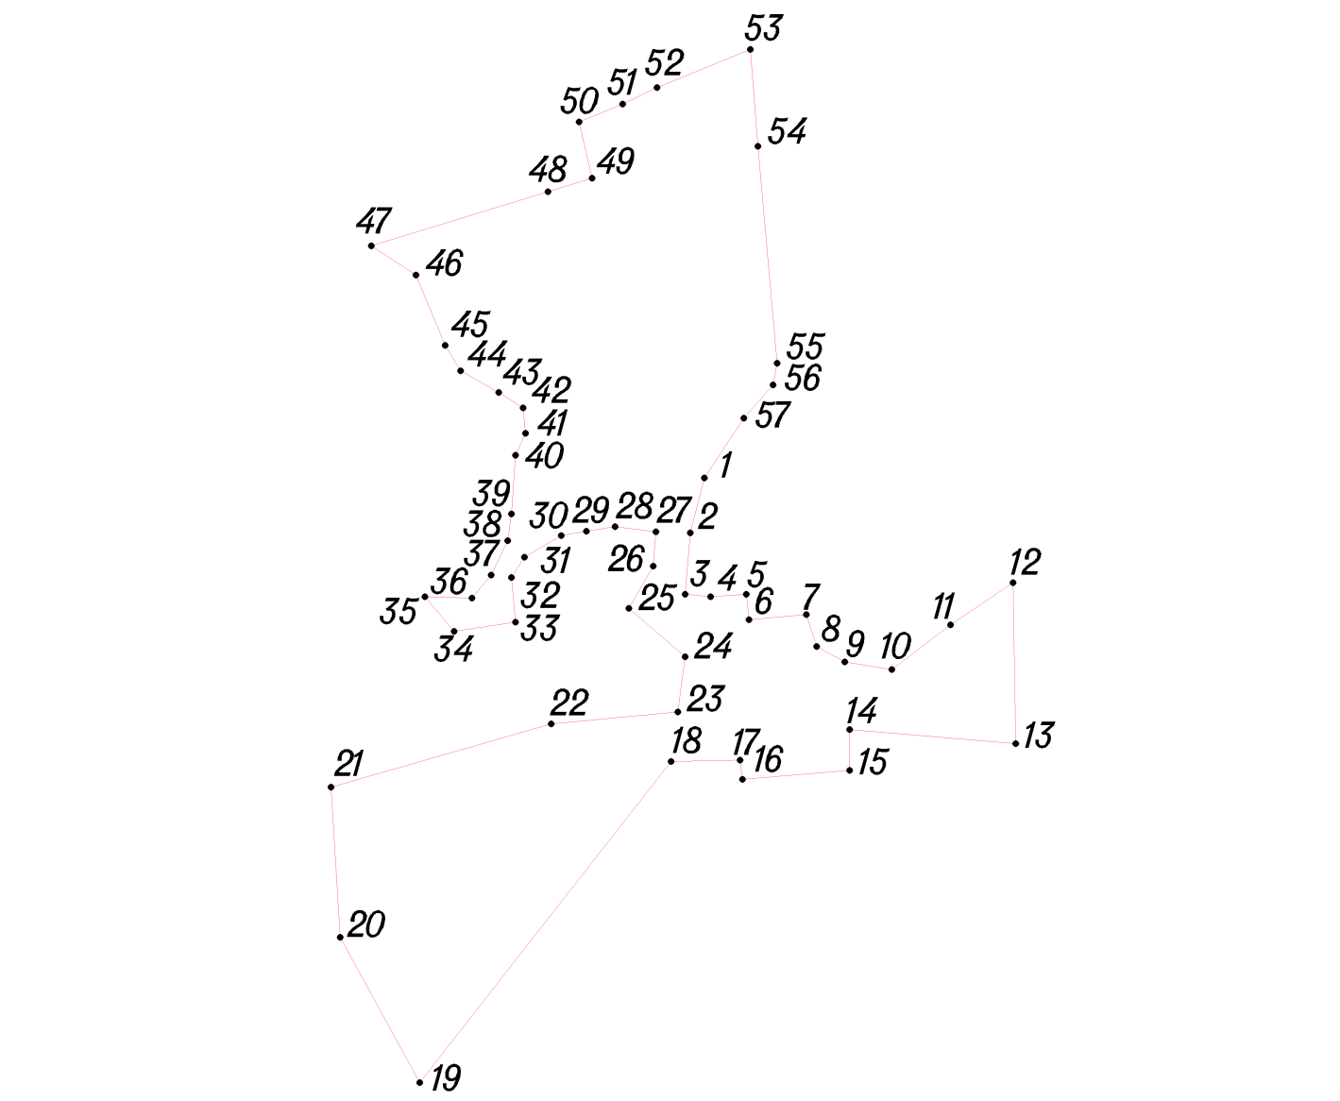
Условное обозначение точки | Координаты
Условное обозначение точки | X | Y
1 | 436412.99 | 1237179.00
2 | 436369.99 | 1237168.00
3 | 436321.99 | 1237164.00
4 | 436319.99 | 1237184.00
5 | 436321.99 | 1237212.00
6 | 436301.99 | 1237214.00
7 | 436305.99 | 1237259.00
8 | 436280.99 | 1237267.00
9 | 436268.99 | 1237289.00
10 | 436262.99 | 1237326.00
11 | 436297.99 | 1237372.00
12 | 436330.99 | 1237421.00
13 | 436204.99 | 1237423.00
14 | 436215.99 | 1237293.00
15 | 436183.99 | 1237293.00
16 | 436176.99 | 1237209.00
17 | 436191.99 | 1237207.00
18 | 436190.99 | 1237153.00
19 | 435939.24 | 1236956.01
20 | 436053.06 | 1236893.63
21 | 436170.86 | 1236886.56
22 | 436220.32 | 1237059.07
23 | 436229.81 | 1237158.21
24 | 436272.99 | 1237164.00
25 | 436310.99 | 1237120.00
26 | 436343.99 | 1237139.00
27 | 436370.99 | 1237141.00
28 | 436374.99 | 1237109.00
29 | 436371.26 | 1237086.60
30 | 436367.99 | 1237067.00
31 | 436350.99 | 1237038.00
32 | 436334.99 | 1237028.00
33 | 436299.99 | 1237031.00
34 | 436292.99 | 1236983.00
35 | 436319.99 | 1236960.00
36 | 436318.99 | 1236997.00
37 | 436336.99 | 1237012.00
38 | 436363.99 | 1237025.00
39 | 436384.99 | 1237028.00
40 | 436430.99 | 1237031.00
41 | 436447.99 | 1237039.00
42 | 436467.99 | 1237037.00
43 | 436479.99 | 1237018.00
44 | 436496.99 | 1236988.00
45 | 436516.99 | 1236976.00
46 | 436571.99 | 1236953.00
47 | 436594.99 | 1236918.00
48 | 436637.43 | 1237056.52
49 | 436647.99 | 1237091.00
50 | 436691.99 | 1237081.00
51 | 436705.99 | 1237115.00
52 | 436718.99 | 1237142.00
53 | 436748.99 | 1237215.00
54 | 436672.99 | 1237221.00
55 | 436502.99 | 1237236.00
56 | 436485.99 | 1237233.00
57 | 436459.99 | 1237210.00

Д. Свиридоново
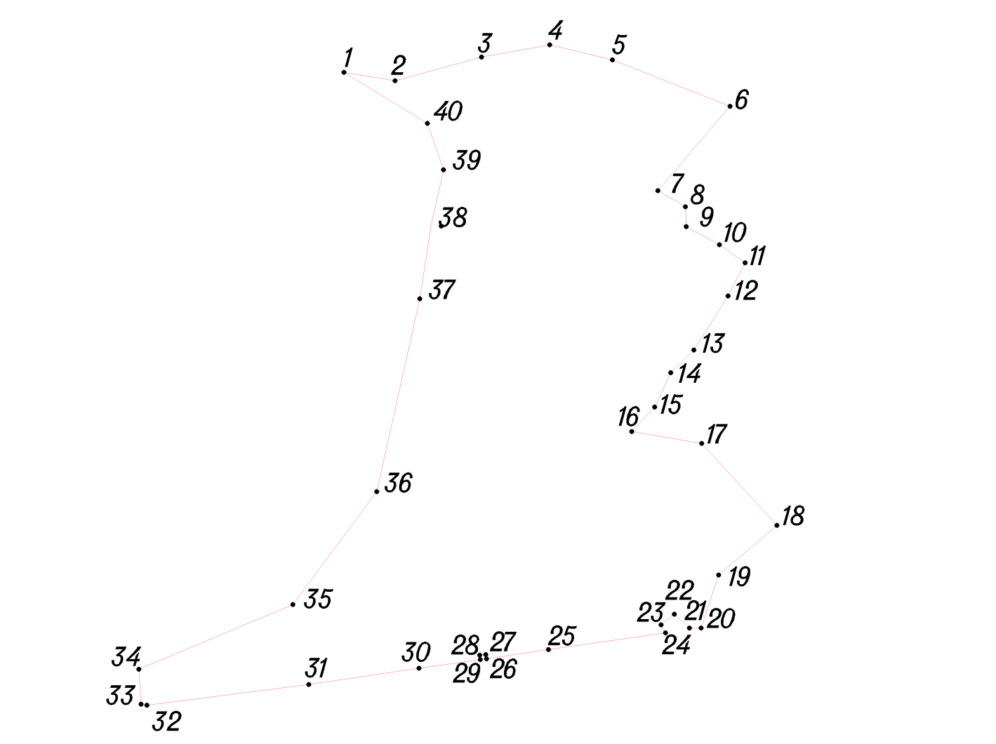
Условное обозначение точки | Координаты
Условное обозначение точки | X | Y
1 | 435455.99 | 1237490.00
2 | 435446.99 | 1237544.00
3 | 435471.99 | 1237635.00
4 | 435484.99 | 1237707.00
5 | 435468.99 | 1237773.00
6 | 435419.99 | 1237897.00
7 | 435330.99 | 1237821.00
8 | 435313.99 | 1237850.00
9 | 435293.15 | 1237850.80
10 | 435274.06 | 1237885.92
11 | 435254.99 | 1237913.00
12 | 435219.99 | 1237895.00
13 | 435162.99 | 1237859.00
14 | 435139.05 | 1237834.57
15 | 435102.79 | 1237817.69
16 | 435076.90 | 1237793.36
17 | 435064.24 | 1237867.24
18 | 434977.76 | 1237946.50
19 | 434925.55 | 1237884.94
20 | 434869.60 | 1237866.54
21 | 434869.49 | 1237854.30
22 | 434884.05 | 1237838.29
23 | 434872.98 | 1237824.46
24 | 434864.41 | 1237828.94
25 | 434846.81 | 1237705.71
26 | 434837.10 | 1237640.35
27 | 434841.62 | 1237639.59
28 | 434840.83 | 1237633.19
29 | 434836.21 | 1237633.76
30 | 434827.12 | 1237569.23
31 | 434809.99 | 1237453.04
32 | 434788.20 | 1237282.22
33 | 434789.21 | 1237276.21
34 | 434826.01 | 1237273.86
35 | 434894.24 | 1237436.29
36 | 435013.55 | 1237524.61
37 | 435216.99 | 1237570.00
38 | 435294.99 | 1237582.00
39 | 435352.99 | 1237595.00
40 | 435401.99 | 1237578.00

Д. Лазарево
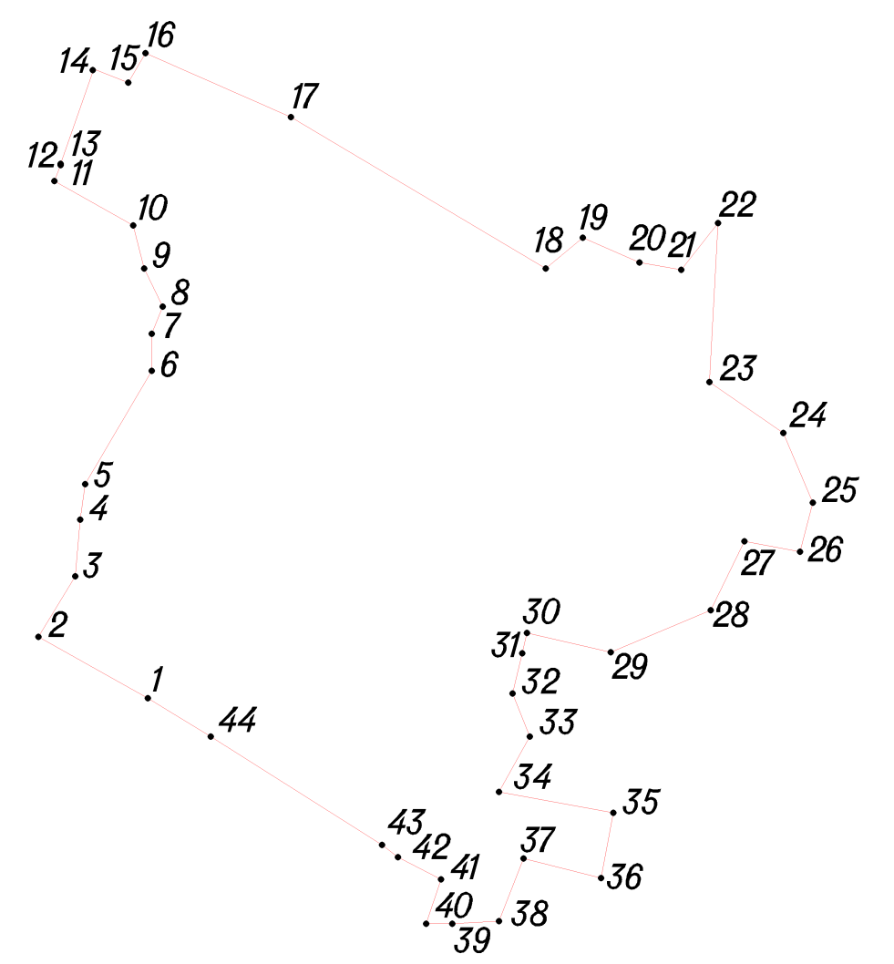
Условное обозначение точки | Координаты
Условное обозначение точки | X | Y
1 | 433306.99 | 1237968.00
2 | 433356.99 | 1237879.00
3 | 433405.99 | 1237909.00
4 | 433451.99 | 1237913.00
5 | 433480.99 | 1237917.00
6 | 433572.99 | 1237971.00
7 | 433602.99 | 1237971.00
8 | 433624.99 | 1237980.00
9 | 433655.99 | 1237965.00
10 | 433690.99 | 1237956.00
11 | 433726.99 | 1237892.00
12 | 433739.99 | 1237897.00
13 | 433740.99 | 1237897.00
14 | 433817.99 | 1237924.00
15 | 433806.99 | 1237952.00
16 | 433830.99 | 1237966.00
17 | 433778.99 | 1238084.00
18 | 433655.99 | 1238291.00
19 | 433680.99 | 1238321.00
20 | 433660.99 | 1238367.00
21 | 433654.99 | 1238401.00
22 | 433692.99 | 1238431.00
23 | 433563.73 | 1238424.01
24 | 433522.57 | 1238483.82
25 | 433465.90 | 1238507.89
26 | 433425.91 | 1238497.41
27 | 433434.39 | 1238452.34
28 | 433378.43 | 1238425.00
29 | 433344.31 | 1238343.78
30 | 433360.01 | 1238275.76
31 | 433343.59 | 1238271.82
32 | 433310.99 | 1238264.00
33 | 433275.99 | 1238278.00
34 | 433230.99 | 1238253.00
35 | 433213.99 | 1238346.00
36 | 433160.99 | 1238336.00
37 | 433176.99 | 1238273.00
38 | 433125.99 | 1238253.00
39 | 433123.99 | 1238215.00
40 | 433123.99 | 1238194.00
41 | 433159.99 | 1238206.00
42 | 433177.99 | 1238171.00
43 | 433187.99 | 1238158.00
44 | 433275.99 | 1238019.00

Д. Ямполье
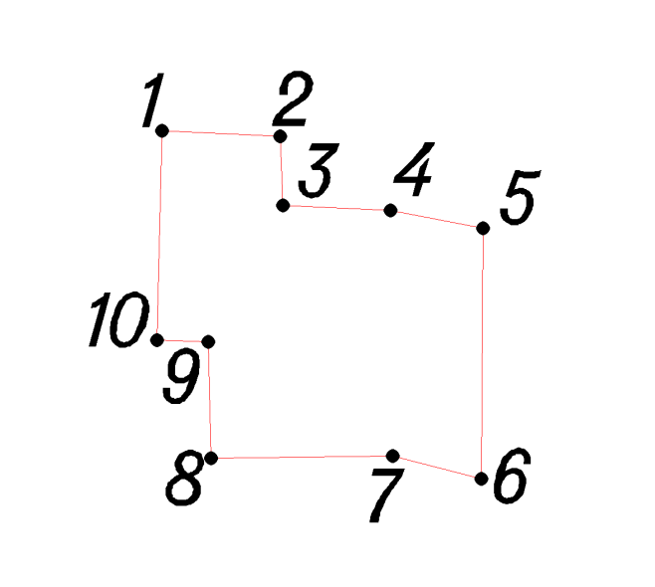
Условное обозначение точки | Координаты
Условное обозначение точки | X | Y
1 | 433152.36 | 1237571.25
2 | 433150.14 | 1237616.24
3 | 433123.84 | 1237617.28
4 | 433122.02 | 1237658.23
5 | 433115.27 | 1237693.29
6 | 433019.82 | 1237692.71
7 | 433028.48 | 1237658.92
8 | 433027.76 | 1237589.98
9 | 433071.86 | 1237588.81
10 | 433072.57 | 1237569.29

Д. Васильево
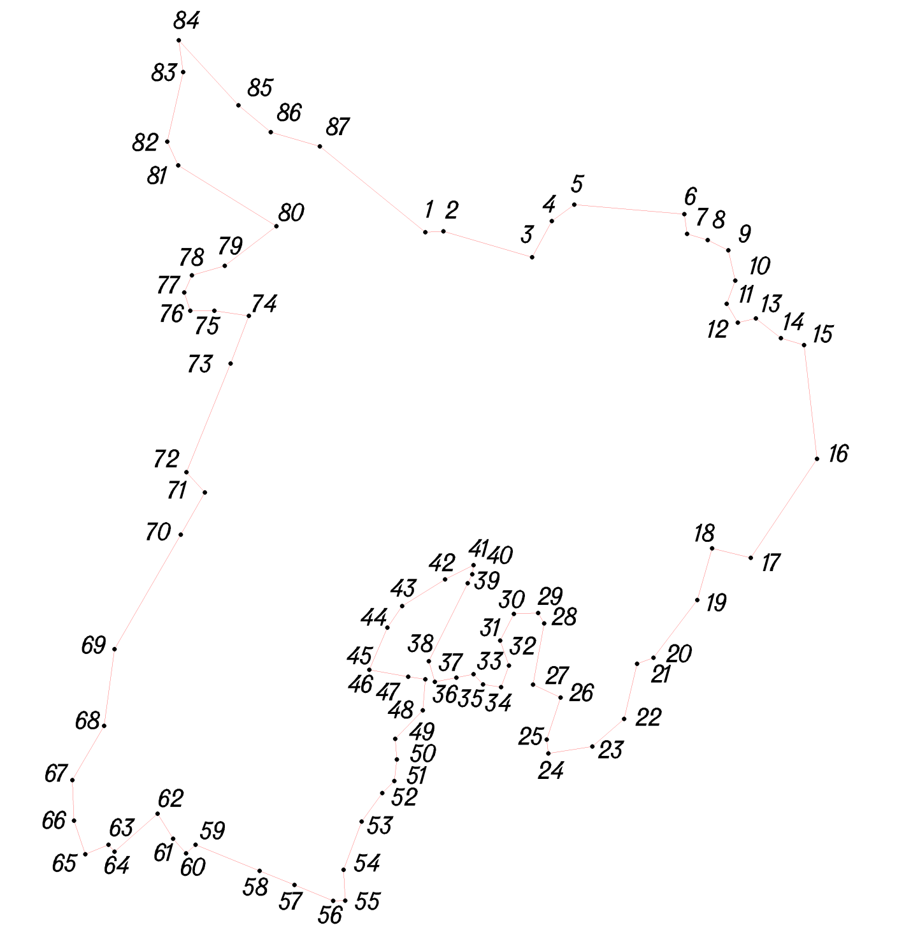
Условное обозначение точки | Координаты
Условное обозначение точки | X | Y
1 | 431953.03 | 1239592.04
2 | 431954.01 | 1239612.96
3 | 431923.94 | 1239715.98
4 | 431965.97 | 1239739.04
5 | 431984.98 | 1239764.99
6 | 431974.03 | 1239892.95
7 | 431951.02 | 1239896.03
8 | 431943.97 | 1239919.95
9 | 431932.00 | 1239944.00
10 | 431896.95 | 1239952.05
11 | 431870.02 | 1239941.99
12 | 431848.00 | 1239955.00
13 | 431852.99 | 1239975.95
14 | 431829.98 | 1240005.00
15 | 431821.95 | 1240031.99
16 | 431689.99 | 1240046.97
17 | 431575.03 | 1239969.96
18 | 431586.04 | 1239925.00
19 | 431525.96 | 1239907.99
20 | 431458.96 | 1239856.96
21 | 431451.98 | 1239838.03
22 | 431387.99 | 1239822.97
23 | 431356.00 | 1239785.98
24 | 431347.96 | 1239734.95
25 | 431364.04 | 1239733.02
26 | 431412.94 | 1239749.05
27 | 431427.98 | 1239717.02
28 | 431498.99 | 1239730.03
29 | 431511.01 | 1239722.96
30 | 431509.99 | 1239694.96
31 | 431478.98 | 1239678.98
32 | 431449.98 | 1239689.03
33 | 431424.98 | 1239679.95
34 | 431428.01 | 1239658.98
35 | 431440.00 | 1239648.02
36 | 431436.02 | 1239628.00
37 | 431431.00 | 1239602.96
38 | 431454.98 | 1239596.02
39 | 431545.49 | 1239641.23
40 | 431555.90 | 1239646.43
41 | 431566.60 | 1239648.11
42 | 431549.97 | 1239614.97
43 | 431519.00 | 1239565.03
44 | 431494.03 | 1239547.95
45 | 431444.97 | 1239527.03
46 | 431436.99 | 1239572.00
47 | 431434.03 | 1239591.97
48 | 431398.00 | 1239588.99
49 | 431364.95 | 1239556.96
50 | 431341.03 | 1239559.00
51 | 431315.96 | 1239556.01
52 | 431301.97 | 1239542.03
53 | 431268.99 | 1239517.99
54 | 431212.99 | 1239497.02
55 | 431177.01 | 1239499.03
56 | 431176.99 | 1239485.04
57 | 431195.30 | 1239439.98
58 | 431211.75 | 1239399.48
59 | 431242.01 | 1239325.04
60 | 431231.97 | 1239314.00
61 | 431249.04 | 1239299.01
62 | 431277.97 | 1239280.97
63 | 431234.02 | 1239230.96
64 | 431242.01 | 1239223.95
65 | 431231.04 | 1239196.99
66 | 431269.95 | 1239184.00
67 | 431317.01 | 1239181.97
68 | 431379.97 | 1239218.97
69 | 431468.98 | 1239231.03
70 | 431601.95 | 1239307.98
71 | 431650.96 | 1239335.99
72 | 431674.52 | 1239314.63
73 | 431800.54 | 1239365.74
74 | 431855.96 | 1239387.03
75 | 431861.97 | 1239346.99
76 | 431861.96 | 1239319.02
77 | 431883.02 | 1239311.97
78 | 431903.01 | 1239320.97
79 | 431913.97 | 1239359.02
80 | 431960.01 | 1239418.99
81 | 432030.68 | 1239304.95
82 | 432058.15 | 1239292.28
83 | 432139.03 | 1239310.72
84 | 432175.76 | 1239305.61
85 | 432100.31 | 1239374.91
86 | 432069.17 | 1239412.46
87 | 432052.57 | 1239469.54

Д. Старинки
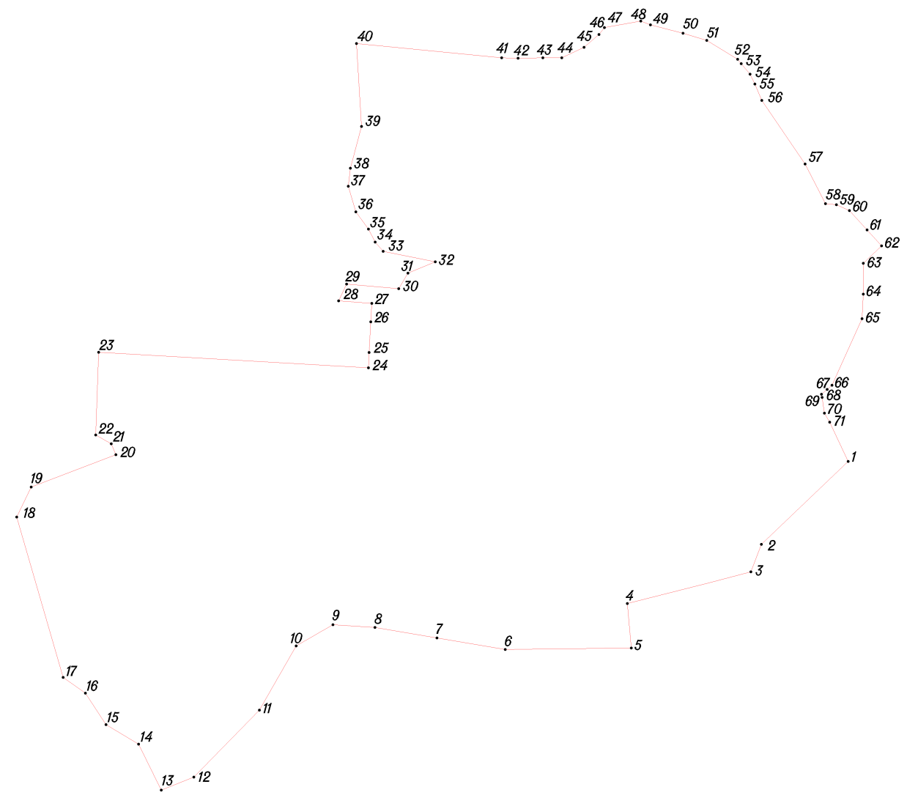
Условное обозначение точки | Координаты
Условное обозначение точки | X | Y
1 | 434648.41 | 1241199.62
2 | 434481.67 | 1241025.06
3 | 434426.15 | 1241003.92
4 | 434362.38 | 1240755.24
5 | 434272.53 | 1240763.20
6 | 434269.55 | 1240509.20
7 | 434292.90 | 1240371.96
8 | 434314.13 | 1240247.24
9 | 434319.30 | 1240162.60
10 | 434276.91 | 1240088.50
11 | 434147.32 | 1240014.47
12 | 434012.35 | 1239882.24
13 | 433986.24 | 1239816.99
14 | 434078.82 | 1239771.13
15 | 434117.96 | 1239705.74
16 | 434181.76 | 1239664.09
17 | 434213.25 | 1239619.31
18 | 434536.49 | 1239525.93
19 | 434597.08 | 1239555.06
20 | 434662.06 | 1239725.49
21 | 434684.27 | 1239716.41
22 | 434701.86 | 1239685.10
23 | 434868.63 | 1239690.88
24 | 434837.30 | 1240233.79
25 | 434867.90 | 1240235.40
26 | 434929.85 | 1240238.69
27 | 434966.87 | 1240240.66
28 | 434972.08 | 1240173.85
29 | 435005.94 | 1240189.94
30 | 434996.63 | 1240294.90
31 | 435027.95 | 1240313.53
32 | 435050.81 | 1240368.55
33 | 435071.97 | 1240263.58
34 | 435090.38 | 1240247.39
35 | 435116.83 | 1240233.96
36 | 435151.54 | 1240208.56
37 | 435203.18 | 1240193.32
38 | 435239.58 | 1240197.56
39 | 435323.56 | 1240219.90
40 | 435490.81 | 1240209.79
41 | 435461.99 | 1240502.00
42 | 435460.99 | 1240535.00
43 | 435461.99 | 1240585.00
44 | 435461.99 | 1240623.00
45 | 435482.99 | 1240668.00
46 | 435508.99 | 1240698.00
47 | 435522.85 | 1240708.99
48 | 435535.99 | 1240782.00
49 | 435528.51 | 1240801.56
50 | 435511.60 | 1240867.13
51 | 435496.99 | 1240915.00
52 | 435458.99 | 1240977.00
53 | 435450.34 | 1240984.21
54 | 435428.99 | 1241002.00
55 | 435408.99 | 1241012.00
56 | 435375.99 | 1241026.00
57 | 435247.99 | 1241113.00
58 | 435167.99 | 1241154.00
59 | 435165.99 | 1241176.00
60 | 435153.99 | 1241202.00
61 | 435115.13 | 1241237.58
62 | 435082.99 | 1241267.00
63 | 435047.99 | 1241230.00
64 | 434985.59 | 1241229.99
65 | 434936.31 | 1241227.59
66 | 434801.99 | 1241167.00
67 | 434793.59 | 1241157.20
68 | 434783.99 | 1241146.00
69 | 434777.55 | 1241147.02
70 | 434745.99 | 1241152.00
71 | 434727.65 | 1241162.57

Д. Харинки
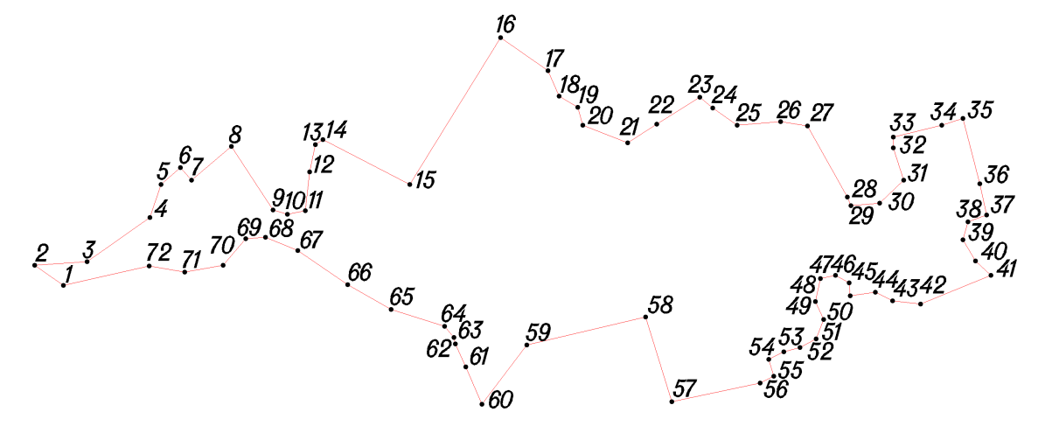
Условное обозначение точки | Координаты
Условное обозначение точки | X | Y
1 | 437207.99 | 1239605.00
2 | 437231.99 | 1239571.00
3 | 437235.99 | 1239633.00
4 | 437287.99 | 1239707.00
5 | 437326.99 | 1239720.00
6 | 437346.99 | 1239743.00
7 | 437331.99 | 1239756.00
8 | 437371.99 | 1239803.00
9 | 437296.99 | 1239852.00
10 | 437291.99 | 1239869.00
11 | 437295.99 | 1239890.00
12 | 437341.99 | 1239895.00
13 | 437373.99 | 1239902.00
14 | 437379.99 | 1239911.00
15 | 437326.99 | 1240013.00
16 | 437499.99 | 1240120.00
17 | 437460.99 | 1240176.00
18 | 437430.99 | 1240189.00
19 | 437417.99 | 1240211.00
20 | 437396.99 | 1240217.00
21 | 437375.99 | 1240270.00
22 | 437397.99 | 1240304.00
23 | 437429.99 | 1240355.00
24 | 437416.99 | 1240370.00
25 | 437396.99 | 1240399.00
26 | 437400.99 | 1240450.00
27 | 437395.99 | 1240482.00
28 | 437311.99 | 1240529.00
29 | 437301.99 | 1240533.00
30 | 437304.99 | 1240567.00
31 | 437331.99 | 1240595.00
32 | 437369.99 | 1240583.00
33 | 437382.99 | 1240583.00
34 | 437396.99 | 1240640.00
35 | 437404.99 | 1240665.00
36 | 437327.99 | 1240685.00
37 | 437290.99 | 1240693.00
38 | 437282.99 | 1240671.00
39 | 437261.99 | 1240665.00
40 | 437236.99 | 1240680.00
41 | 437219.99 | 1240698.00
42 | 437185.99 | 1240615.00
43 | 437189.99 | 1240582.00
44 | 437199.99 | 1240562.00
45 | 437195.99 | 1240532.00
46 | 437210.99 | 1240531.00
47 | 437219.99 | 1240515.00
48 | 437215.99 | 1240497.00
49 | 437188.99 | 1240491.00
50 | 437167.99 | 1240501.00
51 | 437144.98 | 1240492.00
52 | 437134.99 | 1240473.00
53 | 437129.99 | 1240454.00
54 | 437120.99 | 1240436.00
55 | 437100.99 | 1240442.00
56 | 437092.99 | 1240426.00
57 | 437070.99 | 1240322.00
58 | 437170.99 | 1240291.00
59 | 437137.99 | 1240151.00
60 | 437067.99 | 1240098.00
61 | 437111.99 | 1240079.00
62 | 437138.99 | 1240067.00
63 | 437146.99 | 1240065.00
64 | 437159.99 | 1240054.00
65 | 437179.99 | 1239991.00
66 | 437208.99 | 1239940.00
67 | 437248.99 | 1239881.00
68 | 437264.99 | 1239843.00
69 | 437262.99 | 1239820.00
70 | 437231.99 | 1239793.00
71 | 437223.99 | 1239748.00
72 | 437230.99 | 1239706.00

Д. Рожново
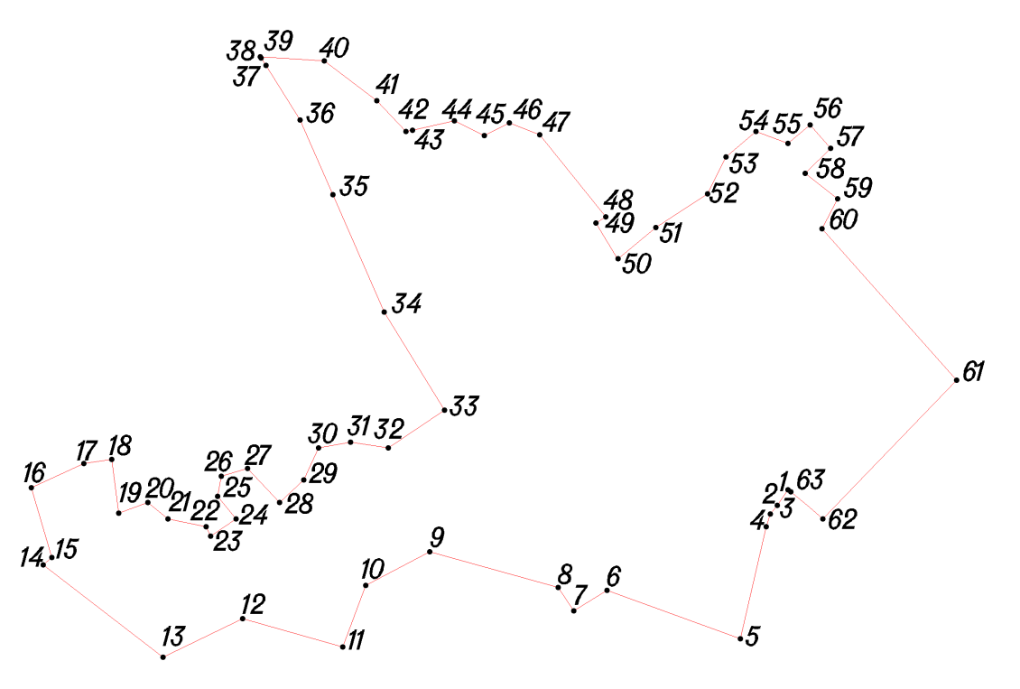
Условное обозначение точки | Координаты
Условное обозначение точки | X | Y
1 | 434047.99 | 1242659.00
2 | 434031.93 | 1242648.14
3 | 434022.99 | 1242641.00
4 | 434009.81 | 1242636.51
5 | 433894.43 | 1242610.08
6 | 433944.46 | 1242472.48
7 | 433923.27 | 1242438.09
8 | 433947.04 | 1242422.23
9 | 433983.86 | 1242289.90
10 | 433949.43 | 1242223.80
11 | 433885.95 | 1242199.99
12 | 433914.89 | 1242096.81
13 | 433875.13 | 1242014.78
14 | 433970.59 | 1241891.19
15 | 433977.99 | 1241900.00
16 | 434049.99 | 1241879.00
17 | 434074.99 | 1241933.00
18 | 434078.99 | 1241962.00
19 | 434023.99 | 1241969.00
20 | 434034.99 | 1241999.00
21 | 434017.99 | 1242020.00
22 | 434009.99 | 1242059.00
23 | 433999.99 | 1242064.00
24 | 434017.99 | 1242090.00
25 | 434040.99 | 1242071.00
26 | 434061.99 | 1242075.00
27 | 434069.99 | 1242102.00
28 | 434034.99 | 1242135.00
29 | 434057.99 | 1242160.00
30 | 434090.99 | 1242175.00
31 | 434096.99 | 1242208.00
32 | 434090.99 | 1242247.00
33 | 434129.99 | 1242305.00
34 | 434230.99 | 1242243.00
35 | 434351.99 | 1242190.00
36 | 434428.99 | 1242156.00
37 | 434485.11 | 1242120.94
38 | 434492.99 | 1242116.00
39 | 434493.99 | 1242115.00
40 | 434489.99 | 1242181.00
41 | 434448.99 | 1242235.00
42 | 434416.99 | 1242265.00
43 | 434418.50 | 1242271.86
44 | 434427.99 | 1242315.00
45 | 434412.99 | 1242346.00
46 | 434425.99 | 1242372.00
47 | 434413.99 | 1242403.00
48 | 434328.99 | 1242471.00
49 | 434322.99 | 1242461.00
50 | 434285.99 | 1242484.00
51 | 434317.99 | 1242523.00
52 | 434352.99 | 1242576.00
53 | 434390.99 | 1242595.00
54 | 434416.99 | 1242626.00
55 | 434404.99 | 1242659.00
56 | 434423.99 | 1242682.00
57 | 434399.99 | 1242703.00
58 | 434373.99 | 1242677.00
59 | 434347.99 | 1242710.00
60 | 434316.99 | 1242694.00
61 | 434160.99 | 1242833.00
62 | 434017.99 | 1242695.00
63 | 434045.99 | 1242662.00

Д. Дементьево
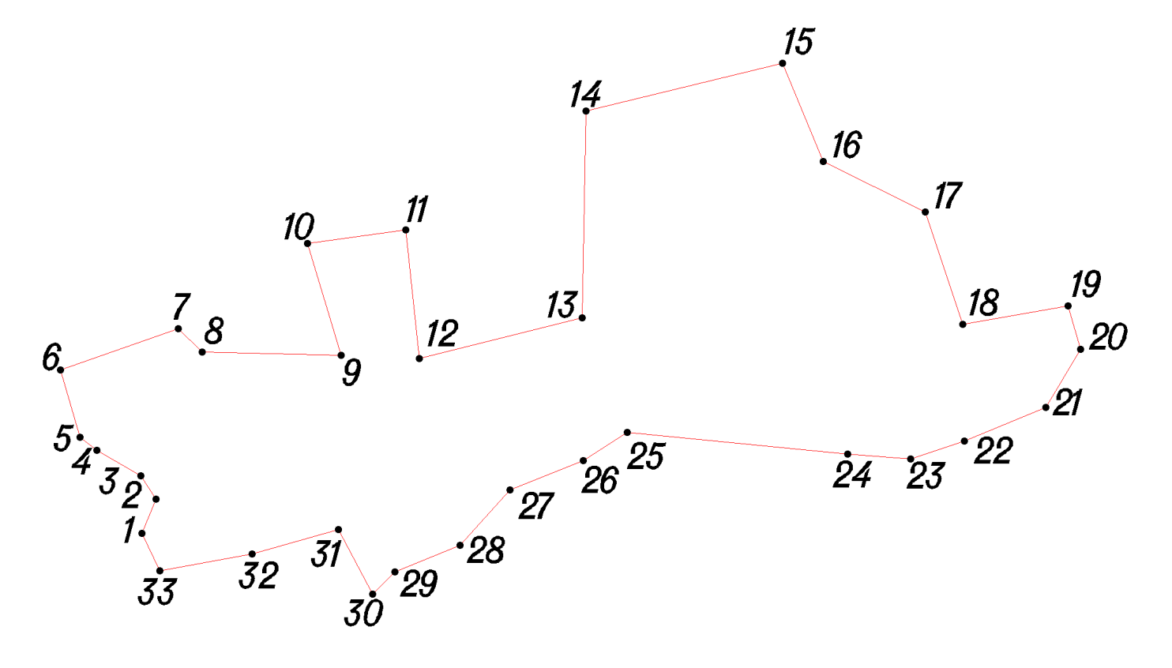
Условное обозначение точки | Координаты
Условное обозначение точки | X | Y
1 | 432158.99 | 1242225.00
2 | 432185.99 | 1242236.00
3 | 432203.99 | 1242224.00
4 | 432223.99 | 1242190.00
5 | 432233.99 | 1242177.00
6 | 432286.69 | 1242161.52
7 | 432318.79 | 1242253.41
8 | 432300.32 | 1242271.96
9 | 432297.82 | 1242380.41
10 | 432385.00 | 1242353.93
11 | 432395.67 | 1242430.68
12 | 432295.26 | 1242441.28
13 | 432327.15 | 1242568.26
14 | 432488.36 | 1242570.85
15 | 432525.57 | 1242724.30
16 | 432448.97 | 1242756.07
17 | 432409.43 | 1242835.46
18 | 432322.25 | 1242864.58
19 | 432336.49 | 1242946.46
20 | 432302.70 | 1242956.47
21 | 432257.35 | 1242929.38
22 | 432230.99 | 1242866.00
23 | 432216.99 | 1242824.00
24 | 432220.99 | 1242775.00
25 | 432237.99 | 1242603.00
26 | 432215.99 | 1242569.00
27 | 432192.99 | 1242512.00
28 | 432149.99 | 1242473.00
29 | 432128.99 | 1242422.00
30 | 432111.99 | 1242405.00
31 | 432161.99 | 1242378.00
32 | 432142.99 | 1242311.00
33 | 432129.99 | 1242239.00

Д. Лихачево
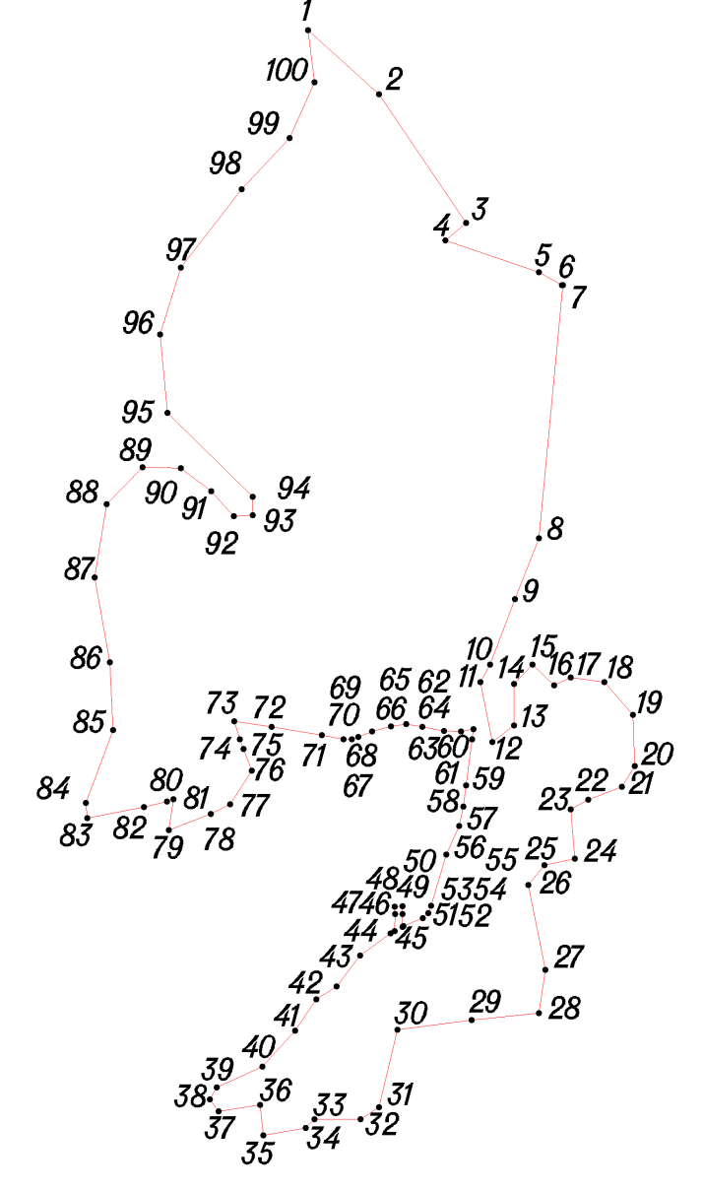
Условное обозначение точки | Координаты
Условное обозначение точки | X | Y
1 | 433184.99 | 1243294.00
2 | 433125.99 | 1243359.00
3 | 433007.99 | 1243439.00
4 | 432991.99 | 1243420.00
5 | 432962.99 | 1243506.00
6 | 432950.99 | 1243527.00
7 | 432950.99 | 1243528.00
8 | 432718.99 | 1243506.00
9 | 432662.99 | 1243484.00
10 | 432602.99 | 1243461.00
11 | 432586.99 | 1243452.00
12 | 432531.99 | 1243463.00
13 | 432546.99 | 1243483.00
14 | 432584.99 | 1243483.00
15 | 432602.99 | 1243500.00
16 | 432583.99 | 1243520.00
17 | 432590.99 | 1243535.00
18 | 432586.99 | 1243566.00
19 | 432556.99 | 1243592.00
20 | 432509.99 | 1243594.00
21 | 432490.99 | 1243582.00
22 | 432478.99 | 1243551.00
23 | 432469.99 | 1243535.00
24 | 432424.99 | 1243539.00
25 | 432418.99 | 1243511.00
26 | 432400.60 | 1243495.95
27 | 432322.99 | 1243512.00
28 | 432282.99 | 1243506.00
29 | 432276.99 | 1243444.00
30 | 432267.79 | 1243375.94
31 | 432196.99 | 1243359.00
32 | 432185.99 | 1243342.00
33 | 432185.99 | 1243300.00
34 | 432177.99 | 1243292.00
35 | 432170.99 | 1243253.00
36 | 432198.99 | 1243250.00
37 | 432192.99 | 1243212.00
38 | 432203.99 | 1243204.00
39 | 432215.01 | 1243210.00
40 | 432234.00 | 1243252.00
41 | 432267.00 | 1243282.00
42 | 432295.68 | 1243301.41
43 | 432307.69 | 1243320.34
44 | 432336.01 | 1243341.57
45 | 432356.33 | 1243369.56
46 | 432358.56 | 1243373.64
47 | 432373.92 | 1243373.73
48 | 432380.99 | 1243373.60
49 | 432381.13 | 1243380.67
50 | 432374.06 | 1243380.81
51 | 432362.43 | 1243380.71
52 | 432362.88 | 1243381.53
53 | 432370.10 | 1243399.14
54 | 432374.84 | 1243404.33
55 | 432381.84 | 1243407.04
56 | 432428.58 | 1243421.04
57 | 432454.88 | 1243432.78
58 | 432472.72 | 1243436.39
59 | 432491.99 | 1243439.00
60 | 432534.24 | 1243444.70
61 | 432543.73 | 1243445.65
62 | 432541.47 | 1243434.59
63 | 432541.92 | 1243418.56
64 | 432545.77 | 1243398.69
65 | 432548.24 | 1243384.24
66 | 432546.21 | 1243370.25
67 | 432541.70 | 1243352.62
68 | 432536.39 | 1243339.98
69 | 432534.58 | 1243334.11
70 | 432534.58 | 1243326.45
71 | 432538.20 | 1243306.57
72 | 432545.65 | 1243260.52
73 | 432550.84 | 1243226.18
74 | 432534.36 | 1243231.40
75 | 432525.48 | 1243234.80
76 | 432505.50 | 1243242.15
77 | 432474.89 | 1243222.58
78 | 432465.88 | 1243204.73
79 | 432451.27 | 1243166.05
80 | 432479.27 | 1243170.42
81 | 432477.46 | 1243164.55
82 | 432472.27 | 1243143.32
83 | 432462.10 | 1243091.44
84 | 432475.99 | 1243090.00
85 | 432542.99 | 1243115.00
86 | 432604.99 | 1243112.00
87 | 432682.99 | 1243098.00
88 | 432749.99 | 1243109.00
89 | 432783.99 | 1243142.00
90 | 432782.99 | 1243177.00
91 | 432761.99 | 1243205.00
92 | 432738.99 | 1243226.00
93 | 432739.99 | 1243243.00
94 | 432756.99 | 1243243.00
95 | 432833.99 | 1243165.00
96 | 432905.99 | 1243158.00
97 | 432966.99 | 1243177.00
98 | 433038.99 | 1243233.00
99 | 433085.99 | 1243277.00
100 | 433136.99 | 1243300.00

Д. Панское-2
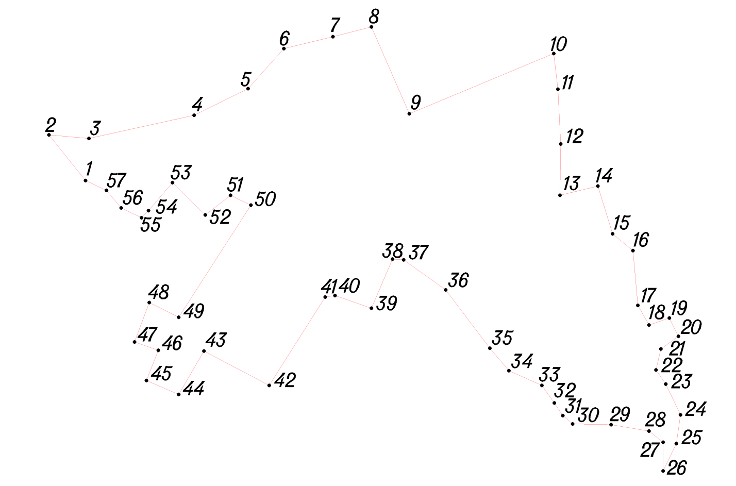
Условное обозначение точки | Координаты
Условное обозначение точки | X | Y
1 | 436992.99 | 1242797.00
2 | 437057.99 | 1242745.00
3 | 437052.99 | 1242802.00
4 | 437085.99 | 1242952.00
5 | 437123.99 | 1243029.00
6 | 437180.99 | 1243080.00
7 | 437197.99 | 1243150.00
8 | 437211.99 | 1243205.00
9 | 437087.99 | 1243259.00
10 | 437173.99 | 1243465.00
11 | 437122.99 | 1243471.00
12 | 437044.99 | 1243475.00
13 | 436971.99 | 1243474.00
14 | 436984.99 | 1243528.00
15 | 436916.99 | 1243549.00
16 | 436892.99 | 1243578.00
17 | 436814.99 | 1243585.00
18 | 436786.99 | 1243601.00
19 | 436796.99 | 1243630.00
20 | 436770.99 | 1243643.00
21 | 436752.99 | 1243618.00
22 | 436722.99 | 1243611.00
23 | 436702.99 | 1243625.00
24 | 436658.99 | 1243646.00
25 | 436617.99 | 1243640.00
26 | 436578.99 | 1243621.00
27 | 436619.99 | 1243621.00
28 | 436635.99 | 1243601.00
29 | 436644.99 | 1243547.00
30 | 436645.99 | 1243492.00
31 | 436657.99 | 1243478.00
32 | 436675.99 | 1243466.00
33 | 436700.99 | 1243448.00
34 | 436721.99 | 1243401.00
35 | 436753.99 | 1243374.00
36 | 436836.99 | 1243311.00
37 | 436879.99 | 1243251.00
38 | 436880.99 | 1243235.00
39 | 436810.99 | 1243205.00
40 | 436828.99 | 1243153.00
41 | 436826.99 | 1243139.00
42 | 436700.98 | 1243059.00
43 | 436749.99 | 1242966.00
44 | 436687.99 | 1242930.00
45 | 436707.99 | 1242884.00
46 | 436750.99 | 1242901.00
47 | 436762.99 | 1242867.00
48 | 436818.99 | 1242888.00
49 | 436797.99 | 1242930.00
50 | 436957.99 | 1243033.00
51 | 436971.99 | 1243004.00
52 | 436943.99 | 1242968.00
53 | 436989.99 | 1242921.00
54 | 436949.99 | 1242887.00
55 | 436939.99 | 1242877.00
56 | 436953.99 | 1242848.00
57 | 436978.99 | 1242827.00

Д. Панское-3

Условное обозначение точки | Координаты
Условное обозначение точки | X | Y
1 | 427407.98 | 1235446.96
2 | 427435.00 | 1235378.00
3 | 427435.95 | 1235307.02
4 | 427440.97 | 1235282.03
5 | 427490.99 | 1235248.04
6 | 427511.04 | 1235224.98
7 | 427517.00 | 1235205.02
8 | 427567.03 | 1235184.01
9 | 427594.05 | 1235165.01
10 | 427610.97 | 1235145.03
11 | 427618.96 | 1235162.00
12 | 427647.99 | 1235158.03
13 | 427666.01 | 1235122.02
14 | 427683.03 | 1235099.04
15 | 427720.97 | 1235088.01
16 | 427750.02 | 1235111.02
17 | 427799.02 | 1235176.99
18 | 427853.02 | 1235225.95
19 | 427897.02 | 1235268.97
20 | 427939.95 | 1235344.02
21 | 437093.99 | 1242830.00
22 | 437136.99 | 1242801.00
23 | 437154.99 | 1242785.00
24 | 437178.99 | 1242807.00
25 | 437179.99 | 1242848.00
26 | 437186.99 | 1242885.00
27 | 437200.99 | 1242910.00
28 | 437212.99 | 1242928.00
29 | 437233.99 | 1242914.00
30 | 437239.99 | 1242938.00
31 | 437221.99 | 1242951.00
32 | 437235.99 | 1242982.00
33 | 437193.99 | 1243017.00
34 | 437147.99 | 1242940.00
35 | 437120.99 | 1242891.00

Д. Панское-1
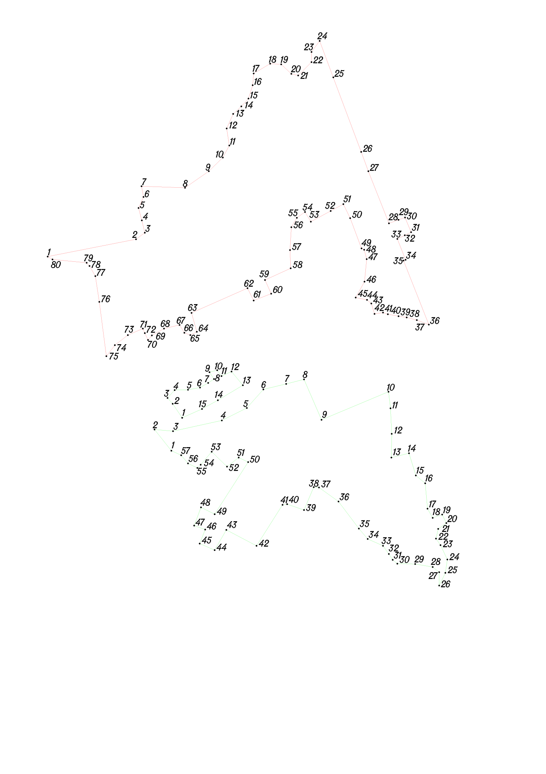
Условное обозначение точки | Координаты
Условное обозначение точки | X | Y
1 | 437588.99 | 1242416.00
2 | 437641.99 | 1242688.00
3 | 437661.99 | 1242715.00
4 | 437699.99 | 1242706.00
5 | 437737.99 | 1242696.00
6 | 437771.99 | 1242711.00
7 | 437804.99 | 1242705.00
8 | 437799.99 | 1242839.00
9 | 437850.99 | 1242912.00
10 | 437892.99 | 1242955.00
11 | 437929.99 | 1242975.00
12 | 437981.99 | 1242967.00
13 | 438026.99 | 1242987.00
14 | 438049.99 | 1243012.00
15 | 438073.99 | 1243034.00
16 | 438114.99 | 1243047.00
17 | 438150.99 | 1243050.00
18 | 438180.99 | 1243101.00
19 | 438178.99 | 1243135.00
20 | 438149.99 | 1243166.00
21 | 438144.99 | 1243187.00
22 | 438185.99 | 1243228.00
23 | 438216.99 | 1243228.00
24 | 438250.99 | 1243253.00
25 | 438138.99 | 1243295.00
26 | 437910.19 | 1243380.80
27 | 437850.99 | 1243403.00
28 | 437690.87 | 1243466.23
29 | 437701.75 | 1243495.85
30 | 437709.08 | 1243515.80
31 | 437663.76 | 1243534.37
32 | 437654.47 | 1243515.24
33 | 437643.20 | 1243492.03
34 | 437579.07 | 1243517.66
35 | 437576.84 | 1243511.26
36 | 437379.99 | 1243589.00
37 | 437393.99 | 1243552.00
38 | 437401.99 | 1243521.00
39 | 437405.99 | 1243496.00
40 | 437411.99 | 1243463.00
41 | 437416.99 | 1243448.00
42 | 437412.99 | 1243422.00
43 | 437444.99 | 1243412.00
44 | 437455.99 | 1243399.00
45 | 437462.99 | 1243364.00
46 | 437511.99 | 1243391.00
47 | 437580.99 | 1243398.00
48 | 437609.99 | 1243390.00
49 | 437613.99 | 1243382.00
50 | 437706.99 | 1243347.00
51 | 437749.99 | 1243326.00
52 | 437728.99 | 1243287.12
53 | 437695.99 | 1243226.00
54 | 437725.99 | 1243208.00
55 | 437707.99 | 1243183.00
56 | 437678.99 | 1243166.00
57 | 437608.99 | 1243162.00
58 | 437552.99 | 1243164.00
59 | 437516.99 | 1243085.00
60 | 437474.99 | 1243104.00
61 | 437453.99 | 1243050.00
62 | 437491.99 | 1243031.00
63 | 437415.99 | 1242859.00
64 | 437357.99 | 1242875.00
65 | 437347.99 | 1242855.00
66 | 437354.99 | 1242837.00
67 | 437378.99 | 1242822.00
68 | 437367.99 | 1242774.00
69 | 437346.99 | 1242737.00
70 | 437332.99 | 1242725.00
71 | 437353.99 | 1242715.00
72 | 437367.99 | 1242709.00
73 | 437347.99 | 1242663.00
74 | 437316.99 | 1242623.00
75 | 437282.99 | 1242597.00
76 | 437449.99 | 1242575.00
77 | 437528.99 | 1242563.00
78 | 437559.99 | 1242545.00
79 | 437569.99 | 1242536.00
80 | 437579.99 | 1242431.00

Д. Акулы
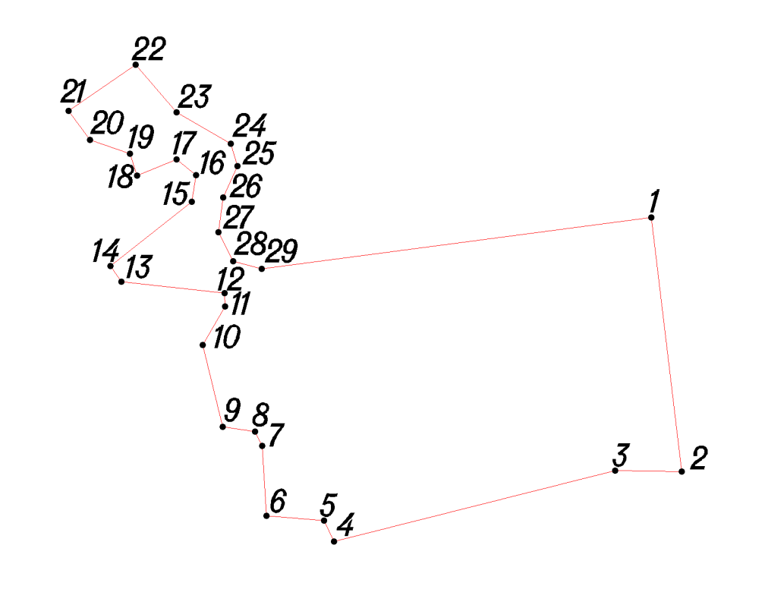
Условное обозначение точки | Координаты
Условное обозначение точки | X | Y
1 | 438808.16 | 1243707.16
2 | 438582.47 | 1243734.23
3 | 438583.16 | 1243674.92
4 | 438520.33 | 1243425.20
5 | 438538.90 | 1243416.03
6 | 438543.04 | 1243365.17
7 | 438605.13 | 1243361.33
8 | 438618.08 | 1243355.02
9 | 438622.38 | 1243326.19
10 | 438695.10 | 1243308.15
11 | 438729.13 | 1243328.23
12 | 438740.98 | 1243327.58
13 | 438751.04 | 1243236.02
14 | 438765.09 | 1243226.31
15 | 438822.09 | 1243298.75
16 | 438845.84 | 1243302.53
17 | 438859.83 | 1243284.92
18 | 438845.45 | 1243250.01
19 | 438865.17 | 1243243.65
20 | 438877.33 | 1243207.98
21 | 438903.17 | 1243189.16
22 | 438944.27 | 1243248.72
23 | 438901.62 | 1243285.18
24 | 438873.74 | 1243333.38
25 | 438854.01 | 1243339.18
26 | 438826.25 | 1243326.39
27 | 438795.16 | 1243322.10
28 | 438769.28 | 1243335.28
29 | 438762.60 | 1243360.84

Д. Лосня
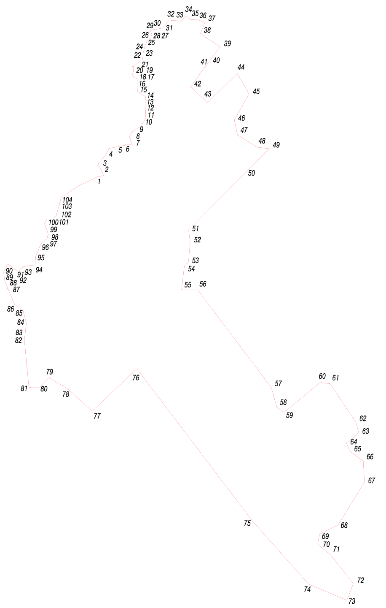
Условное обозначение точки | Координаты
Условное обозначение точки | X | Y
1 | 440019.99 | 1240471.00
2 | 440058.99 | 1240553.00
3 | 440059.99 | 1240571.00
4 | 440105.99 | 1240550.00
5 | 440140.99 | 1240579.00
6 | 440164.99 | 1240592.00
7 | 440178.99 | 1240661.00
8 | 440178.99 | 1240681.00
9 | 440209.99 | 1240670.00
10 | 440227.99 | 1240679.00
11 | 440249.99 | 1240713.00
12 | 440267.99 | 1240725.00
13 | 440280.99 | 1240733.00
14 | 440341.99 | 1240730.00
15 | 440362.99 | 1240732.00
16 | 440382.99 | 1240702.00
17 | 440399.99 | 1240699.00
18 | 440432.99 | 1240699.00
19 | 440442.99 | 1240680.00
20 | 440459.99 | 1240685.00
21 | 440478.99 | 1240686.00
22 | 440489.99 | 1240698.00
23 | 440506.99 | 1240721.00
24 | 440531.99 | 1240723.00
25 | 440550.99 | 1240728.00
26 | 440578.99 | 1240738.00
27 | 440592.99 | 1240752.00
28 | 440601.99 | 1240756.00
29 | 440618.99 | 1240749.00
30 | 440620.99 | 1240766.00
31 | 440626.99 | 1240799.00
32 | 440656.99 | 1240822.00
33 | 440652.99 | 1240869.01
34 | 440673.99 | 1240886.00
35 | 440658.99 | 1240905.00
36 | 440659.99 | 1240929.00
37 | 440647.99 | 1240960.00
38 | 440603.99 | 1240942.00
39 | 440554.99 | 1241019.00
40 | 440501.99 | 1240979.00
41 | 440486.31 | 1240967.24
42 | 440401.99 | 1240904.00
43 | 440340.99 | 1240970.00
44 | 440451.99 | 1241084.00
45 | 440373.99 | 1241129.00
46 | 440273.99 | 1241073.00
47 | 440216.99 | 1241085.00
48 | 440169.99 | 1241161.00
49 | 440163.99 | 1241207.00
50 | 440071.81 | 1241115.12
51 | 439852.99 | 1240897.00
52 | 439804.99 | 1240903.00
53 | 439731.99 | 1240897.00
54 | 439713.99 | 1240881.00
55 | 439622.99 | 1240870.00
56 | 439622.91 | 1240932.60
57 | 439247.83 | 1241215.60
58 | 439173.71 | 1241235.81
59 | 439153.49 | 1241263.89
60 | 439268.04 | 1241402.02
61 | 439263.55 | 1241441.32
62 | 439114.19 | 1241540.15
63 | 439076.01 | 1241550.25
64 | 439034.45 | 1241504.21
65 | 439004.13 | 1241517.69
66 | 438967.07 | 1241568.22
67 | 438886.22 | 1241572.71
68 | 438722.26 | 1241471.64
69 | 438686.32 | 1241399.77
70 | 438648.14 | 1241393.03
71 | 438608.83 | 1241441.32
72 | 438497.65 | 1241530.04
73 | 438433.64 | 1241505.33
74 | 438494.29 | 1241359.34
75 | 438735.73 | 1241143.72
76 | 439320.99 | 1240698.00
77 | 439157.99 | 1240527.00
78 | 439243.99 | 1240433.00
79 | 439286.99 | 1240361.00
80 | 439247.99 | 1240323.00
81 | 439248.99 | 1240284.00
82 | 439433.99 | 1240266.00
83 | 439443.99 | 1240268.00
84 | 439495.99 | 1240274.00
85 | 439544.99 | 1240261.00
86 | 439566.99 | 1240229.00
87 | 439629.65 | 1240202.83
88 | 439657.99 | 1240191.00
89 | 439682.41 | 1240187.95
90 | 439689.99 | 1240187.00
91 | 439721.99 | 1240203.00
92 | 439693.99 | 1240243.00
93 | 439711.99 | 1240263.00
94 | 439718.99 | 1240307.00
95 | 439751.99 | 1240310.00
96 | 439799.99 | 1240330.00
97 | 439818.99 | 1240353.00
98 | 439836.99 | 1240358.00
99 | 439876.99 | 1240344.00
100 | 439897.99 | 1240354.00
101 | 439897.99 | 1240379.00
102 | 439904.99 | 1240388.00
103 | 439965.99 | 1240405.00
104 | 439975.99 | 1240407.00

Д. Загорье
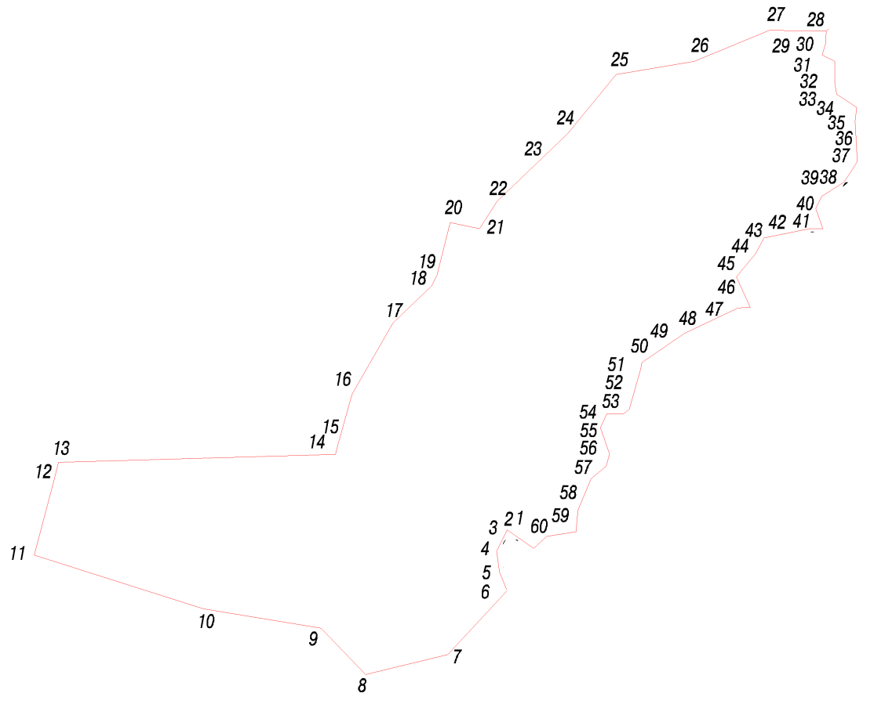
Условное обозначение точки | Координаты
Условное обозначение точки | X | Y
1 | 439693.99 | 1240243.00
2 | 439721.99 | 1240203.00
3 | 439689.99 | 1240187.00
4 | 439682.41 | 1240187.95
5 | 439657.99 | 1240191.00
6 | 439629.65 | 1240202.83
7 | 440478.99 | 1240686.00
8 | 440459.99 | 1240685.00
9 | 440442.99 | 1240680.00
10 | 440432.99 | 1240699.00
11 | 440399.99 | 1240699.00
12 | 440382.99 | 1240702.00
13 | 440362.99 | 1240732.00
14 | 440341.99 | 1240730.00
15 | 440280.99 | 1240733.00
16 | 440267.99 | 1240725.00
17 | 440249.99 | 1240713.00
18 | 440227.99 | 1240679.00
19 | 440209.99 | 1240670.00
20 | 440178.99 | 1240681.00
21 | 440178.99 | 1240661.00
22 | 440164.99 | 1240592.00
23 | 440140.99 | 1240579.00
24 | 440105.99 | 1240550.00
25 | 440059.99 | 1240571.00
26 | 440058.99 | 1240553.00
27 | 440019.99 | 1240471.00
28 | 439975.99 | 1240407.00
29 | 439965.99 | 1240405.00
30 | 439904.99 | 1240388.00
31 | 439897.99 | 1240379.00
32 | 439897.99 | 1240354.00
33 | 439876.99 | 1240344.00
34 | 439836.99 | 1240358.00
35 | 439818.99 | 1240353.00
36 | 439799.99 | 1240330.00
37 | 439751.99 | 1240310.00
38 | 439718.99 | 1240307.00
39 | 439711.99 | 1240263.00

Д. Белоручье
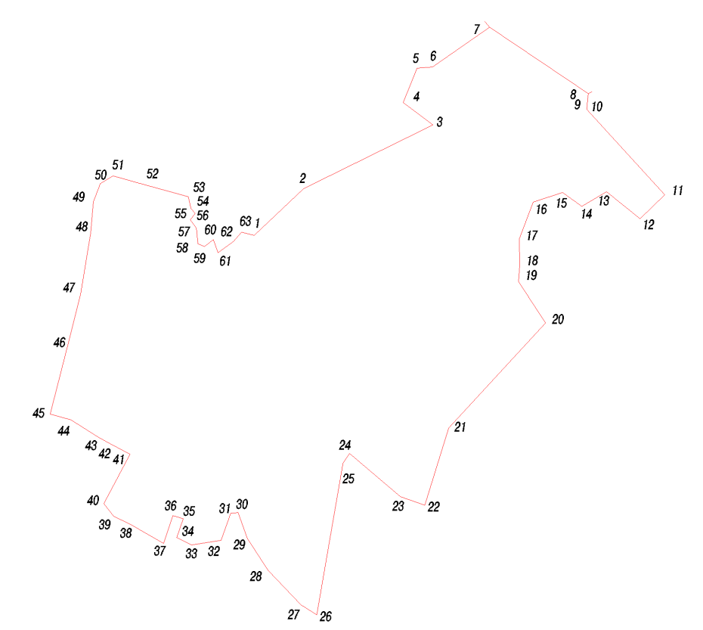
Условное обозначение точки | Координаты
Условное обозначение точки | X | Y
1 | 440684.99 | 1238503.00
2 | 440787.46 | 1238611.61
3 | 440927.01 | 1238894.85
4 | 440976.60 | 1238830.00
5 | 441051.49 | 1238860.00
6 | 441054.29 | 1238893.92
7 | 441141.13 | 1239019.93
8 | 440995.65 | 1239236.15
9 | 440982.48 | 1239234.35
10 | 440961.32 | 1239233.18
11 | 440774.21 | 1239404.47
12 | 440720.99 | 1239350.13
13 | 440780.91 | 1239276.50
14 | 440748.05 | 1239222.01
15 | 440778.92 | 1239179.78
16 | 440758.08 | 1239115.02
17 | 440677.67 | 1239084.43
18 | 440619.70 | 1239085.43
19 | 440583.67 | 1239083.34
20 | 440492.49 | 1239142.10
21 | 440262.37 | 1238929.63
22 | 440093.02 | 1238877.14
23 | 440111.53 | 1238823.97
24 | 440206.13 | 1238711.94
25 | 440184.95 | 1238697.58
26 | 439852.24 | 1238640.56
27 | 439874.14 | 1238605.21
28 | 439949.38 | 1238533.60
29 | 440019.99 | 1238487.83
30 | 440077.19 | 1238467.28
31 | 440074.99 | 1238451.00
32 | 440015.99 | 1238430.00
33 | 440005.99 | 1238365.00
34 | 440021.99 | 1238333.00
35 | 440062.99 | 1238347.00
36 | 440069.99 | 1238324.00
37 | 440008.99 | 1238304.00
38 | 440050.99 | 1238230.00
39 | 440067.99 | 1238195.00
40 | 440095.99 | 1238173.00
41 | 440204.99 | 1238230.00
42 | 440227.88 | 1238187.31
43 | 440241.99 | 1238161.00
44 | 440279.99 | 1238101.00
45 | 440292.99 | 1238055.00
46 | 440438.55 | 1238092.08
47 | 440555.99 | 1238122.00
48 | 440689.99 | 1238144.00
49 | 440758.99 | 1238150.00
50 | 440797.99 | 1238165.00
51 | 440814.99 | 1238193.00
52 | 440796.07 | 1238262.38
53 | 440769.99 | 1238358.00
54 | 440742.99 | 1238364.00
55 | 440732.99 | 1238373.00
56 | 440718.99 | 1238362.00
57 | 440700.99 | 1238376.00
58 | 440665.99 | 1238379.00
59 | 440659.99 | 1238394.00
60 | 440675.99 | 1238413.00
61 | 440646.99 | 1238423.00
62 | 440670.99 | 1238457.00
63 | 440691.99 | 1238475.00

Д. Кучино
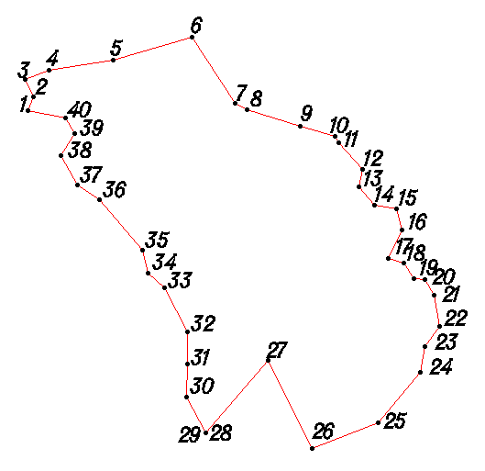
Условное обозначение точки | Координаты
Условное обозначение точки | X | Y
1 | 441544.99 | 1237478.00
2 | 441562.99 | 1237486.00
3 | 441585.99 | 1237475.00
4 | 441597.99 | 1237507.00
5 | 441611.99 | 1237591.00
6 | 441641.99 | 1237696.00
7 | 441553.99 | 1237753.00
8 | 441545.99 | 1237769.00
9 | 441524.70 | 1237839.56
10 | 441510.99 | 1237885.00
11 | 441501.99 | 1237890.00
12 | 441466.99 | 1237922.00
13 | 441443.99 | 1237917.00
14 | 441419.99 | 1237938.00
15 | 441414.99 | 1237967.00
16 | 441386.99 | 1237974.00
17 | 441348.99 | 1237956.00
18 | 441342.99 | 1237976.00
19 | 441322.99 | 1237990.00
20 | 441320.99 | 1238005.00
21 | 441300.99 | 1238017.00
22 | 441258.99 | 1238024.00
23 | 441232.99 | 1238004.00
24 | 441198.99 | 1237999.00
25 | 441131.99 | 1237943.00
26 | 441097.99 | 1237855.00
27 | 441213.99 | 1237797.00
28 | 441117.99 | 1237714.00
29 | 441118.99 | 1237714.00
30 | 441165.99 | 1237689.00
31 | 441209.99 | 1237690.00
32 | 441251.99 | 1237690.00
33 | 441310.99 | 1237660.00
34 | 441329.99 | 1237638.00
35 | 441359.99 | 1237630.00
36 | 441426.99 | 1237573.00
37 | 441446.99 | 1237544.00
38 | 441484.99 | 1237522.00
39 | 441514.99 | 1237541.00
40 | 441534.99 | 1237528.00

Д. Коленово
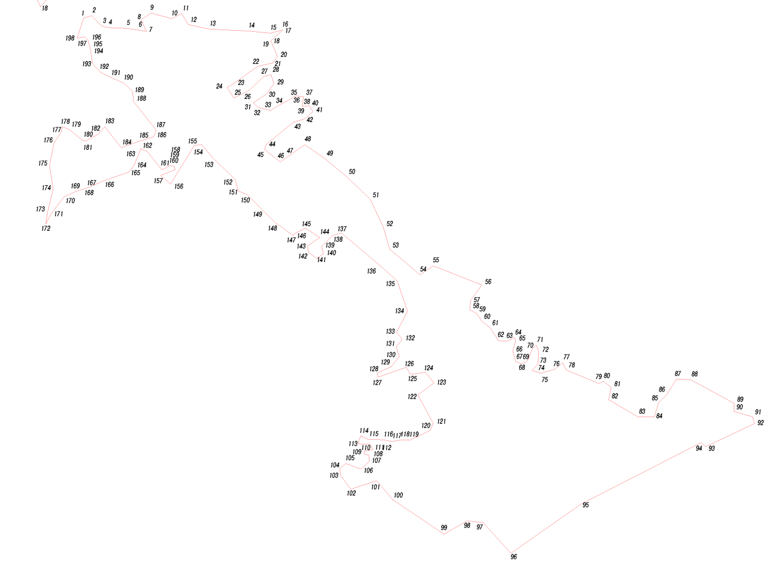
Условное обозначение точки | Координаты
Условное обозначение точки | X | Y
1 | 443186.99 | 1237706.00
2 | 443196.99 | 1237740.00
3 | 443153.99 | 1237781.00
4 | 443145.99 | 1237811.00
5 | 443142.99 | 1237888.00
6 | 443135.99 | 1237938.00
7 | 443129.99 | 1237973.00
8 | 443178.99 | 1237950.00
9 | 443207.99 | 1237992.00
10 | 443183.99 | 1238080.00
11 | 443205.73 | 1238122.52
12 | 443158.99 | 1238151.00
13 | 443139.99 | 1238239.00
14 | 443131.99 | 1238405.00
15 | 443122.99 | 1238500.00
16 | 443135.99 | 1238548.00
17 | 443134.99 | 1238551.00
18 | 443090.99 | 1238502.00
19 | 443089.99 | 1238501.00
20 | 443023.99 | 1238529.00
21 | 442995.99 | 1238510.00
22 | 442981.99 | 1238445.00
23 | 442915.99 | 1238354.00
24 | 442891.99 | 1238316.00
25 | 442846.99 | 1238344.00
26 | 442879.99 | 1238411.00
27 | 442937.99 | 1238469.00
28 | 442945.99 | 1238502.00
29 | 442907.99 | 1238514.00
30 | 442863.99 | 1238483.00
31 | 442826.99 | 1238427.00
32 | 442806.99 | 1238450.00
33 | 442794.99 | 1238500.00
34 | 442813.99 | 1238532.00
35 | 442848.99 | 1238595.00
36 | 442856.99 | 1238607.00
37 | 442852.99 | 1238640.00
38 | 442825.99 | 1238636.00
39 | 442812.99 | 1238634.00
40 | 442813.99 | 1238665.00
41 | 442789.99 | 1238680.00
42 | 442758.99 | 1238646.00
43 | 442743.99 | 1238596.00
44 | 442650.99 | 1238482.00
45 | 442628.99 | 1238474.00
46 | 442575.99 | 1238541.00
47 | 442602.49 | 1238578.76
48 | 442648.99 | 1238645.00
49 | 442590.99 | 1238730.00
50 | 442513.99 | 1238823.00
51 | 442417.99 | 1238923.00
52 | 442298.99 | 1238979.00
53 | 442204.99 | 1239006.00
54 | 442096.57 | 1239135.12
55 | 442135.17 | 1239191.48
56 | 442053.32 | 1239397.64
57 | 441985.83 | 1239349.44
58 | 441947.94 | 1239346.86
59 | 441930.98 | 1239376.90
60 | 441900.58 | 1239396.21
61 | 441873.47 | 1239431.42
62 | 441817.11 | 1239468.74
63 | 441814.83 | 1239505.03
64 | 441829.68 | 1239534.84
65 | 441817.00 | 1239541.29
66 | 441771.73 | 1239528.90
67 | 441727.92 | 1239542.58
68 | 441717.95 | 1239571.30
69 | 441732.73 | 1239591.55
70 | 441785.08 | 1239613.44
71 | 441797.92 | 1239628.62
72 | 441767.45 | 1239639.67
73 | 441719.06 | 1239636.20
74 | 441690.87 | 1239610.95
75 | 441678.42 | 1239648.59
76 | 441696.69 | 1239708.92
77 | 441723.65 | 1239741.18
78 | 441692.58 | 1239756.04
79 | 441635.05 | 1239894.57
80 | 441644.23 | 1239913.97
81 | 441619.02 | 1239946.74
82 | 441566.50 | 1239935.93
83 | 441493.09 | 1240061.71
84 | 441493.59 | 1240129.93
85 | 441554.31 | 1240148.33
86 | 441589.20 | 1240184.22
87 | 441654.15 | 1240224.47
88 | 441651.54 | 1240284.57
89 | 441551.08 | 1240469.10
90 | 441516.96 | 1240467.83
91 | 441494.13 | 1240547.93
92 | 441465.16 | 1240555.27
93 | 441367.93 | 1240349.78
94 | 441384.06 | 1240327.77
95 | 441123.04 | 1239818.34
96 | 440914.66 | 1239521.18
97 | 441045.30 | 1239402.27
98 | 441051.53 | 1239334.37
99 | 440995.65 | 1239236.15
100 | 441141.13 | 1239019.93
101 | 441222.71 | 1238950.60
102 | 441186.27 | 1238840.77
103 | 441244.49 | 1238797.06
104 | 441273.75 | 1238794.30
105 | 441295.57 | 1238819.60
106 | 441271.86 | 1238883.42
107 | 441303.94 | 1238919.46
108 | 441330.66 | 1238917.35
109 | 441336.86 | 1238896.30
110 | 441347.70 | 1238898.13
111 | 441354.96 | 1238934.36
112 | 441376.52 | 1238924.02
113 | 441379.31 | 1238870.54
114 | 441412.24 | 1238882.22
115 | 441398.10 | 1238915.58
116 | 441396.02 | 1238978.61
117 | 441388.66 | 1239016.84
118 | 441395.93 | 1239052.43
119 | 441394.95 | 1239092.53
120 | 441436.31 | 1239178.14
121 | 441466.43 | 1239190.43
122 | 441587.17 | 1239125.91
123 | 441637.74 | 1239194.28
124 | 441682.44 | 1239157.46
125 | 441674.34 | 1239093.88
126 | 441703.90 | 1239075.84
127 | 441662.30 | 1238957.35
128 | 441679.25 | 1238953.83
129 | 441706.83 | 1239013.03
130 | 441749.51 | 1239046.66
131 | 441790.98 | 1239032.78
132 | 441823.43 | 1239060.54
133 | 441852.09 | 1239034.87
134 | 441941.54 | 1239081.74
135 | 442070.99 | 1239038.00
136 | 442138.99 | 1238961.00
137 | 442274.99 | 1238800.00
138 | 442262.99 | 1238762.00
139 | 442216.99 | 1238717.00
140 | 442185.99 | 1238724.00
141 | 442165.99 | 1238696.00
142 | 442190.99 | 1238662.00
143 | 442217.99 | 1238656.00
144 | 442254.99 | 1238709.00
145 | 442294.99 | 1238648.00
146 | 442271.99 | 1238603.00
147 | 442262.99 | 1238597.00
148 | 442316.99 | 1238522.00
149 | 442372.99 | 1238464.00
150 | 442436.99 | 1238401.00
151 | 442452.99 | 1238362.00
152 | 442501.99 | 1238350.00
153 | 442593.99 | 1238254.00
154 | 442649.99 | 1238207.00
155 | 442644.99 | 1238175.00
156 | 442481.99 | 1238075.00
157 | 442518.99 | 1238033.00
158 | 442542.99 | 1238095.00
159 | 442557.99 | 1238090.00
160 | 442561.99 | 1238074.00
161 | 442541.99 | 1238039.00
162 | 442620.99 | 1237975.00
163 | 442631.99 | 1237949.00
164 | 442560.99 | 1237920.00
165 | 442532.99 | 1237898.00
166 | 442495.99 | 1237791.00
167 | 442469.99 | 1237733.00
168 | 442461.31 | 1237706.06
169 | 442450.99 | 1237674.00
170 | 442427.99 | 1237623.00
171 | 442353.99 | 1237567.00
172 | 442312.99 | 1237545.00
173 | 442360.99 | 1237553.00
174 | 442459.99 | 1237576.00
175 | 442561.99 | 1237561.00
176 | 442656.99 | 1237580.00
177 | 442704.99 | 1237612.00
178 | 442724.99 | 1237615.00
179 | 442712.99 | 1237647.00
180 | 442670.99 | 1237697.00
181 | 442663.99 | 1237714.00
182 | 442694.99 | 1237769.00
183 | 442725.99 | 1237796.00
184 | 442635.99 | 1237865.00
185 | 442664.99 | 1237946.00
186 | 442682.99 | 1238003.00
187 | 442712.00 | 1238014.00
188 | 442831.99 | 1237918.00
189 | 442874.99 | 1237914.00
190 | 442909.99 | 1237878.00
191 | 442931.99 | 1237829.00
192 | 442955.99 | 1237779.00
193 | 442991.99 | 1237744.00
194 | 443054.99 | 1237735.00
195 | 443072.99 | 1237730.00
196 | 443093.99 | 1237724.00
197 | 443106.99 | 1237710.00
198 | 443100.99 | 1237678.00

Д. Долгомостье
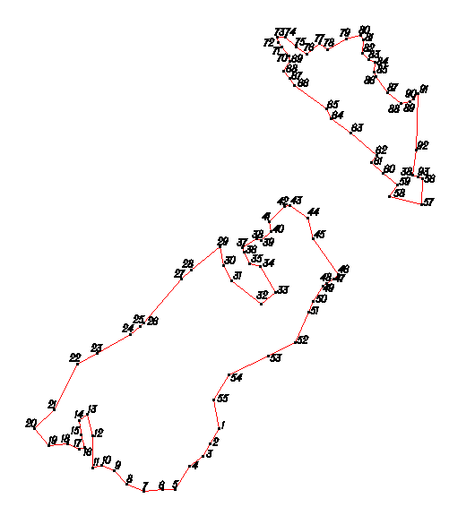
Условное обозначение точки | Координаты
Условное обозначение точки | X | Y
1 | 441552.99 | 1241814.00
2 | 441509.67 | 1241789.16
3 | 441477.99 | 1241771.00
4 | 441448.99 | 1241735.00
5 | 441387.99 | 1241694.00
6 | 441386.06 | 1241661.24
7 | 441382.99 | 1241609.00
8 | 441400.99 | 1241563.00
9 | 441437.99 | 1241531.00
10 | 441452.99 | 1241496.00
11 | 441445.99 | 1241472.00
12 | 441531.99 | 1241472.00
13 | 441590.99 | 1241457.00
14 | 441573.99 | 1241436.00
15 | 441535.99 | 1241441.00
16 | 441500.99 | 1241450.00
17 | 441495.99 | 1241434.00
18 | 441511.99 | 1241403.00
19 | 441505.99 | 1241353.00
20 | 441551.99 | 1241313.00
21 | 441603.99 | 1241367.00
22 | 441726.99 | 1241429.00
23 | 441756.99 | 1241483.00
24 | 441807.81 | 1241574.32
25 | 441829.53 | 1241599.09
26 | 441839.26 | 1241610.51
27 | 441957.99 | 1241711.00
28 | 441981.92 | 1241739.88
29 | 442044.99 | 1241816.00
30 | 441994.99 | 1241826.00
31 | 441953.99 | 1241849.00
32 | 441889.99 | 1241929.00
33 | 441920.99 | 1241966.00
34 | 441991.99 | 1241927.00
35 | 441999.99 | 1241897.00
36 | 442029.99 | 1241882.00
37 | 442042.99 | 1241878.00
38 | 442067.99 | 1241916.00
39 | 442061.99 | 1241928.00
40 | 442085.99 | 1241955.00
41 | 442112.99 | 1241949.00
42 | 442153.99 | 1241991.00
43 | 442157.99 | 1242007.00
44 | 442123.99 | 1242054.00
45 | 442065.99 | 1242069.00
46 | 441970.99 | 1242136.00
47 | 441958.99 | 1242124.00
48 | 441944.93 | 1242104.58
49 | 441937.99 | 1242095.00
50 | 441897.99 | 1242069.00
51 | 441867.99 | 1242056.00
52 | 441785.99 | 1242020.00
53 | 441749.99 | 1241948.00
54 | 441697.99 | 1241840.00
55 | 441629.99 | 1241799.00
56 | 427364.99 | 1235502.97
57 | 427377.99 | 1235481.95
58 | 427407.98 | 1235446.96
59 | 427435.00 | 1235378.00
60 | 427435.95 | 1235307.02
61 | 427440.97 | 1235282.03
62 | 427490.99 | 1235248.04
63 | 427511.04 | 1235224.98
64 | 427517.00 | 1235205.02
65 | 427567.03 | 1235184.01
66 | 427594.05 | 1235165.01
67 | 427610.97 | 1235145.03
68 | 427618.96 | 1235162.00
69 | 427647.99 | 1235158.03
70 | 427666.01 | 1235122.02
71 | 427683.03 | 1235099.04
72 | 427720.97 | 1235088.01
73 | 427750.02 | 1235111.02
74 | 427799.02 | 1235176.99
75 | 427853.02 | 1235225.95
76 | 427897.02 | 1235268.97
77 | 427939.95 | 1235344.02
56 | 442228.99 | 1242366.00
57 | 442158.99 | 1242363.00
58 | 442180.99 | 1242275.00
59 | 442212.99 | 1242298.00
60 | 442243.99 | 1242259.00
61 | 442272.99 | 1242227.00
62 | 442292.99 | 1242241.00
63 | 442354.99 | 1242171.00
64 | 442392.99 | 1242117.00
65 | 442418.99 | 1242105.00
66 | 442482.99 | 1242019.00
67 | 442501.03 | 1242005.12
68 | 442521.99 | 1241989.00
69 | 442547.99 | 1242006.00
70 | 442561.99 | 1242004.00
71 | 442587.00 | 1241983.72
72 | 442598.99 | 1241974.00
73 | 442614.99 | 1241971.00
74 | 442614.99 | 1241994.00
75 | 442585.99 | 1242023.00
76 | 442566.99 | 1242051.00
77 | 442596.99 | 1242085.00
78 | 442579.99 | 1242107.00
79 | 442609.99 | 1242160.00
80 | 442618.99 | 1242199.00
81 | 442605.99 | 1242206.00
82 | 442570.99 | 1242203.00
83 | 442551.99 | 1242220.00
84 | 442544.99 | 1242237.00
85 | 442518.99 | 1242235.00
86 | 442507.99 | 1242238.00
87 | 442462.99 | 1242270.00
88 | 442432.99 | 1242308.00
89 | 442437.99 | 1242332.00

Д. Авдотьино
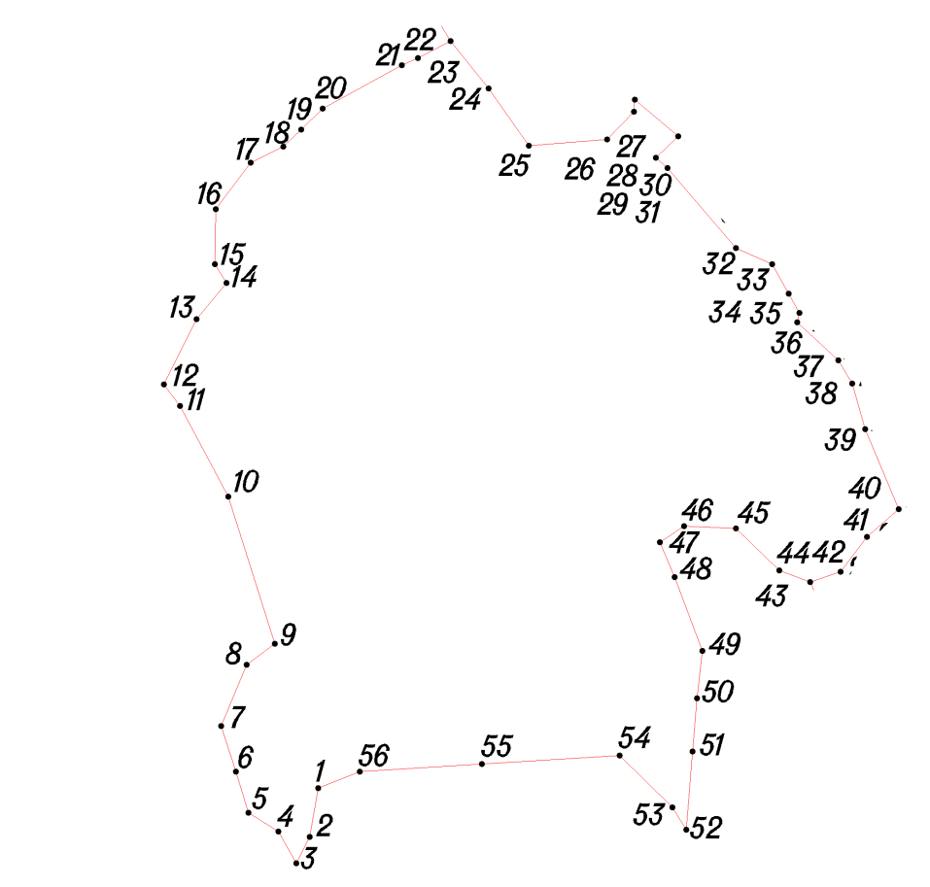
Условное обозначение точки | Координаты
Условное обозначение точки | X | Y
1 | 443365.99 | 1236859.00
2 | 443319.99 | 1236851.00
3 | 443294.99 | 1236838.00
4 | 443324.99 | 1236821.00
5 | 443342.99 | 1236793.00
6 | 443381.99 | 1236781.00
7 | 443424.99 | 1236767.00
8 | 443482.99 | 1236791.00
9 | 443502.99 | 1236818.00
10 | 443641.99 | 1236774.00
11 | 443727.99 | 1236728.00
12 | 443747.99 | 1236713.00
13 | 443809.99 | 1236744.00
14 | 443843.99 | 1236772.00
15 | 443861.99 | 1236761.00
16 | 443913.99 | 1236762.00
17 | 443957.99 | 1236795.00
18 | 443972.99 | 1236826.00
19 | 443989.12 | 1236842.58
20 | 444008.99 | 1236863.00
21 | 444049.99 | 1236938.00
22 | 444056.99 | 1236953.00
23 | 444072.99 | 1236984.00
24 | 444027.99 | 1237020.00
25 | 443973.99 | 1237058.00
26 | 443979.99 | 1237132.00
27 | 444006.20 | 1237157.34
28 | 444017.49 | 1237158.47
29 | 443982.93 | 1237199.16
30 | 443962.49 | 1237178.15
31 | 443952.99 | 1237189.00
32 | 443876.99 | 1237254.00
33 | 443861.99 | 1237288.00
34 | 443833.99 | 1237304.00
35 | 443815.99 | 1237314.00
36 | 443806.99 | 1237312.00
37 | 443770.99 | 1237351.00
38 | 443748.99 | 1237364.00
39 | 443705.99 | 1237376.00
40 | 443629.99 | 1237408.00
41 | 443603.99 | 1237378.00
42 | 443570.99 | 1237353.00
43 | 443560.99 | 1237324.00
44 | 443571.99 | 1237295.00
45 | 443611.99 | 1237254.00
46 | 443613.99 | 1237205.00
47 | 443598.99 | 1237182.00
48 | 443565.99 | 1237196.00
49 | 443495.99 | 1237222.00
50 | 443450.99 | 1237217.00
51 | 443400.99 | 1237213.00
52 | 443326.99 | 1237207.00
53 | 443347.99 | 1237194.00
54 | 443396.99 | 1237144.00
55 | 443389.05 | 1237013.84
56 | 443381.99 | 1236898.00

Д. Яново
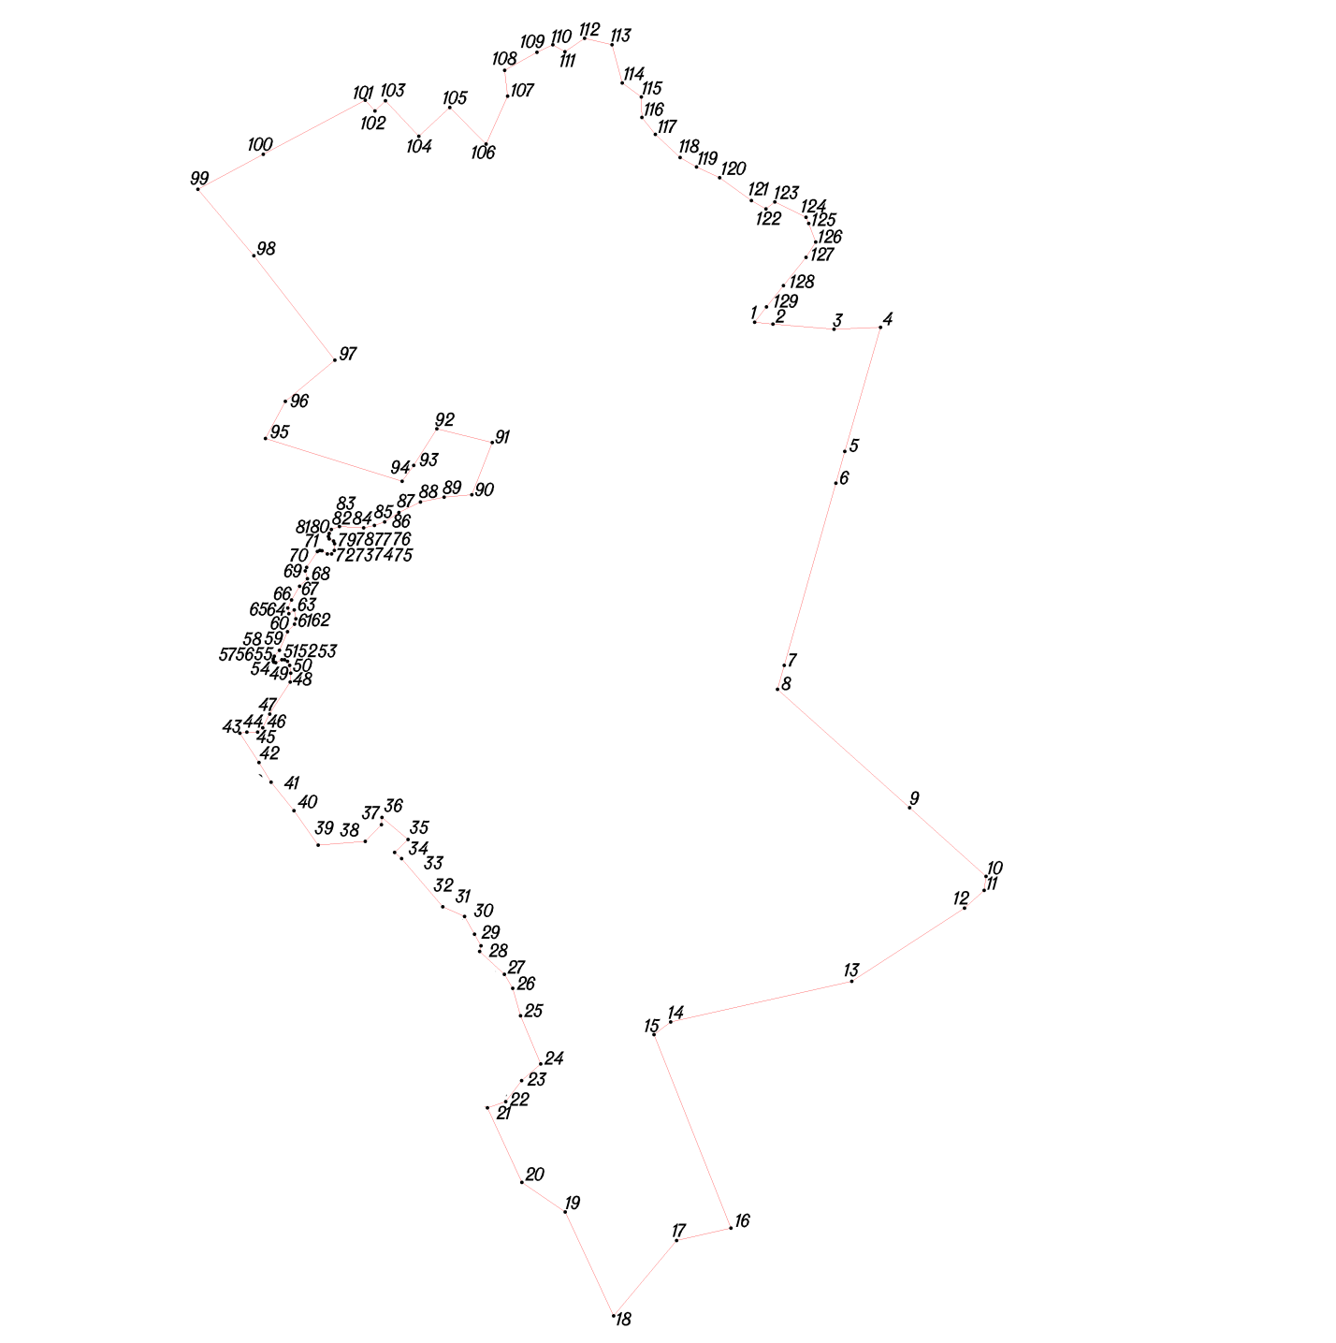
Условное обозначение точки | Координаты
Условное обозначение точки | X | Y
1 | 444795.99 | 1237744.00
2 | 444792.99 | 1237773.00
3 | 444784.99 | 1237869.00
4 | 444787.99 | 1237942.00
5 | 444592.99 | 1237886.00
6 | 444542.99 | 1237872.00
7 | 444256.60 | 1237790.68
8 | 444218.99 | 1237780.00
9 | 444032.99 | 1237988.00
10 | 443924.99 | 1238108.00
11 | 443902.99 | 1238105.00
12 | 443874.99 | 1238074.00
13 | 443759.99 | 1237897.00
14 | 443695.99 | 1237612.00
15 | 443676.15 | 1237586.11
16 | 443372.06 | 1237706.76
17 | 443352.62 | 1237621.31
18 | 443234.19 | 1237522.68
19 | 443397.48 | 1237446.28
20 | 443443.92 | 1237378.12
21 | 443560.99 | 1237324.00
22 | 443570.99 | 1237353.00
23 | 443603.99 | 1237378.00
24 | 443629.99 | 1237408.00
25 | 443705.99 | 1237376.00
26 | 443748.99 | 1237364.00
27 | 443770.99 | 1237351.00
28 | 443806.99 | 1237312.00
29 | 443815.99 | 1237314.00
30 | 443833.99 | 1237304.00
31 | 443861.99 | 1237288.00
32 | 443876.99 | 1237254.00
33 | 443952.99 | 1237189.00
34 | 443962.49 | 1237178.15
35 | 443982.93 | 1237199.16
36 | 444017.49 | 1237158.47
37 | 444006.20 | 1237157.34
38 | 443979.99 | 1237132.00
39 | 443973.99 | 1237058.00
40 | 444027.99 | 1237020.00
41 | 444072.99 | 1236984.00
42 | 444103.99 | 1236965.00
43 | 444149.99 | 1236935.00
44 | 444151.88 | 1236945.80
45 | 444151.88 | 1236963.04
46 | 444158.23 | 1236970.98
47 | 444179.71 | 1236981.15
48 | 444230.51 | 1237014.26
49 | 444244.13 | 1237014.94
50 | 444256.39 | 1237013.12
51 | 444263.11 | 1237009.75
52 | 444265.38 | 1237005.21
53 | 444265.38 | 1237001.12
54 | 444260.61 | 1236991.14
55 | 444261.52 | 1236988.42
56 | 444263.33 | 1236987.51
57 | 444266.74 | 1236987.51
58 | 444270.83 | 1236989.10
59 | 444280.14 | 1236997.04
60 | 444309.42 | 1237009.75
61 | 444321.37 | 1237020.85
62 | 444329.55 | 1237022.89
63 | 444343.62 | 1237020.62
64 | 444337.72 | 1237011.77
65 | 444346.58 | 1237010.41
66 | 444359.52 | 1237016.08
67 | 444380.86 | 1237028.79
68 | 444392.95 | 1237041.18
69 | 444404.97 | 1237037.78
70 | 444410.64 | 1237039.82
71 | 444435.60 | 1237056.84
72 | 444437.19 | 1237060.70
73 | 444436.74 | 1237063.87
74 | 444431.75 | 1237072.27
75 | 444431.52 | 1237079.30
76 | 444437.19 | 1237083.39
77 | 444447.63 | 1237083.84
78 | 444452.17 | 1237082.25
79 | 444455.35 | 1237075.45
80 | 444459.20 | 1237074.08
81 | 444463.74 | 1237075.22
82 | 444470.32 | 1237078.85
83 | 444474.86 | 1237091.56
84 | 444472.82 | 1237129.68
85 | 444476.67 | 1237146.69
86 | 444481.89 | 1237162.58
87 | 444496.98 | 1237185.07
88 | 444513.31 | 1237218.80
89 | 444521.05 | 1237255.88
90 | 444524.78 | 1237299.56
91 | 444606.68 | 1237331.73
92 | 444628.34 | 1237244.53
93 | 444570.96 | 1237208.33
94 | 444545.99 | 1237190.00
95 | 444612.99 | 1236975.00
96 | 444671.72 | 1237006.38
97 | 444736.12 | 1237084.38
98 | 444900.21 | 1236957.15
99 | 445004.99 | 1236869.00
100 | 445059.78 | 1236971.92
101 | 445144.99 | 1237132.00
102 | 445128.12 | 1237147.18
103 | 445144.07 | 1237163.79
104 | 445088.16 | 1237216.42
105 | 445133.28 | 1237264.92
106 | 445075.99 | 1237322.00
107 | 445151.25 | 1237355.69
108 | 445191.70 | 1237351.22
109 | 445219.99 | 1237402.00
110 | 445231.99 | 1237427.00
111 | 445220.99 | 1237446.00
112 | 445241.99 | 1237477.00
113 | 445231.99 | 1237520.00
114 | 445171.99 | 1237536.00
115 | 445149.99 | 1237566.00
116 | 445117.99 | 1237567.00
117 | 445090.99 | 1237588.00
118 | 445054.99 | 1237627.00
119 | 445039.99 | 1237653.00
120 | 445022.99 | 1237689.00
121 | 444986.99 | 1237739.00
122 | 444973.99 | 1237762.00
123 | 444984.99 | 1237776.00
124 | 444960.99 | 1237825.00
125 | 444950.99 | 1237829.00
126 | 444921.99 | 1237840.00
127 | 444897.99 | 1237825.00
128 | 444853.34 | 1237789.51
129 | 444819.99 | 1237763.00

Д. Заборье
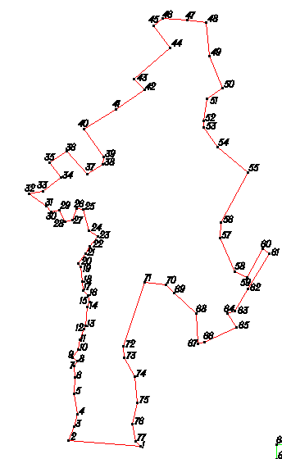
Условное обозначение точки | Координаты
Условное обозначение точки | X | Y
1 | 444667.99 | 1239644.00
2 | 444664.99 | 1239887.00
3 | 444606.99 | 1239876.00
4 | 444598.99 | 1239900.00
5 | 444576.99 | 1239917.00
6 | 444547.99 | 1239927.00
7 | 444524.99 | 1239903.00
8 | 444527.99 | 1239849.00
9 | 444513.99 | 1239815.00
10 | 444491.99 | 1239844.00
11 | 444487.99 | 1239881.00
12 | 444466.99 | 1239891.00
13 | 444451.99 | 1239872.00
14 | 444448.99 | 1239824.00
15 | 444421.99 | 1239791.00
16 | 444412.99 | 1239809.00
17 | 444406.99 | 1239860.00
18 | 444407.99 | 1239901.00
19 | 444359.99 | 1239901.00
20 | 444362.99 | 1239843.00
21 | 444357.99 | 1239799.00
22 | 444343.99 | 1239808.00
23 | 444322.99 | 1239839.00
24 | 444291.99 | 1239872.00
25 | 444261.99 | 1239856.00
26 | 444247.99 | 1239834.00
27 | 444331.99 | 1239777.00
28 | 444342.99 | 1239739.00
29 | 444371.99 | 1239690.00
30 | 444356.99 | 1239649.00
31 | 444276.99 | 1239600.00
32 | 444215.99 | 1239557.00
33 | 444233.21 | 1239510.92
34 | 444249.99 | 1239466.00
35 | 444206.99 | 1239449.00
36 | 444101.99 | 1239389.00
37 | 444053.99 | 1239366.00
38 | 444077.99 | 1239330.00
39 | 444123.99 | 1239334.00
40 | 444138.99 | 1239301.00
41 | 444196.99 | 1239309.00
42 | 444199.99 | 1239240.00
43 | 444203.99 | 1239200.00
44 | 444301.99 | 1239209.00
45 | 444320.99 | 1239210.00
46 | 444333.99 | 1239240.00
47 | 444351.99 | 1239257.00
48 | 444389.99 | 1239265.00
49 | 444403.99 | 1239259.00
50 | 444440.86 | 1239264.53
51 | 444463.30 | 1239274.46
52 | 444456.99 | 1239334.00
53 | 444488.99 | 1239344.00
54 | 444553.99 | 1239366.00
55 | 444557.99 | 1239357.00
56 | 444580.99 | 1239341.00
57 | 444617.60 | 1239303.27
58 | 444637.59 | 1239308.03
59 | 444657.58 | 1239331.82
60 | 444653.58 | 1239375.42
61 | 444630.45 | 1239410.70
62 | 444605.99 | 1239448.00
63 | 444642.99 | 1239459.00
64 | 444652.99 | 1239494.00
65 | 444612.99 | 1239541.00
66 | 444639.99 | 1239576.00
67 | 444643.99 | 1239607.00
68 | 444644.99 | 1239633.00
69 | 444753.99 | 1240086.00
70 | 444771.99 | 1239874.00
71 | 444812.99 | 1239890.00
72 | 444847.99 | 1239899.00
73 | 444909.99 | 1239890.00
74 | 444958.99 | 1239892.00
75 | 444992.99 | 1239891.00
76 | 445005.99 | 1239899.00
 | 445015.99 | 1239886.00
 | 445039.99 | 1239903.00
 | 445068.99 | 1239906.00
 | 445101.99 | 1239919.00
 | 445110.99 | 1239925.00
 | 445166.99 | 1239929.00
 | 445182.99 | 1239935.00
 | 445200.99 | 1239932.00
 | 445215.99 | 1239916.00
 | 445242.99 | 1239914.00
 | 445285.99 | 1239910.00
 | 445294.99 | 1239902.00
 | 445325.99 | 1239924.00
 | 445347.99 | 1239935.00
 | 445375.99 | 1239960.00
 | 445393.99 | 1239934.00
 | 445455.99 | 1239916.00
 | 445459.99 | 1239898.00
 | 445424.99 | 1239886.00
 | 445420.99 | 1239864.00
 | 445454.99 | 1239846.00
 | 445449.99 | 1239822.00
 | 445464.99 | 1239808.00
 | 445501.99 | 1239757.00
 | 445510.99 | 1239798.00
 | 445549.99 | 1239852.00
 | 445595.99 | 1239817.00
 | 445627.99 | 1239869.00
 | 445559.99 | 1239929.00
 | 445589.99 | 1239974.00
 | 445610.99 | 1239977.00
 | 445694.99 | 1239919.00
 | 445752.99 | 1240013.00
 | 445811.99 | 1240098.00
 | 445841.99 | 1240068.00
 | 445935.99 | 1240175.00
 | 446000.99 | 1240126.00
 | 446021.99 | 1240153.00
 | 446016.99 | 1240225.00
 | 446009.99 | 1240280.00
 | 445909.99 | 1240291.00
 | 445815.99 | 1240330.00
 | 445783.99 | 1240284.00
 | 445718.99 | 1240274.00
 | 445698.99 | 1240274.00
 | 445641.99 | 1240315.00
 | 445565.99 | 1240405.00
 | 445416.99 | 1240325.00
 | 445370.99 | 1240322.00
 | 445271.99 | 1240366.00
 | 445253.99 | 1240402.00
 | 445338.99 | 1240449.00
 | 445323.99 | 1240469.00
 | 445219.99 | 1240406.00
 | 445154.99 | 1240366.00
 | 445148.99 | 1240345.00
 | 445106.99 | 1240372.00
 | 445062.99 | 1240276.00
 | 445056.99 | 1240256.00
 | 445148.99 | 1240251.00
 | 445208.99 | 1240186.00
 | 445232.99 | 1240162.00
 | 445238.99 | 1240099.00
 | 445049.99 | 1240035.00
 | 445015.99 | 1240039.00
 | 444960.99 | 1240069.00
 | 444881.99 | 1240078.00
 | 444819.99 | 1240063.00
 | 444767.99 | 1240071.00

Д. Рябцево
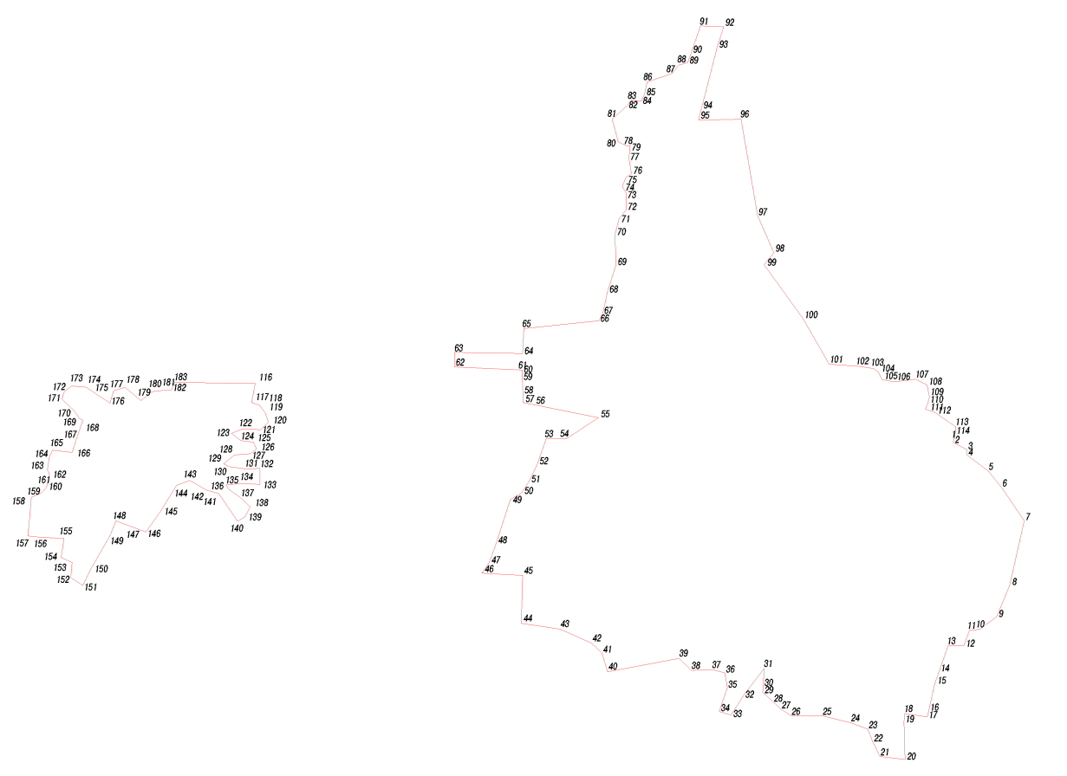
Условное обозначение точки | Координаты
Условное обозначение точки | X | Y
1 | 444502.99 | 1242000.00
2 | 444486.79 | 1241994.85
3 | 444464.21 | 1242037.13
4 | 444448.72 | 1242036.43
5 | 444399.99 | 1242102.00
6 | 444350.99 | 1242142.00
7 | 444249.99 | 1242210.00
8 | 444054.99 | 1242166.00
9 | 443959.99 | 1242127.00
10 | 443920.99 | 1242075.00
11 | 443919.99 | 1242045.00
12 | 443871.99 | 1242027.00
13 | 443871.99 | 1241980.00
14 | 443796.31 | 1241953.21
15 | 443758.99 | 1241940.00
16 | 443677.99 | 1241922.00
17 | 443656.84 | 1241917.08
18 | 443667.55 | 1241849.11
19 | 443642.99 | 1241847.00
20 | 443527.99 | 1241850.00
21 | 443537.99 | 1241774.00
22 | 443582.99 | 1241752.00
23 | 443619.99 | 1241738.00
24 | 443638.99 | 1241687.00
25 | 443659.99 | 1241603.00
26 | 443659.99 | 1241508.00
27 | 443680.99 | 1241475.00
28 | 443699.00 | 1241455.58
29 | 443731.99 | 1241420.00
30 | 443746.99 | 1241422.00
31 | 443803.99 | 1241424.00
32 | 443719.99 | 1241361.00
33 | 443662.99 | 1241324.00
34 | 443672.99 | 1241289.00
35 | 443745.99 | 1241313.00
36 | 443789.99 | 1241306.00
37 | 443799.99 | 1241269.00
38 | 443797.99 | 1241205.00
39 | 443833.99 | 1241168.00
40 | 443793.23 | 1240951.96
41 | 443850.79 | 1240933.72
42 | 443880.11 | 1240903.28
43 | 443921.97 | 1240809.71
44 | 443939.84 | 1240690.90
45 | 444085.02 | 1240694.89
46 | 444091.97 | 1240571.15
47 | 444124.56 | 1240594.51
48 | 444183.19 | 1240615.77
49 | 444313.95 | 1240657.32
50 | 444333.67 | 1240691.41
51 | 444369.55 | 1240714.62
52 | 444421.08 | 1240739.01
53 | 444498.49 | 1240766.08
54 | 444498.87 | 1240829.02
55 | 444561.99 | 1240924.00
56 | 444600.99 | 1240730.00
57 | 444606.99 | 1240696.00
58 | 444631.46 | 1240695.44
59 | 444686.47 | 1240694.19
60 | 444694.99 | 1240694.00
61 | 444705.24 | 1240693.21
62 | 444715.30 | 1240489.03
63 | 444758.57 | 1240489.03
64 | 444755.53 | 1240694.93
65 | 444830.99 | 1240698.00
66 | 444854.99 | 1240925.00
67 | 444876.99 | 1240937.00
68 | 444940.99 | 1240951.00
69 | 445023.99 | 1240977.00
70 | 445114.99 | 1240974.00
71 | 445162.99 | 1240986.00
72 | 445190.99 | 1241008.00
73 | 445238.99 | 1241008.00
74 | 445260.99 | 1240996.00
75 | 445288.43 | 1241007.26
76 | 445298.99 | 1241024.00
77 | 445343.99 | 1241016.00
78 | 445381.99 | 1241019.00
79 | 445382.99 | 1241009.00
80 | 445394.99 | 1240984.00
81 | 445463.99 | 1240965.00
82 | 445505.99 | 1241012.00
83 | 445520.99 | 1241023.00
84 | 445517.99 | 1241053.00
85 | 445537.99 | 1241063.00
86 | 445575.99 | 1241071.00
87 | 445601.99 | 1241146.00
88 | 445627.99 | 1241168.00
89 | 445634.99 | 1241193.00
90 | 445665.99 | 1241205.00
91 | 445745.99 | 1241232.00
92 | 445742.99 | 1241302.00
93 | 445681.99 | 1241283.00
94 | 445497.23 | 1241235.35
95 | 445460.99 | 1241226.00
96 | 445463.99 | 1241355.00
97 | 445171.99 | 1241405.00
98 | 445059.99 | 1241454.00
99 | 445023.99 | 1241424.00
100 | 444860.99 | 1241542.00
101 | 444722.99 | 1241621.00
102 | 444716.99 | 1241713.00
103 | 444709.99 | 1241755.00
104 | 444698.99 | 1241770.00
105 | 444677.10 | 1241779.88
106 | 444669.77 | 1241817.46
107 | 444677.99 | 1241882.00
108 | 444660.99 | 1241916.00
109 | 444623.99 | 1241924.00
110 | 444605.99 | 1241919.00
111 | 444587.99 | 1241911.00
112 | 444576.99 | 1241941.00
113 | 444533.99 | 1242004.00
114 | 444511.17 | 1242001.06
115 | 444667.99 | 1239644.00
116 | 444664.99 | 1239887.00
117 | 444606.99 | 1239876.00
118 | 444598.99 | 1239900.00
119 | 444576.99 | 1239917.00
120 | 444547.99 | 1239927.00
121 | 444524.99 | 1239903.00
122 | 444527.99 | 1239849.00
123 | 444513.99 | 1239815.00
124 | 444491.99 | 1239844.00
125 | 444487.99 | 1239881.00
126 | 444466.99 | 1239891.00
127 | 444451.99 | 1239872.00
128 | 444448.99 | 1239824.00
129 | 444421.99 | 1239791.00
130 | 444412.99 | 1239809.00
131 | 444406.99 | 1239860.00
132 | 444407.99 | 1239901.00
133 | 444359.99 | 1239901.00
134 | 444362.99 | 1239843.00
135 | 444357.99 | 1239799.00
136 | 444343.99 | 1239808.00
137 | 444322.99 | 1239839.00
138 | 444291.99 | 1239872.00
139 | 444261.99 | 1239856.00
140 | 444247.99 | 1239834.00
141 | 444331.99 | 1239777.00
142 | 444342.99 | 1239739.00
143 | 444371.99 | 1239690.00
144 | 444356.99 | 1239649.00
145 | 444276.99 | 1239600.00
146 | 444215.99 | 1239557.00
147 | 444233.21 | 1239510.92
148 | 444249.99 | 1239466.00
149 | 444206.99 | 1239449.00
150 | 444101.99 | 1239389.00
151 | 444053.99 | 1239366.00
152 | 444077.99 | 1239330.00
153 | 444123.99 | 1239334.00
154 | 444138.99 | 1239301.00
155 | 444196.99 | 1239309.00
156 | 444199.99 | 1239240.00
157 | 444203.99 | 1239200.00
158 | 444301.99 | 1239209.00
159 | 444320.99 | 1239210.00
160 | 444333.99 | 1239240.00
161 | 444351.99 | 1239257.00
162 | 444389.99 | 1239265.00
163 | 444403.99 | 1239259.00
164 | 444440.86 | 1239264.53
165 | 444463.30 | 1239274.46
166 | 444456.99 | 1239334.00
167 | 444488.99 | 1239344.00
168 | 444553.99 | 1239366.00
169 | 444557.99 | 1239357.00
170 | 444580.99 | 1239341.00
171 | 444617.60 | 1239303.27
172 | 444637.59 | 1239308.03
173 | 444657.58 | 1239331.82
174 | 444653.58 | 1239375.42
175 | 444630.45 | 1239410.70
176 | 444605.99 | 1239448.00
177 | 444642.99 | 1239459.00
178 | 444652.99 | 1239494.00
179 | 444612.99 | 1239541.00
180 | 444639.99 | 1239576.00
181 | 444643.99 | 1239607.00
182 | 444644.99 | 1239633.00

Д. Нижние Немыкари
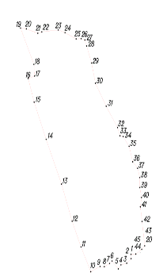
Условное обозначение точки | Координаты
Условное обозначение точки | X | Y
1 | 447845.99 | 1245048.00
2 | 447829.99 | 1245049.00
3 | 447812.99 | 1245027.00
4 | 447806.99 | 1244999.00
5 | 447791.99 | 1244986.00
6 | 447820.99 | 1244955.00
7 | 447811.99 | 1244942.00
8 | 447799.99 | 1244917.00
9 | 447800.99 | 1244896.00
10 | 447781.99 | 1244850.00
11 | 447872.99 | 1244802.00
12 | 447967.99 | 1244758.00
13 | 448104.99 | 1244706.00
14 | 448269.99 | 1244630.00
15 | 448406.99 | 1244571.00
16 | 448494.19 | 1244542.04
17 | 448503.17 | 1244572.82
18 | 448545.99 | 1244570.00
19 | 448679.99 | 1244504.00
20 | 448676.99 | 1244533.00
21 | 448660.99 | 1244589.00
22 | 448665.99 | 1244609.00
23 | 448672.99 | 1244690.00
24 | 448662.99 | 1244723.00
25 | 448639.99 | 1244778.00
26 | 448640.99 | 1244803.00
27 | 448635.99 | 1244821.00
28 | 448614.13 | 1244829.48
29 | 448550.99 | 1244854.00
30 | 448476.99 | 1244873.00
31 | 448391.99 | 1244926.00
32 | 448312.99 | 1244982.00
33 | 448282.99 | 1244994.00
34 | 448279.99 | 1245010.00
35 | 448243.99 | 1245039.00
36 | 448186.99 | 1245057.00
37 | 448162.99 | 1245081.00
38 | 448128.99 | 1245092.00
39 | 448091.99 | 1245092.00
40 | 448054.99 | 1245100.00
41 | 448020.99 | 1245094.00
42 | 447966.99 | 1245103.00
43 | 447876.99 | 1245116.00
44 | 447863.99 | 1245101.00
45 | 447846.99 | 1245072.00

Д. Верхние Немыкари
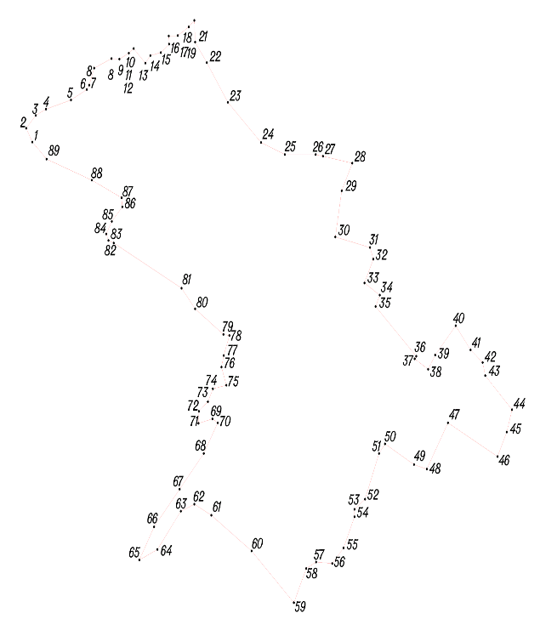
Условное обозначение точки | Координаты
Условное обозначение точки | X | Y
1 | 447634.99 | 1244686.00
2 | 447662.39 | 1244669.69
3 | 447687.98 | 1244695.10
4 | 447700.37 | 1244722.15
5 | 447718.59 | 1244788.51
6 | 447739.40 | 1244830.46
7 | 447747.99 | 1244837.00
8 | 447781.99 | 1244850.00
9 | 447800.99 | 1244896.00
10 | 447799.99 | 1244917.00
11 | 447811.99 | 1244942.00
12 | 447820.99 | 1244955.00
13 | 447791.99 | 1244986.00
14 | 447806.99 | 1244999.00
15 | 447812.99 | 1245027.00
16 | 447829.99 | 1245049.00
17 | 447845.99 | 1245048.00
18 | 447846.99 | 1245072.00
19 | 447863.99 | 1245101.00
20 | 447876.99 | 1245116.00
21 | 447833.99 | 1245118.00
22 | 447792.99 | 1245149.00
23 | 447713.99 | 1245205.00
24 | 447633.99 | 1245293.00
25 | 447609.99 | 1245356.00
26 | 447609.99 | 1245438.00
27 | 447606.59 | 1245457.38
28 | 447592.99 | 1245535.00
29 | 447537.99 | 1245507.00
30 | 447445.99 | 1245490.00
31 | 447424.99 | 1245582.00
32 | 447401.99 | 1245591.00
33 | 447354.37 | 1245567.43
34 | 447330.24 | 1245607.93
35 | 447307.49 | 1245597.01
36 | 447208.50 | 1245704.88
37 | 447203.45 | 1245700.71
38 | 447182.69 | 1245736.52
39 | 447210.99 | 1245755.00
40 | 447269.37 | 1245809.50
41 | 447220.99 | 1245849.00
42 | 447195.99 | 1245881.00
43 | 447169.99 | 1245888.00
44 | 447102.05 | 1245958.93
45 | 447057.66 | 1245944.98
46 | 447008.76 | 1245920.62
47 | 447075.99 | 1245789.00
48 | 446983.99 | 1245733.00
49 | 446992.99 | 1245699.00
50 | 447033.99 | 1245622.00
51 | 447014.99 | 1245606.00
52 | 446923.99 | 1245569.00
53 | 446903.99 | 1245541.00
54 | 446888.99 | 1245541.00
55 | 446826.99 | 1245512.00
56 | 446795.99 | 1245482.00
57 | 446798.99 | 1245439.00
58 | 446785.99 | 1245413.00
59 | 446717.99 | 1245380.00
60 | 446820.99 | 1245268.00
61 | 446891.99 | 1245161.00
62 | 446913.99 | 1245116.00
63 | 446899.99 | 1245080.00
64 | 446823.99 | 1245018.00
65 | 446802.99 | 1244970.00
66 | 446868.99 | 1245009.00
67 | 446944.03 | 1245076.85
68 | 447014.99 | 1245141.00
69 | 447075.99 | 1245178.00
70 | 447083.99 | 1245164.00
71 | 447074.99 | 1245127.00
72 | 447098.99 | 1245128.00
73 | 447117.99 | 1245152.00
74 | 447143.99 | 1245165.00
75 | 447150.99 | 1245201.00
76 | 447186.99 | 1245188.00
77 | 447209.99 | 1245194.00
78 | 447249.99 | 1245209.00
79 | 447251.99 | 1245193.00
80 | 447302.99 | 1245118.00
81 | 447343.99 | 1245082.00
82 | 447433.99 | 1244902.00
83 | 447438.99 | 1244888.00
84 | 447451.99 | 1244882.00
85 | 447476.99 | 1244897.00
86 | 447505.99 | 1244925.00
87 | 447523.99 | 1244923.00
88 | 447558.99 | 1244844.00
89 | 447600.99 | 1244724.00

Д. Арефино
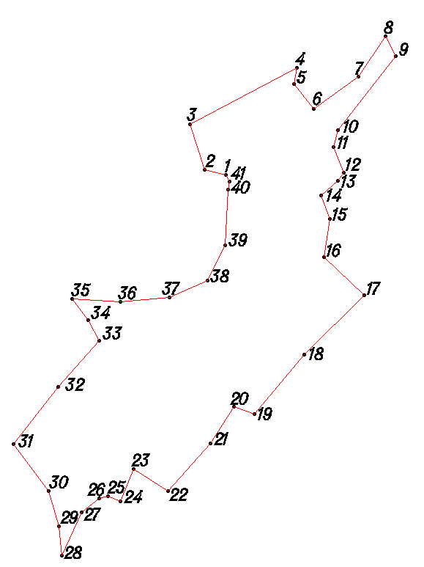
Условное обозначение точки | Координаты
Условное обозначение точки | X | Y
1 | 441387.99 | 1246886.00
2 | 441396.99 | 1246850.00
3 | 441471.99 | 1246826.00
4 | 441565.99 | 1247003.00
5 | 441538.99 | 1246999.00
6 | 441497.99 | 1247031.00
7 | 441550.99 | 1247106.00
8 | 441617.99 | 1247150.00
9 | 441584.99 | 1247168.00
10 | 441461.99 | 1247071.00
11 | 441433.99 | 1247064.00
12 | 441391.99 | 1247081.00
13 | 441378.99 | 1247071.00
14 | 441353.99 | 1247044.00
15 | 441314.99 | 1247058.00
16 | 441251.99 | 1247048.00
17 | 441188.99 | 1247115.00
18 | 441089.99 | 1247016.00
19 | 440991.99 | 1246933.00
20 | 441003.99 | 1246899.00
21 | 440943.99 | 1246860.00
22 | 440863.99 | 1246790.00
23 | 440900.99 | 1246733.00
24 | 440846.99 | 1246711.00
25 | 440855.99 | 1246690.00
26 | 440851.99 | 1246676.00
27 | 440828.99 | 1246646.00
28 | 440757.99 | 1246613.00
29 | 440805.99 | 1246609.00
30 | 440864.99 | 1246592.00
31 | 440941.99 | 1246533.00
32 | 441036.99 | 1246607.00
33 | 441113.99 | 1246676.00
34 | 441147.99 | 1246657.00
35 | 441182.99 | 1246631.00
36 | 441177.99 | 1246711.00
37 | 441184.99 | 1246792.00
38 | 441212.99 | 1246855.00
39 | 441270.99 | 1246884.00
40 | 441363.99 | 1246889.00
41 | 441376.99 | 1246892.00

Д. Труханово
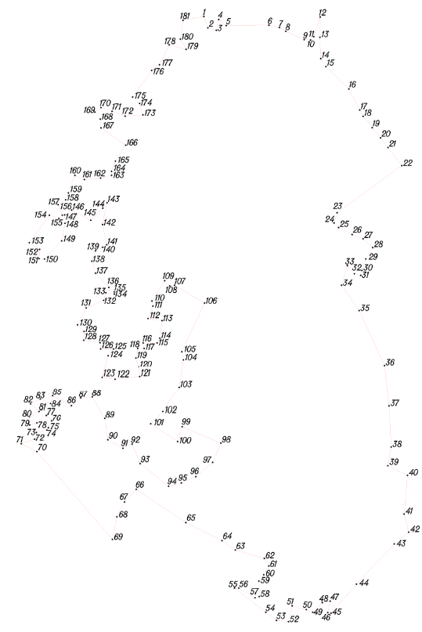
Условное обозначение точки | Координаты
Условное обозначение точки | X | Y
1 | 439520.99 | 1245865.00
2 | 439482.99 | 1245878.00
3 | 439474.99 | 1245906.00
4 | 439510.99 | 1245914.00
5 | 439490.99 | 1245939.00
6 | 439491.99 | 1246080.00
7 | 439483.99 | 1246115.00
8 | 439471.99 | 1246136.00
9 | 439443.99 | 1246197.00
10 | 439442.99 | 1246218.00
11 | 439453.99 | 1246229.00
12 | 439518.99 | 1246250.00
13 | 439451.99 | 1246249.00
14 | 439380.99 | 1246252.00
15 | 439354.99 | 1246269.00
16 | 439280.99 | 1246345.00
17 | 439211.47 | 1246380.91
18 | 439189.99 | 1246392.00
19 | 439152.99 | 1246422.00
20 | 439118.99 | 1246450.00
21 | 439086.76 | 1246474.52
22 | 439026.99 | 1246520.00
23 | 438870.99 | 1246306.00
24 | 438836.99 | 1246296.00
25 | 438821.99 | 1246311.00
26 | 438798.99 | 1246356.00
27 | 438784.99 | 1246392.00
28 | 438755.99 | 1246424.00
29 | 438717.99 | 1246401.00
30 | 438679.99 | 1246388.00
31 | 438663.99 | 1246384.00
32 | 438668.99 | 1246363.00
33 | 438695.99 | 1246340.00
34 | 438630.99 | 1246321.00
35 | 438546.99 | 1246379.00
36 | 438364.99 | 1246463.00
37 | 438228.99 | 1246478.00
38 | 438092.99 | 1246485.00
39 | 438030.99 | 1246474.00
40 | 437998.99 | 1246539.00
41 | 437870.99 | 1246528.00
42 | 437810.99 | 1246543.00
43 | 437771.99 | 1246495.00
44 | 437638.99 | 1246370.00
45 | 437542.99 | 1246286.00
46 | 437544.99 | 1246275.00
47 | 437582.99 | 1246283.00
48 | 437577.99 | 1246257.00
49 | 437545.99 | 1246225.00
50 | 437554.99 | 1246204.00
51 | 437566.99 | 1246157.00
52 | 437514.99 | 1246145.00
53 | 437518.99 | 1246105.00
54 | 437545.99 | 1246070.00
55 | 437625.99 | 1245966.00
56 | 437625.99 | 1245980.00
57 | 437593.99 | 1246034.00
58 | 437597.99 | 1246048.00
59 | 437648.99 | 1246047.00
60 | 437669.99 | 1246063.00
61 | 437698.99 | 1246080.00
62 | 437723.99 | 1246065.00
63 | 437751.99 | 1245969.00
64 | 437782.99 | 1245925.00
65 | 437842.99 | 1245805.00
66 | 437952.99 | 1245641.00
67 | 437910.99 | 1245602.00
68 | 437861.99 | 1245577.00
69 | 437786.99 | 1245562.00
70 | 438077.99 | 1245312.00
71 | 438103.99 | 1245260.00
72 | 438118.99 | 1245304.00
73 | 438140.99 | 1245310.00
74 | 438148.99 | 1245345.00
75 | 438156.99 | 1245350.00
76 | 438179.99 | 1245361.00
77 | 438199.99 | 1245343.00
78 | 438172.99 | 1245312.00
79 | 438165.99 | 1245288.00
80 | 438192.99 | 1245287.00
81 | 438212.99 | 1245319.00
82 | 438235.99 | 1245291.00
83 | 438251.99 | 1245323.00
84 | 438236.99 | 1245357.00
85 | 438262.99 | 1245364.00
86 | 438229.99 | 1245426.00
87 | 438255.99 | 1245457.00
88 | 438258.99 | 1245495.00
89 | 438187.99 | 1245537.00
90 | 438116.99 | 1245547.00
91 | 438088.99 | 1245597.00
92 | 438102.99 | 1245627.01
93 | 438037.99 | 1245654.00
94 | 437962.99 | 1245748.00
95 | 437973.99 | 1245790.00
96 | 437994.99 | 1245838.00
97 | 438041.99 | 1245894.00
98 | 438105.99 | 1245921.00
99 | 438159.99 | 1245793.00
100 | 438110.99 | 1245778.00
101 | 438169.99 | 1245689.00
102 | 438212.99 | 1245729.00
103 | 438292.99 | 1245783.00
104 | 438383.99 | 1245797.00
105 | 438410.99 | 1245792.00
106 | 438571.99 | 1245867.00
107 | 438630.99 | 1245768.00
108 | 438628.99 | 1245752.00
109 | 438645.99 | 1245735.00
110 | 438578.99 | 1245693.00
111 | 438561.99 | 1245696.00
112 | 438520.99 | 1245680.00
113 | 438513.99 | 1245726.00
114 | 438455.99 | 1245719.00
115 | 438439.99 | 1245710.00
116 | 438439.99 | 1245664.00
117 | 438421.99 | 1245667.00
118 | 438421.99 | 1245646.00
119 | 438389.99 | 1245640.00
120 | 438359.99 | 1245649.00
121 | 438328.99 | 1245652.00
122 | 438319.99 | 1245571.00
123 | 438325.99 | 1245528.00
124 | 438397.99 | 1245548.00
125 | 438419.99 | 1245566.00
126 | 438419.99 | 1245523.00
127 | 438440.99 | 1245521.00
128 | 438448.99 | 1245467.00
129 | 438477.99 | 1245468.00
130 | 438499.99 | 1245446.00
131 | 438555.99 | 1245475.00
132 | 438580.99 | 1245533.00
133 | 438605.99 | 1245540.00
134 | 438601.99 | 1245568.00
135 | 438608.99 | 1245568.00
136 | 438623.99 | 1245550.00
137 | 438670.99 | 1245506.00
138 | 438710.99 | 1245494.00
139 | 438744.99 | 1245506.00
140 | 438756.99 | 1245529.00
141 | 438764.99 | 1245543.00
142 | 438831.99 | 1245529.00
143 | 438903.99 | 1245544.00
144 | 438885.99 | 1245530.00
145 | 438845.99 | 1245490.00
146 | 438879.99 | 1245427.00
147 | 438863.99 | 1245404.00
148 | 438835.99 | 1245405.00
149 | 438777.99 | 1245394.00
150 | 438717.99 | 1245337.00
151 | 438718.99 | 1245319.00
152 | 438749.99 | 1245321.00
153 | 438771.99 | 1245287.00
154 | 438862.99 | 1245353.00
155 | 438851.99 | 1245385.00
156 | 438862.99 | 1245396.00
157 | 438897.99 | 1245382.00
158 | 438913.99 | 1245407.00
159 | 438936.99 | 1245416.00
160 | 438994.99 | 1245438.00
161 | 438980.99 | 1245469.00
162 | 438985.99 | 1245523.00
163 | 438994.99 | 1245559.00
164 | 439007.99 | 1245559.00
165 | 439041.99 | 1245572.00
166 | 439094.99 | 1245606.00
167 | 439151.99 | 1245524.00
168 | 439180.99 | 1245522.00
169 | 439203.99 | 1245504.00
170 | 439218.99 | 1245524.00
171 | 439206.99 | 1245561.00
172 | 439190.99 | 1245604.00
173 | 439194.99 | 1245663.00
174 | 439232.99 | 1245652.00
175 | 439253.99 | 1245629.00
176 | 439341.99 | 1245692.00
177 | 439360.99 | 1245718.00
178 | 439426.99 | 1245750.00
179 | 439411.99 | 1245806.00
180 | 439445.99 | 1245787.00
181 | 439507.99 | 1245796.00

Д. Чучелово
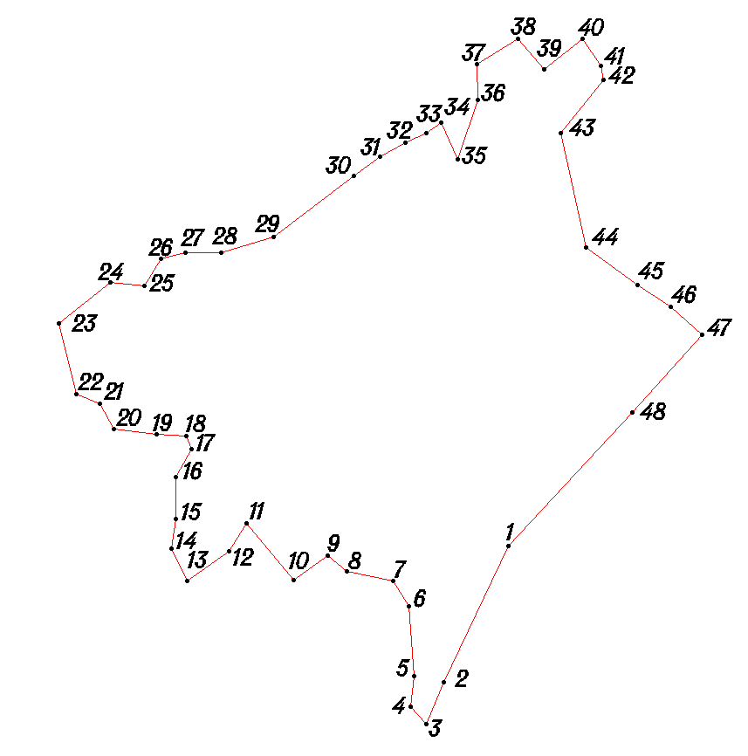
Условное обозначение точки | Координаты
Условное обозначение точки | X | Y
1 | 434308.39 | 1246783.99
2 | 434143.81 | 1246705.20
3 | 434092.66 | 1246684.58
4 | 434113.52 | 1246665.42
5 | 434150.54 | 1246669.15
6 | 434235.50 | 1246662.53
7 | 434266.36 | 1246644.30
8 | 434277.94 | 1246587.21
9 | 434296.77 | 1246564.07
10 | 434267.47 | 1246523.29
11 | 434336.05 | 1246465.78
12 | 434302.89 | 1246444.03
13 | 434266.52 | 1246393.30
14 | 434305.38 | 1246374.01
15 | 434341.42 | 1246379.74
16 | 434392.42 | 1246379.37
17 | 434426.56 | 1246399.12
18 | 434442.51 | 1246392.00
19 | 434444.25 | 1246355.99
20 | 434450.86 | 1246303.94
21 | 434481.74 | 1246287.71
22 | 434493.53 | 1246258.63
23 | 434579.38 | 1246237.99
24 | 434628.84 | 1246300.63
25 | 434625.14 | 1246341.66
26 | 434657.29 | 1246361.42
27 | 434665.51 | 1246391.36
28 | 434664.82 | 1246434.37
29 | 434684.29 | 1246498.23
30 | 434758.01 | 1246595.69
31 | 434781.24 | 1246627.53
32 | 434798.47 | 1246658.40
33 | 434810.66 | 1246684.31
34 | 434822.79 | 1246702.22
35 | 434778.94 | 1246722.54
36 | 434850.12 | 1246747.02
37 | 434894.11 | 1246745.70
38 | 434924.48 | 1246795.47
39 | 434887.71 | 1246826.75
40 | 434925.05 | 1246873.47
41 | 434892.21 | 1246895.71
42 | 434875.24 | 1246899.84
43 | 434809.86 | 1246847.32
44 | 434671.08 | 1246878.34
45 | 434625.54 | 1246940.67
46 | 434598.84 | 1246980.87
47 | 434565.12 | 1247019.12
48 | 434471.50 | 1246934.79

Д. Редчина
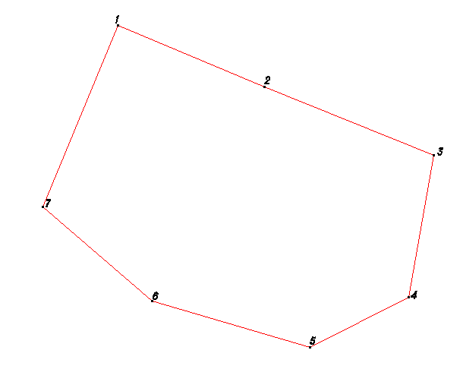
Условное обозначение точки | Координаты
Условное обозначение точки | X | Y
1 | 434055.40 | 1248181.44
2 | 433884.90 | 1248590.89
3 | 433694.33 | 1249063.61
4 | 433297.76 | 1248995.53
5 | 433157.94 | 1248718.77
6 | 433286.31 | 1248278.19
7 | 433550.25 | 1247971.52

Д. Егорье
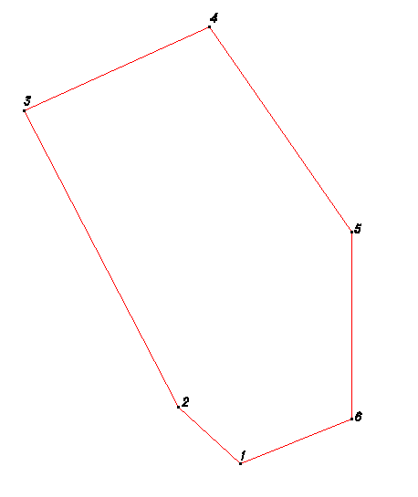
Условное обозначение точки | Координаты
Условное обозначение точки | X | Y
1 | 432317.44 | 1251614.13
2 | 432448.37 | 1251470.28
3 | 433138.20 | 1251111.48
4 | 433333.30 | 1251542.33
5 | 432855.64 | 1251872.19
6 | 432420.60 | 1251872.19

Д. Гусаково
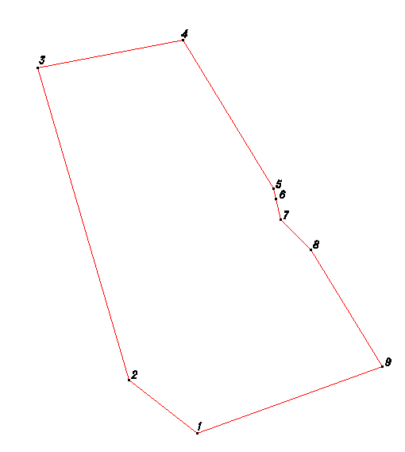
Условное обозначение точки | Координаты
Условное обозначение точки | X | Y
1 | 430992.88 | 1252061.31
2 | 431134.45 | 1251878.52
3 | 431967.87 | 1251634.04
4 | 432040.94 | 1252022.46
5 | 431645.32 | 1252264.56
6 | 431617.95 | 1252271.58
7 | 431562.77 | 1252284.52
8 | 431481.37 | 1252365.07
9 | 431170.98 | 1252554.84

Д. Буловица
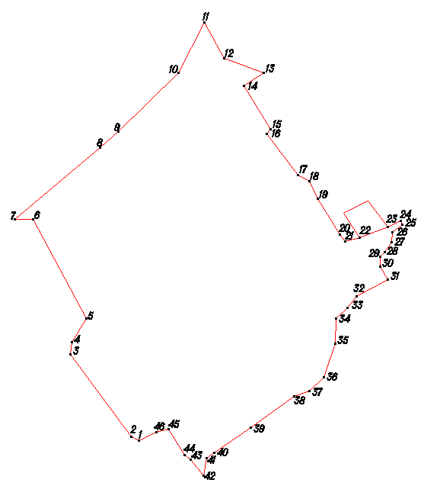
Условное обозначение точки | Координаты
Условное обозначение точки | X | Y
1 | 425662.97 | 1250416.51
2 | 425685.31 | 1250463.34
3 | 425693.57 | 1250498.28
4 | 425621.88 | 1250541.81
5 | 425610.02 | 1250559.9
6 | 425565.28 | 1250596.23
7 | 425614.34 | 1250603.87
8 | 425628.49 | 1250624.76
9 | 425698.25 | 1250727.25
10 | 425786.14 | 1250848.61
11 | 425800.45 | 1250890.5
12 | 425837.74 | 1250930.23
13 | 425931.98 | 1250962.54
14 | 426001.99 | 1250964.02
15 | 426032.23 | 1250996.8
16 | 426063.42 | 1251022.57
17 | 426109.05 | 1251109.24
18 | 426145.89 | 1251086.97
19 | 426173.9 | 1251087.76
20 | 426186.99 | 1251099.67
21 | 426213.14 | 1251120.48
22 | 426241.15 | 1251122.27
23 | 426262.36 | 1251150.12
24 | 426274.31 | 1251144.03
25 | 426256.05 | 1251108.16
26 | 426327.66 | 1251054.63
27 | 426295.16 | 1250986.87
28 | 426226.48 | 1251031.38
29 | 426215.18 | 1250990.46
30 | 426235.07 | 1250975.31
31 | 426335.63 | 1250914.57
32 | 426383.45 | 1250890.22
33 | 426401.22 | 1250859.09
34 | 426515.58 | 1250771.25
35 | 426527.67 | 1250783.16
36 | 426648.11 | 1250707.28
37 | 426685.53 | 1250764
38 | 426725.71 | 1250652.71
39 | 426824.31 | 1250596.98
40 | 426683.78 | 1250525.01
41 | 426520.55 | 1250357.21
42 | 426476.18 | 1250306.53
43 | 426277.43 | 1250068.99
44 | 426277.81 | 1250119.99
45 | 426001.9 | 1250270.02
46 | 425936.61 | 1250229.49
47 | 425901.57 | 1250224.75
48 | 425672.8 | 1250394.43

Д. Зяхино
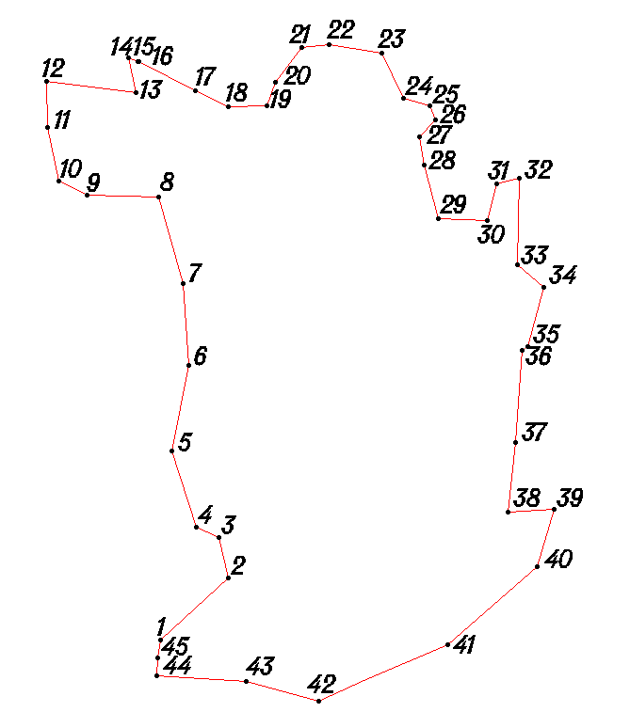
Условное обозначение точки | Координаты
Условное обозначение точки | X | Y
1 | 424385.74 | 1248070.84
2 | 424365.72 | 1248067.99
3 | 424345.71 | 1248067.14
4 | 424339.44 | 1248167.18
5 | 424317.05 | 1248249.35
6 | 424381.12 | 1248394.88
7 | 424468.85 | 1248495.24
8 | 424532.99 | 1248513.77
9 | 424530.61 | 1248462.78
10 | 424608.68 | 1248471.21
11 | 424712.74 | 1248478.45
12 | 424716.79 | 1248484.42
13 | 424783.92 | 1248502.92
14 | 424808.7 | 1248472.74
15 | 424906.72 | 1248475.02
16 | 424900.54 | 1248450.07
17 | 424858.46 | 1248439.38
18 | 424861.05 | 1248383.36
19 | 424920.93 | 1248367.92
20 | 424952.89 | 1248362.68
21 | 424972.03 | 1248380.54
22 | 424987.98 | 1248374.43
23 | 424996.76 | 1248344.36
24 | 425047.58 | 1248319.99
25 | 425057.15 | 1248260.92
26 | 425053.92 | 1248229.94
27 | 425014.7 | 1248200.23
28 | 424988.63 | 1248190.42
29 | 424987.32 | 1248147.43
30 | 425005.04 | 1248110.3
31 | 425037.58 | 1248047.06
32 | 425037.56 | 1248045.06
33 | 425042.49 | 1248035.02
34 | 425003.55 | 1248043.31
35 | 425015.81 | 1247942.22
36 | 424963.82 | 1247943.6
37 | 424902.91 | 1247956.04
38 | 424887.15 | 1247988.16
39 | 424885.74 | 1248069.17
40 | 424787.94 | 1248096.89
41 | 424695.98 | 1248102.57
42 | 424598.84 | 1248084.28
43 | 424513.03 | 1248110.91
44 | 424501.22 | 1248137
45 | 424456.3 | 1248147.32

Д. Лобково
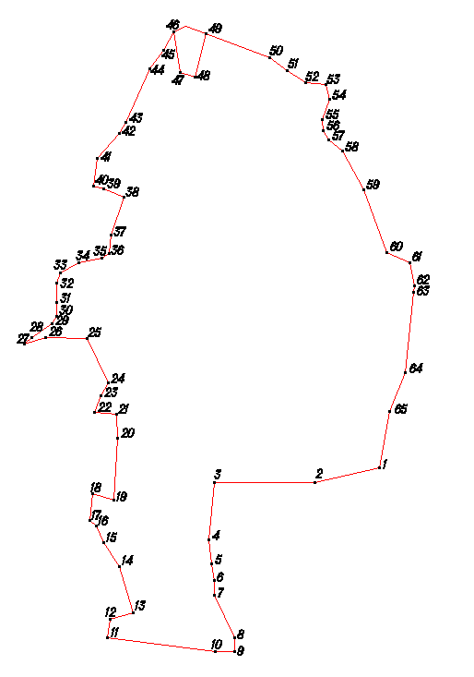
Условное обозначение точки | Координаты
Условное обозначение точки | X | Y
1 | 425462.58 | 1247501.93
2 | 425592.75 | 1247524.98
3 | 425681.02 | 1247561.33
4 | 425867.16 | 1247579.97
5 | 425881.17 | 1247581.87
6 | 425933.1 | 1247571.49
7 | 425957.72 | 1247519.31
8 | 426102.32 | 1247465.25
9 | 426190.96 | 1247416.59
10 | 426215.73 | 1247384.41
11 | 426236.63 | 1247371.26
12 | 426262.62 | 1247370.07
13 | 426309.75 | 1247386.72
14 | 426342.69 | 1247378.48
15 | 426347.34 | 1247331.45
16 | 426376.03 | 1247289.23
17 | 426404.74 | 1247249.02
18 | 426479.32 | 1247055.47
19 | 426464.13 | 1247029.58
20 | 426420.95 | 1247004.9
21 | 426378.72 | 1246974.21
22 | 426257.31 | 1246918.1
23 | 426230.2 | 1246903.3
24 | 426172.83 | 1246852.72
25 | 426109.76 | 1246844.17
26 | 426103.93 | 1246867.22
27 | 426085.28 | 1246914.35
28 | 425997.05 | 1246884
29 | 425956.02 | 1246879.3
30 | 425944.89 | 1246862.38
31 | 425934.51 | 1246809.46
32 | 425911.2 | 1246767.63
33 | 425887.13 | 1246758.81
34 | 425842.14 | 1246759.14
35 | 425811.13 | 1246758.37
36 | 425794.06 | 1246749.49
37 | 425762.72 | 1246702.72
38 | 425746.6 | 1246685.84
39 | 425762.96 | 1246734.72
40 | 425759.65 | 1246829.74
41 | 425659.01 | 1246878.48
42 | 425628.89 | 1246861.7
43 | 425590.78 | 1246846.98
44 | 425586.15 | 1246898.02
45 | 425532.16 | 1246899.41
46 | 425389.1 | 1246891.46
47 | 425404.74 | 1246842.35
48 | 425342.69 | 1246835.8
49 | 425329.8 | 1246850.9
50 | 425291.93 | 1246868.18
51 | 425237.19 | 1246903.58
52 | 425130.43 | 1246936.36
53 | 425116.03 | 1246882.47
54 | 425073.99 | 1246876.78
55 | 425040.81 | 1247124.02
56 | 425042.13 | 1247168.01
57 | 425073.13 | 1247167.79
58 | 425170.79 | 1247122.07
59 | 425204.79 | 1247121.82
60 | 425241.75 | 1247116.55
61 | 425298.7 | 1247109.13
62 | 425428.79 | 1247121.18
63 | 425429.5 | 1247354.17

Д. Грудинино
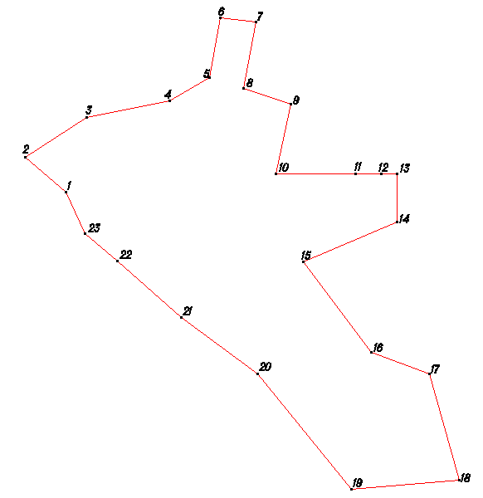
Условное обозначение точки | Координаты
Условное обозначение точки | X | Y
1 | 423539.16 | 1244859.01
2 | 423627.89 | 1244755.18
3 | 423731.29 | 1244912.63
4 | 423772.82 | 1245123.47
5 | 423831.86 | 1245226.87
6 | 423986.06 | 1245253.74
7 | 423973.73 | 1245344.83
8 | 423805.5 | 1245314.06
9 | 423764.12 | 1245433.09
10 | 423587.07 | 1245395.68
11 | 423587.07 | 1245705.21
12 | 423463.18 | 1245705.21
13 | 423361.12 | 1245466.33
14 | 423129.89 | 1245639.02
15 | 423075.99 | 1245788.42
16 | 422804.54 | 1245863.41
17 | 422781.53 | 1245589.58
18 | 423074.76 | 1245348.43
19 | 423219.32 | 1245153.36
20 | 423364.13 | 1244991.3
21 | 423433.53 | 1244908.79

Д. Поляны
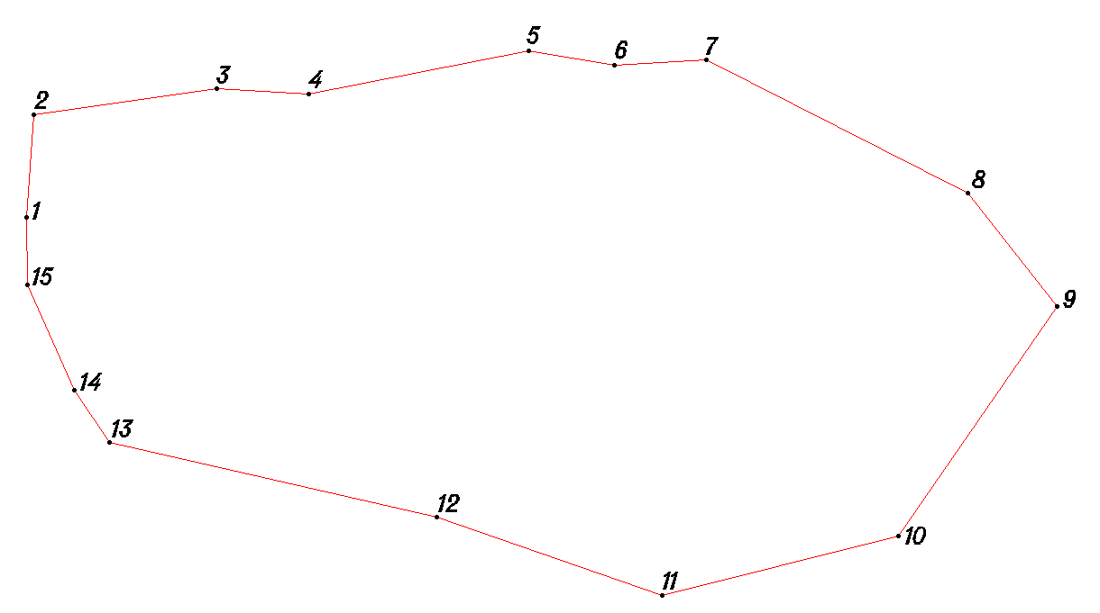
Условное обозначение точки | Координаты
Условное обозначение точки | X | Y
1 | 424678.11 | 1243213.64
2 | 424799.43 | 1243221.49
3 | 424830.48 | 1243437.15
4 | 424823.41 | 1243545.62
5 | 424874.98 | 1243804
6 | 424858.18 | 1243905.32
7 | 424863.98 | 1244013.29
8 | 424707.54 | 1244320.84
9 | 424574 | 1244425.41
10 | 424303.13 | 1244239.4
11 | 424233.53 | 1243961.59
12 | 424325.49 | 1243696.29
13 | 424413.98 | 1243311.45
14 | 424474.52 | 1243270.14
15 | 424598.82 | 1243215.03

Д. Денисово
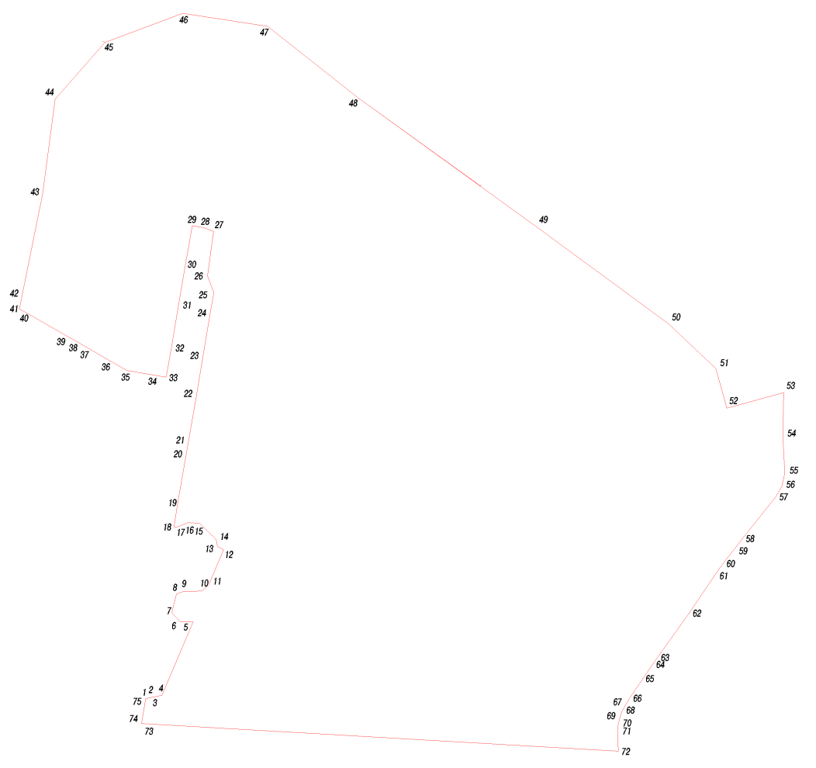
Условное обозначение точки | Координаты
Условное обозначение точки | X | Y
1 | 428477.3 | 1245187.97
2 | 428480.34 | 1245200.46
3 | 428482.09 | 1245210.46
4 | 428488.33 | 1245238.33
5 | 428712.71 | 1245333.34
6 | 428713.4 | 1245293.05
7 | 428740.21 | 1245267.86
8 | 428797.32 | 1245282.44
9 | 428804.47 | 1245302.39
10 | 428806.89 | 1245360.37
11 | 428826.35 | 1245381.45
12 | 428933.13 | 1245426.67
13 | 428943.24 | 1245407.37
14 | 428965.21 | 1245403.21
15 | 429012.85 | 1245353.86
16 | 429015.58 | 1245317.84
17 | 429002.34 | 1245283.93
18 | 429002.34 | 1245274.43
19 | 429073.12 | 1245285.69
20 | 429258.14 | 1245317.89
21 | 429402.84 | 1245342.94
22 | 429524.63 | 1245363.66
23 | 429656.72 | 1245386.07
24 | 429718.96 | 1245396.46
25 | 429769.75 | 1245377.31
26 | 429906.19 | 1245396.24
27 | 429917.44 | 1245363.85
28 | 429922.63 | 1245330.2
29 | 429798.08 | 1245308.3
30 | 429673.32 | 1245287.45
31 | 429541.43 | 1245265.08
32 | 429460.53 | 1245251.32
33 | 429481.07 | 1245130.61
34 | 429669.19 | 1244802.09
35 | 430020.88 | 1244873.46
36 | 430310.41 | 1244911.45
37 | 430483.73 | 1245064.06
38 | 430572.73 | 1245302.17
39 | 430533.01 | 1245561.35
40 | 430316.15 | 1245835.56
41 | 429920.4 | 1246382.93
42 | 429623.01 | 1246787.83
43 | 429487.03 | 1246931.77
44 | 429365.26 | 1246965.22
45 | 429412.97 | 1247138.89
46 | 429279.25 | 1247136.17
47 | 429167 | 1247142.41
48 | 429127.88 | 1247133.82
49 | 429093.12 | 1247113.93
50 | 428965.56 | 1247012.25
51 | 428945.77 | 1246996.97
52 | 428889.43 | 1246952.44
53 | 428866.26 | 1246935.55
54 | 428736.8 | 1246848.53
55 | 428601.52 | 1246751.7
56 | 428580.69 | 1246736.79
57 | 428528.7 | 1246701.61
58 | 428476.71 | 1246666.42
59 | 428455.42 | 1246653.31
60 | 428438.32 | 1246644.47
61 | 428420.19 | 1246638.07
62 | 428394.97 | 1246632.83
63 | 428369.25 | 1246631.52
64 | 428316.88 | 1246632.88
65 | 428401.9 | 1245175.27
66 | 428473.15 | 1245187.27

Д. Пересна
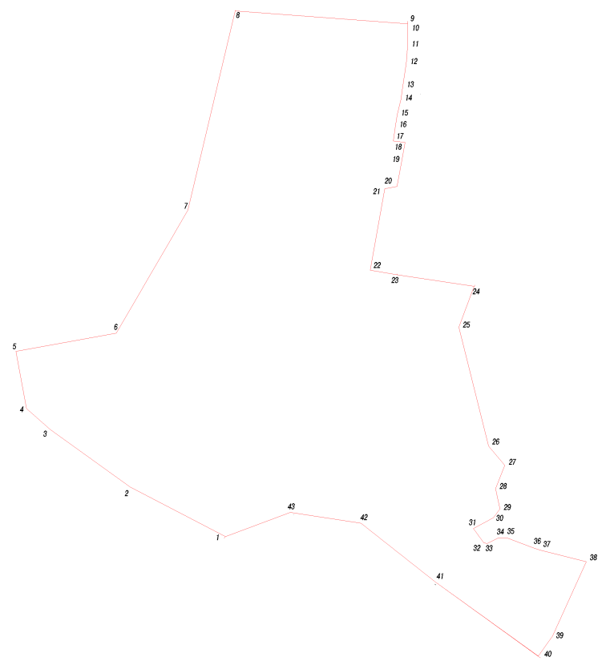
Условное обозначение точки | Координаты
Условное обозначение точки | X | Y
1 | 430483.73 | 1245064.06
2 | 430666.07 | 1244714.24
3 | 430877.02 | 1244421.17
4 | 430954.08 | 1244333.29
5 | 431163.77 | 1244295.09
6 | 431230.89 | 1244663.49
7 | 431682.49 | 1244925.78
8 | 432413.63 | 1245099.25
9 | 432366.66 | 1245732.14
10 | 432341.36 | 1245733.15
11 | 432284.48 | 1245732.27
12 | 432220.74 | 1245727.05
13 | 432136.85 | 1245714.7
14 | 432088.56 | 1245707.69
15 | 432033.06 | 1245693.58
16 | 431990.04 | 1245687.32
17 | 431936.01 | 1245679.49
18 | 431930.89 | 1245722.39
19 | 431860.4 | 1245710.25
20 | 431769.19 | 1245693.32
21 | 431760.95 | 1245648.24
22 | 431461.92 | 1245595.04
23 | 431444.88 | 1245693.58
24 | 431402.65 | 1245976.31
25 | 431253.11 | 1245920.39
26 | 430815.88 | 1246029.68
27 | 430745.3 | 1246088.94
28 | 430660.01 | 1246054.78
29 | 430585.17 | 1246070.71
30 | 430553.35 | 1246047.41
31 | 430513.52 | 1245973.24
32 | 430461.14 | 1246011.57
33 | 430458.07 | 1246024.06
34 | 430477.57 | 1246063.6
35 | 430479.08 | 1246095.52
36 | 430442.82 | 1246190.77
37 | 430434.77 | 1246216.19
38 | 430391 | 1246387.52
39 | 430118.23 | 1246264.39
40 | 430044.59 | 1246211.15
41 | 430316.15 | 1245835.56
42 | 430533.01 | 1245561.35
43 | 430572.73 | 1245302.17

Д. Холм
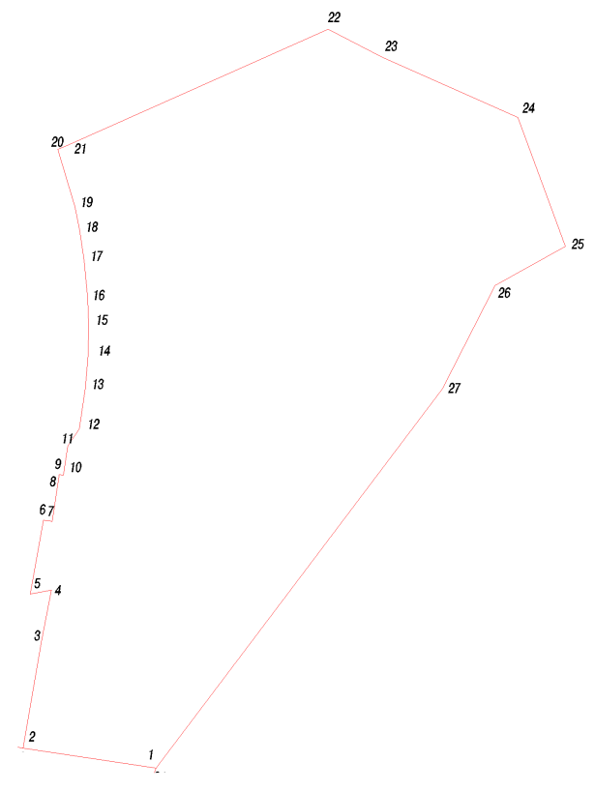
Условное обозначение точки | Координаты
Условное обозначение точки | X | Y
1 | 431402.65 | 1245976.31
2 | 432206.9 | 1246583.42
3 | 432426.81 | 1246695.33
4 | 432509.4 | 1246844.11
5 | 432783.07 | 1246743.03
6 | 432911.45 | 1246455.34
7 | 432970.86 | 1246340.87
8 | 432715.44 | 1245767.86
9 | 432593.68 | 1245804.07
10 | 432542.34 | 1245814.53
11 | 432479.6 | 1245823.67
12 | 432398.42 | 1245830.95
13 | 432342.59 | 1245833.18
14 | 432279.62 | 1245832.2
15 | 432209.38 | 1245826.46
16 | 432122.38 | 1245813.65
17 | 432086.42 | 1245788.94
18 | 432024.19 | 1245779.57
19 | 432025.55 | 1245770.59
20 | 432022.15 | 1245770.07
21 | 431925.87 | 1245755.48
22 | 431929 | 1245737.29
23 | 431772.08 | 1245709.12
24 | 431780.25 | 1245753.84
25 | 431670.75 | 1245732.64
26 | 431444.88 | 1245693.58

Д. Мастерские
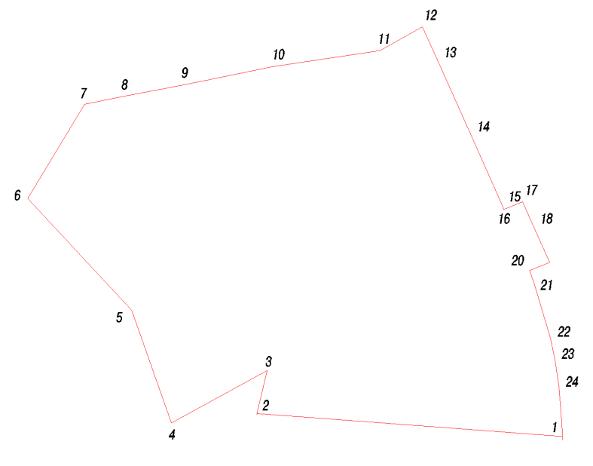
Условное обозначение точки | Координаты
Условное обозначение точки | X | Y
1 | 432366.66 | 1245732.14
2 | 432467.92 | 1245724.32
3 | 432525.14 | 1245715.98
4 | 432569.41 | 1245706.96
5 | 432683.55 | 1245673.02
6 | 432709.61 | 1245663.21
7 | 432726.91 | 1245704.81
8 | 432800.47 | 1245672.11
9 | 432851.92 | 1245648.74
10 | 432835.5 | 1245610.52
11 | 432846.79 | 1245605.67
12 | 432991.78 | 1245541.58
13 | 433145.03 | 1245472.5
14 | 433213.56 | 1245441.48
15 | 433164.82 | 1245354.06
16 | 433131.46 | 1245133.16
17 | 433093.55 | 1244946.65
18 | 433069.6 | 1244822.31
19 | 433053.64 | 1244742.95
20 | 432858.49 | 1244625.34
21 | 432627.13 | 1244840.47
22 | 432394.84 | 1244922.65
23 | 432502.57 | 1245120.35
24 | 432413.63 | 1245099.25

Д. Хлыстовка
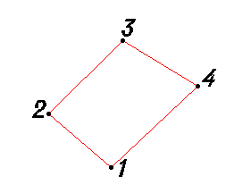
Условное обозначение точки | Координаты
Условное обозначение точки | X | Y
1 | 427170.00 | 1241997.96
2 | 427233.98 | 1241924.02
3 | 427320.98 | 1242012.03
4 | 427266.98 | 1242101.00
Д. Старинки
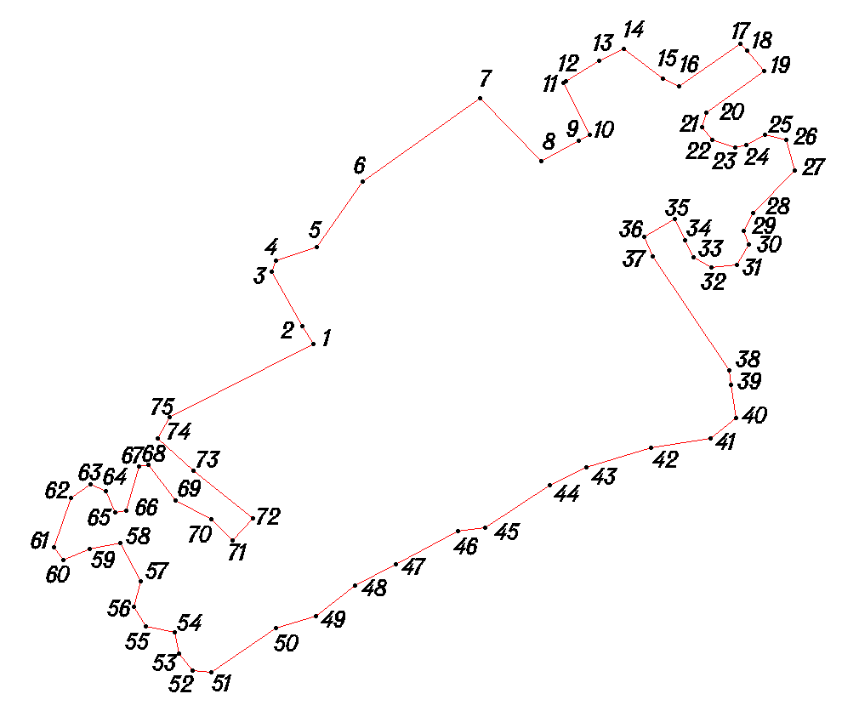
Условное обозначение точки | Координаты
Условное обозначение точки | X | Y
1 | 428380.95 | 1240468.01
2 | 428403.97 | 1240454.04
3 | 428471.96 | 1240416.01
4 | 428484.99 | 1240421.96
5 | 428501.98 | 1240472.01
6 | 428584.36 | 1240529.51
7 | 428687.61 | 1240675.70
8 | 428609.01 | 1240751.99
9 | 428635.03 | 1240798.97
10 | 428641.97 | 1240813.00
11 | 428707.00 | 1240779.95
12 | 428709.04 | 1240783.02
13 | 428734.01 | 1240824.97
14 | 428749.04 | 1240854.97
15 | 428712.01 | 1240903.99
16 | 428703.01 | 1240923.94
17 | 428756.03 | 1241000.95
18 | 428746.94 | 1241009.02
19 | 428721.96 | 1241030.01
20 | 428670.00 | 1240958.04
21 | 428651.94 | 1240953.01
22 | 428635.95 | 1240965.02
23 | 428626.02 | 1240994.03
24 | 428629.95 | 1241007.96
25 | 428642.00 | 1241030.95
26 | 428635.97 | 1241058.02
27 | 428597.94 | 1241067.96
28 | 428545.02 | 1241016.02
29 | 428522.00 | 1241005.01
30 | 428504.95 | 1241011.01
31 | 428479.98 | 1240996.03
32 | 428477.02 | 1240963.95
33 | 428490.02 | 1240942.05
34 | 428510.98 | 1240931.79
35 | 428537.01 | 1240919.04
36 | 428514.99 | 1240881.00
37 | 428491.02 | 1240891.04
38 | 428347.96 | 1240987.04
39 | 428330.83 | 1240988.89
40 | 428288.82 | 1240994.89
41 | 428263.83 | 1240963.89
42 | 428251.81 | 1240888.89
43 | 428227.82 | 1240808.88
44 | 428205.84 | 1240762.88
45 | 428152.01 | 1240682.01
46 | 428148.02 | 1240648.01
47 | 428106.97 | 1240571.04
48 | 428080.02 | 1240520.03
49 | 428042.01 | 1240471.03
50 | 428027.04 | 1240421.95
51 | 427971.97 | 1240340.99
52 | 427973.99 | 1240317.98
53 | 427995.00 | 1240300.95
54 | 428022.00 | 1240295.02
55 | 428028.96 | 1240259.01
56 | 428054.00 | 1240245.02
57 | 428086.04 | 1240253.04
58 | 428133.01 | 1240227.95
59 | 428125.96 | 1240189.05
60 | 428112.02 | 1240155.98
61 | 428128.02 | 1240144.96
62 | 428188.95 | 1240166.01
63 | 428206.03 | 1240189.99
64 | 428197.95 | 1240209.99
65 | 428170.98 | 1240221.01
66 | 428174.01 | 1240234.99
67 | 428228.95 | 1240251.04
68 | 428230.95 | 1240263.00
69 | 428185.96 | 1240295.96
70 | 428162.98 | 1240340.99
71 | 428135.94 | 1240367.99
72 | 428163.99 | 1240392.97
73 | 428222.96 | 1240318.96
74 | 428263.94 | 1240273.96
75 | 428290.01 | 1240288.96

Д. Кирпичный Завод
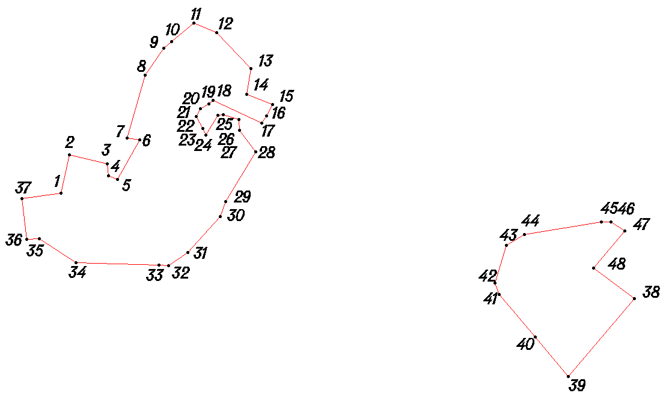
Условное обозначение точки | Координаты
Условное обозначение точки | X | Y
1 | 429547.19 | 1239214.90
2 | 429614.87 | 1239229.87
3 | 429599.03 | 1239296.35
4 | 429576.95 | 1239299.01
5 | 429571.61 | 1239314.14
6 | 429641.19 | 1239354.04
7 | 429644.00 | 1239331.95
8 | 429756.00 | 1239363.01
9 | 429802.92 | 1239396.24
10 | 429814.85 | 1239410.10
11 | 429848.36 | 1239449.05
12 | 429831.03 | 1239489.03
13 | 429767.03 | 1239549.98
14 | 429722.01 | 1239542.99
15 | 429703.97 | 1239588.00
16 | 429683.98 | 1239578.00
17 | 429671.06 | 1239569.17
18 | 429711.15 | 1239482.73
19 | 429704.99 | 1239475.96
20 | 429696.02 | 1239460.96
21 | 429681.97 | 1239452.97
22 | 429660.95 | 1239465.00
23 | 429650.03 | 1239470.00
24 | 429685.00 | 1239492.03
25 | 429685.98 | 1239500.95
26 | 429676.95 | 1239529.01
27 | 429657.95 | 1239530.03
28 | 429619.95 | 1239558.05
29 | 429532.02 | 1239504.96
30 | 429505.00 | 1239496.02
31 | 429441.98 | 1239439.04
32 | 429418.80 | 1239405.04
33 | 429419.94 | 1239388.01
34 | 429424.01 | 1239241.02
35 | 429465.94 | 1239176.99
36 | 429464.96 | 1239153.99
37 | 429537.01 | 1239146.05
38 | 429360.02 | 1240226.03
39 | 429222.00 | 1240110.05
40 | 429292.29 | 1240051.28
41 | 429367.98 | 1239987.99
42 | 429388.05 | 1239981.00
43 | 429453.98 | 1240001.03
44 | 429473.94 | 1240032.01
45 | 429496.04 | 1240168.03
46 | 429495.96 | 1240185.02
47 | 429479.96 | 1240209.02
48 | 429413.96 | 1240154.03

Д. Мурыгино
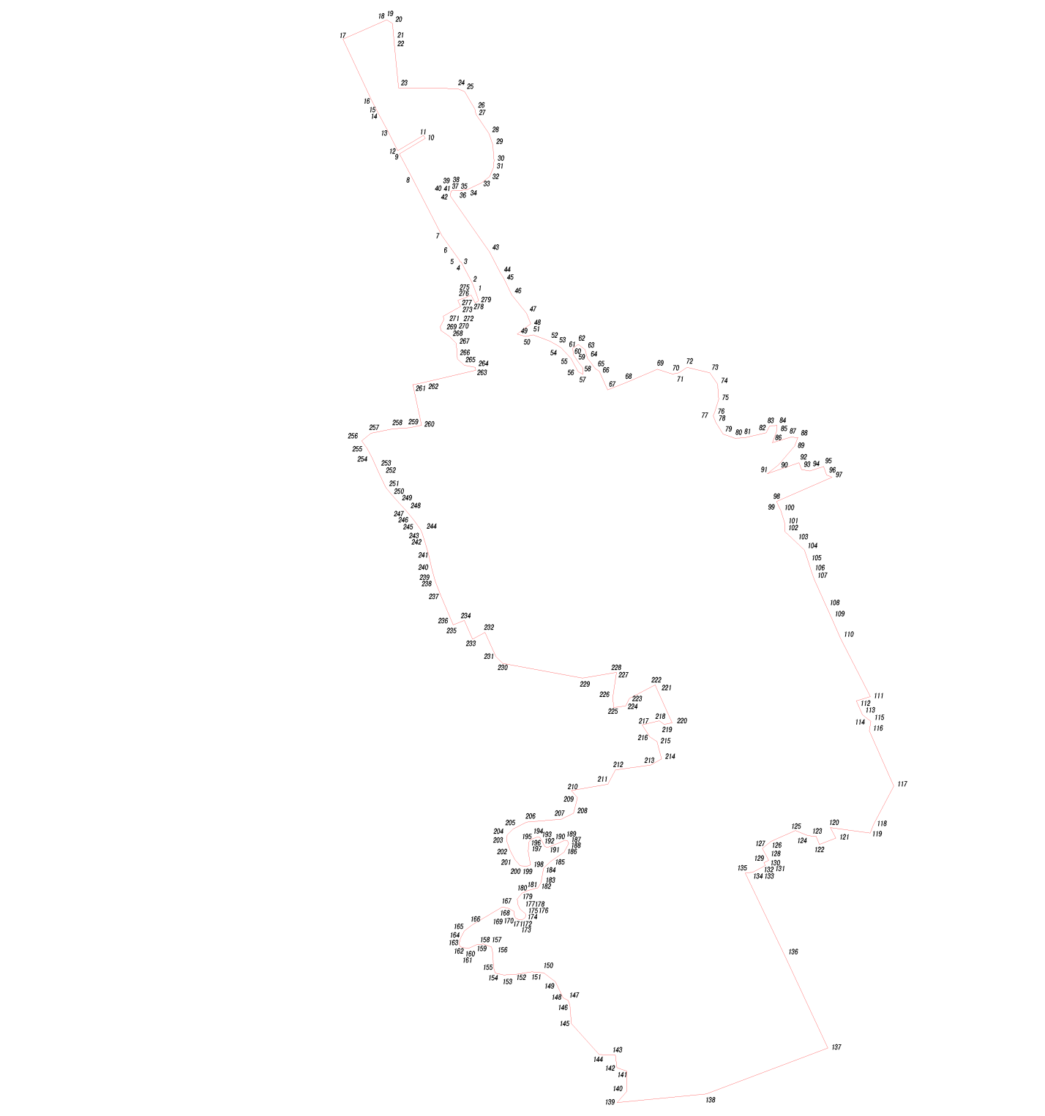
Условное обозначение точки | Координаты
Условное обозначение точки | X | Y
1 | 428860.08 | 1238406.77
2 | 428900.90 | 1238391.01
3 | 428986.65 | 1238345.33
4 | 428985.66 | 1238342.95
5 | 428993.97 | 1238338.52
6 | 429038.44 | 1238306.35
7 | 429090.96 | 1238269.25
8 | 429316.55 | 1238153.33
9 | 429420.69 | 1238097.96
10 | 429483.11 | 1238202.63
11 | 429495.47 | 1238194.79
12 | 429433.77 | 1238091.13
13 | 429507.52 | 1238054.37
14 | 429592.85 | 1238008.53
15 | 429598.57 | 1238005.56
16 | 429630.33 | 1237989.18
17 | 429882.28 | 1237871.14
18 | 429955.33 | 1238037.14
19 | 429960.49 | 1238046.39
20 | 429945.15 | 1238069.85
21 | 429887.84 | 1238075.28
22 | 429867.61 | 1238076.86
23 | 429685.72 | 1238095.08
24 | 429683.05 | 1238331.42
25 | 429671.14 | 1238359.72
26 | 429601.45 | 1238400.91
27 | 429579.90 | 1238405.33
28 | 429501.92 | 1238458.44
29 | 429458.14 | 1238472.95
30 | 429393.92 | 1238478.61
31 | 429365.82 | 1238475.45
32 | 429329.09 | 1238460.43
33 | 429303.93 | 1238427.81
34 | 429276.33 | 1238370.21
35 | 429276.80 | 1238358.56
36 | 429272.85 | 1238344.82
37 | 429272.47 | 1238328.09
38 | 429275.20 | 1238316.00
39 | 429271.21 | 1238307.67
40 | 429271.21 | 1238307.66
41 | 429270.36 | 1238305.89
42 | 429251.99 | 1238302.18
43 | 429027.20 | 1238459.82
44 | 428938.46 | 1238505.66
45 | 428920.07 | 1238517.64
46 | 428852.91 | 1238549.46
47 | 428779.73 | 1238609.01
48 | 428737.03 | 1238625.47
49 | 428696.01 | 1238571.96
50 | 428686.01 | 1238604.97
51 | 428691.99 | 1238635.95
52 | 428667.97 | 1238702.02
53 | 428650.02 | 1238733.04
54 | 428639.99 | 1238748.98
55 | 428598.95 | 1238786.97
56 | 428544.96 | 1238816.01
57 | 428533.95 | 1238835.01
58 | 428558.99 | 1238834.99
59 | 428589.00 | 1238812.98
60 | 428613.02 | 1238797.95
61 | 428639.04 | 1238793.98
62 | 428654.00 | 1238816.99
63 | 428633.00 | 1238844.02
64 | 428598.98 | 1238854.00
65 | 428555.97 | 1238886.02
66 | 428546.94 | 1238900.99
67 | 428470.97 | 1238935.05
68 | 428501.96 | 1239011.96
69 | 428554.02 | 1239134.97
70 | 428535.00 | 1239196.03
71 | 428540.03 | 1239220.97
72 | 428562.02 | 1239254.02
73 | 428540.02 | 1239346.03
74 | 428494.00 | 1239376.96
75 | 428432.98 | 1239380.99
76 | 428381.05 | 1239364.95
77 | 428367.01 | 1239358.96
78 | 428341.05 | 1239369.02
79 | 428293.00 | 1239398.99
80 | 428275.98 | 1239447.02
81 | 428279.01 | 1239486.98
82 | 428298.00 | 1239571.96
83 | 428325.97 | 1239586.05
84 | 428328.01 | 1239615.98
85 | 428309.01 | 1239616.00
86 | 428258.96 | 1239597.05
87 | 428280.96 | 1239668.95
88 | 428280.00 | 1239699.97
89 | 428246.00 | 1239686.98
90 | 428169.95 | 1239622.05
91 | 428133.98 | 1239577.02
92 | 428178.05 | 1239704.04
93 | 428149.97 | 1239715.04
94 | 428145.00 | 1239748.01
95 | 428163.02 | 1239802.99
96 | 428129.03 | 1239814.97
97 | 428119.95 | 1239837.03
98 | 428022.03 | 1239613.99
99 | 428007.99 | 1239619.99
100 | 427982.95 | 1239631.98
101 | 427932.98 | 1239646.99
102 | 427900.99 | 1239646.95
103 | 427859.99 | 1239691.04
104 | 427826.99 | 1239726.02
105 | 427781.04 | 1239740.97
106 | 427741.00 | 1239754.03
107 | 427710.01 | 1239765.01
108 | 427599.54 | 1239814.21
109 | 427554.73 | 1239834.17
110 | 427471.97 | 1239871.03
111 | 427236.96 | 1239991.02
112 | 427220.01 | 1239933.98
113 | 427163.98 | 1239958.96
114 | 427148.94 | 1239978.01
115 | 427137.99 | 1239993.00
116 | 427099.02 | 1239987.01
117 | 426876.72 | 1240084.92
118 | 426722.89 | 1240003.90
119 | 426688.52 | 1239990.25
120 | 426710.62 | 1239830.27
121 | 426668.18 | 1239852.26
122 | 426642.72 | 1239785.91
123 | 426675.74 | 1239772.41
124 | 426677.35 | 1239742.29
125 | 426698.75 | 1239689.70
126 | 426655.20 | 1239592.05
127 | 426626.24 | 1239556.70
128 | 426588.94 | 1239577.32
129 | 426577.98 | 1239582.30
130 | 426569.28 | 1239563.19
131 | 426557.48 | 1239568.55
132 | 426551.00 | 1239556.21
133 | 426536.04 | 1239527.76
134 | 426530.67 | 1239518.02
135 | 426527.05 | 1239487.94
136 | 426194.84 | 1239646.91
137 | 425823.18 | 1239820.19
138 | 425638.85 | 1239331.50
139 | 425603.71 | 1238973.39
140 | 425649.18 | 1239012.18
141 | 425730.14 | 1239012.26
142 | 425744.69 | 1238972.36
143 | 425794.56 | 1238965.92
144 | 425796.77 | 1238901.14
145 | 425921.42 | 1238788.92
146 | 425995.57 | 1238782.98
147 | 426015.10 | 1238776.77
148 | 426025.06 | 1238756.46
149 | 426090.26 | 1238724.95
150 | 426125.67 | 1238678.14
151 | 426129.96 | 1238630.49
152 | 426120.18 | 1238566.03
153 | 426117.23 | 1238517.74
154 | 426125.34 | 1238483.54
155 | 426146.47 | 1238476.39
156 | 426208.78 | 1238472.23
157 | 426229.71 | 1238468.22
158 | 426241.65 | 1238435.31
159 | 426239.64 | 1238409.23
160 | 426224.54 | 1238377.01
161 | 426226.52 | 1238358.85
162 | 426230.63 | 1238342.62
163 | 426241.89 | 1238337.41
164 | 426264.20 | 1238342.68
165 | 426293.99 | 1238359.10
166 | 426320.04 | 1238392.01
167 | 426390.91 | 1238511.66
168 | 426385.58 | 1238536.31
169 | 426372.96 | 1238559.20
170 | 426353.80 | 1238560.20
171 | 426345.60 | 1238566.43
172 | 426340.51 | 1238578.73
173 | 426340.29 | 1238592.21
174 | 426347.47 | 1238602.48
175 | 426353.21 | 1238605.59
176 | 426362.69 | 1238605.15
177 | 426382.09 | 1238582.47
178 | 426401.14 | 1238574.33
179 | 426423.17 | 1238571.37
180 | 426447.27 | 1238590.86
181 | 426458.08 | 1238616.26
182 | 426468.19 | 1238654.47
183 | 426488.91 | 1238667.20
184 | 426546.52 | 1238677.48
185 | 426573.81 | 1238705.49
186 | 426611.35 | 1238759.92
187 | 426645.62 | 1238777.93
188 | 426656.79 | 1238774.19
189 | 426659.21 | 1238762.64
190 | 426648.97 | 1238740.83
191 | 426631.42 | 1238695.69
192 | 426633.29 | 1238683.02
193 | 426671.67 | 1238661.85
194 | 426671.15 | 1238649.33
195 | 426662.54 | 1238626.69
196 | 426651.81 | 1238618.11
197 | 426614.91 | 1238615.34
198 | 426560.37 | 1238624.70
199 | 426554.07 | 1238609.27
200 | 426557.12 | 1238583.80
201 | 426581.74 | 1238561.97
202 | 426618.93 | 1238542.88
203 | 426657.12 | 1238528.80
204 | 426680.25 | 1238530.81
205 | 426704.38 | 1238554.93
206 | 426732.51 | 1238609.23
207 | 426744.01 | 1238748.50
208 | 426767.71 | 1238797.97
209 | 426830.60 | 1238813.63
210 | 426859.71 | 1238789.24
211 | 426884.45 | 1238935.80
212 | 426941.95 | 1238966.24
213 | 426961.99 | 1239108.09
214 | 426985.98 | 1239152.04
215 | 427056.94 | 1239132.99
216 | 427075.02 | 1239103.96
217 | 427123.97 | 1239074.04
218 | 427140.00 | 1239142.03
219 | 427124.97 | 1239162.97
220 | 427131.96 | 1239193.99
221 | 427270.97 | 1239131.01
222 | 427284.83 | 1239126.19
223 | 427229.97 | 1239022.98
224 | 427199.88 | 1239007.85
225 | 427192.69 | 1238958.47
226 | 427237.00 | 1238955.75
227 | 427334.71 | 1238970.78
228 | 427334.47 | 1238968.51
229 | 427311.96 | 1238834.38
230 | 427371.08 | 1238513.21
231 | 427398.24 | 1238485.96
232 | 427495.36 | 1238442.27
233 | 427468.24 | 1238392.28
234 | 427544.11 | 1238358.74
235 | 427525.73 | 1238314.01
236 | 427538.47 | 1238309.32
237 | 427640.52 | 1238265.68
238 | 427700.89 | 1238241.94
239 | 427710.51 | 1238239.38
240 | 427753.41 | 1238227.95
241 | 427807.03 | 1238216.15
242 | 427859.63 | 1238200.59
243 | 427896.88 | 1238188.72
244 | 427909.94 | 1238182.43
245 | 427932.10 | 1238166.94
246 | 427955.46 | 1238149.33
247 | 427991.23 | 1238119.79
248 | 427992.93 | 1238118.27
249 | 428015.44 | 1238097.44
250 | 428053.18 | 1238063.48
251 | 428078.72 | 1238043.28
252 | 428132.35 | 1238017.73
253 | 428160.72 | 1238004.68
254 | 428196.89 | 1237989.03
255 | 428236.36 | 1237967.49
256 | 428266.22 | 1237946.42
257 | 428296.50 | 1237983.47
258 | 428314.72 | 1238072.06
259 | 428318.50 | 1238136.77
260 | 428329.05 | 1238186.90
261 | 428491.62 | 1238152.58
262 | 428500.70 | 1238195.70
263 | 428549.83 | 1238404.50
264 | 428562.00 | 1238402.99
265 | 428570.00 | 1238359.02
266 | 428596.03 | 1238330.98
267 | 428657.96 | 1238326.99
268 | 428685.99 | 1238299.02
269 | 428709.96 | 1238265.01
270 | 428725.03 | 1238262.05
271 | 428754.02 | 1238276.97
272 | 428767.98 | 1238273.97
273 | 428806.96 | 1238343.98
274 | 428831.00 | 1238333.04
275 | 428835.94 | 1238345.25
276 | 428841.36 | 1238361.11
277 | 428852.20 | 1238386.36
278 | 428821.64 | 1238401.97
279 | 428829.45 | 1238416.58

Д. Льнозавод
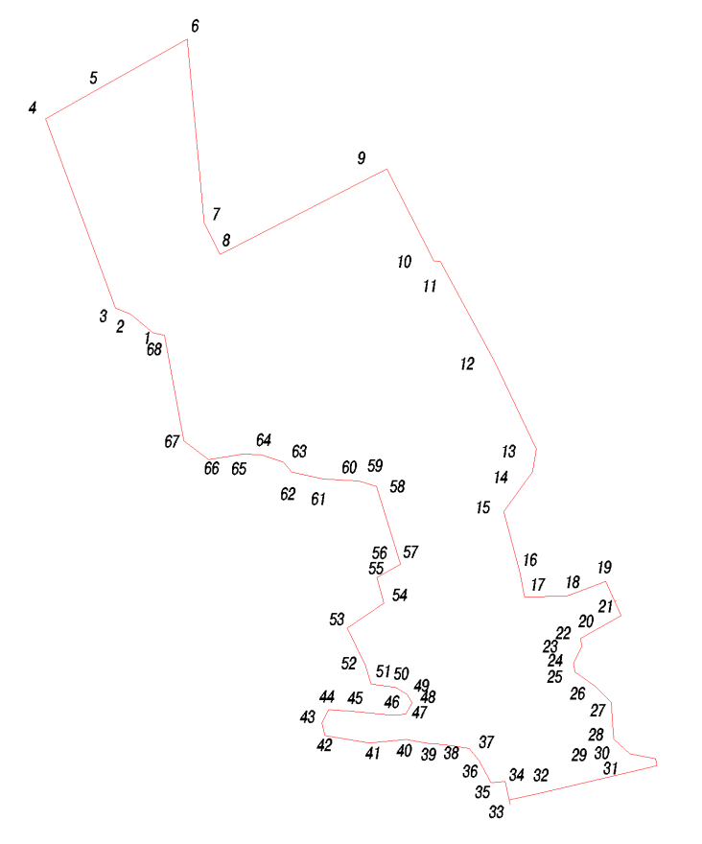
Условное обозначение точки | Координаты
Условное обозначение точки | X | Y
1 | 429290.04 | 1237542.97
2 | 429322.74 | 1237504.21
3 | 429332.17 | 1237478.50
4 | 429656.32 | 1237359.14
5 | 429702.78 | 1237442.02
6 | 429792.09 | 1237601.35
7 | 429479.50 | 1237630.69
8 | 429424.45 | 1237657.29
9 | 429570.57 | 1237942.69
10 | 429413.01 | 1238023.35
11 | 429412.02 | 1238034.96
12 | 429239.96 | 1238128.04
13 | 429090.95 | 1238199.05
14 | 429051.97 | 1238191.97
15 | 428984.08 | 1238142.60
16 | 428879.55 | 1238170.83
17 | 428838.49 | 1238178.74
18 | 428839.62 | 1238249.78
19 | 428864.97 | 1238317.73
20 | 428831.00 | 1238333.04
21 | 428806.96 | 1238343.98
22 | 428767.98 | 1238273.97
23 | 428754.02 | 1238276.97
24 | 428725.03 | 1238262.05
25 | 428709.96 | 1238265.01
26 | 428685.99 | 1238299.02
27 | 428657.96 | 1238326.99
28 | 428596.03 | 1238330.98
29 | 428570.00 | 1238359.02
30 | 428562.00 | 1238402.99
31 | 428549.83 | 1238404.50
32 | 428500.70 | 1238195.70
33 | 428491.62 | 1238152.58
34 | 428523.19 | 1238145.91
35 | 428521.18 | 1238121.33
36 | 428559.13 | 1238100.64
37 | 428579.86 | 1238083.99
38 | 428586.45 | 1238039.07
39 | 428588.03 | 1238014.26
40 | 428594.62 | 1237976.24
41 | 428588.93 | 1237912.20
42 | 428601.53 | 1237837.08
43 | 428622.85 | 1237831.78
44 | 428645.47 | 1237843.09
45 | 428642.96 | 1237884.56
46 | 428636.68 | 1237951.15
47 | 428637.97 | 1237974.98
48 | 428657.14 | 1237986.61
49 | 428671.91 | 1237977.81
50 | 428683.84 | 1237958.34
51 | 428689.45 | 1237915.97
52 | 428720.86 | 1237906.61
53 | 428785.63 | 1237875.17
54 | 428828.05 | 1237938.04
55 | 428871.61 | 1237925.92
56 | 428894.38 | 1237966.73
57 | 428898.99 | 1237965.29
58 | 429028.03 | 1237925.01
59 | 429037.04 | 1237894.97
60 | 429038.02 | 1237874.63
61 | 429039.98 | 1237833.95
62 | 429052.03 | 1237780.04
63 | 429069.00 | 1237765.95
64 | 429081.98 | 1237727.97
65 | 429083.04 | 1237696.03
66 | 429073.02 | 1237637.94
67 | 429105.98 | 1237595.97
68 | 429285.95 | 1237563.01

